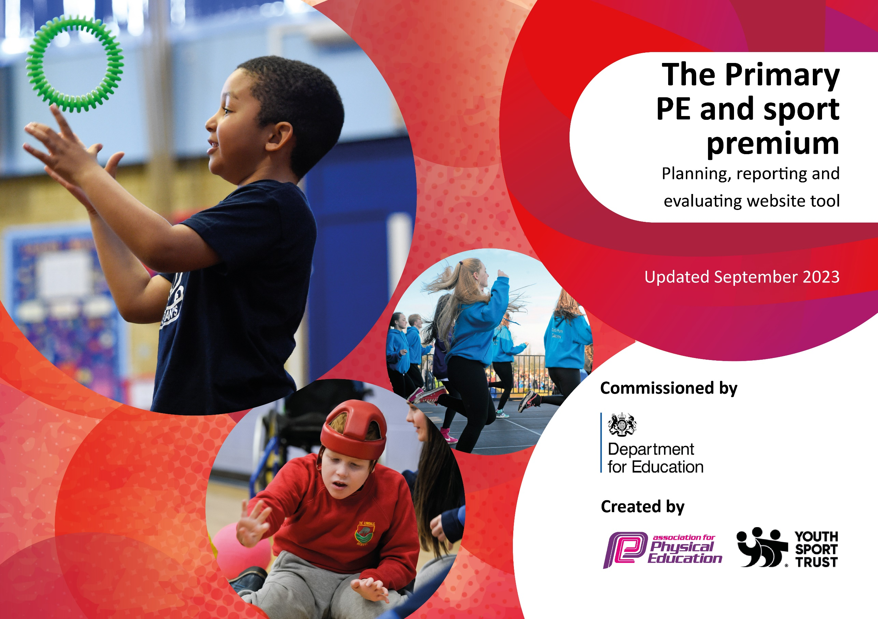

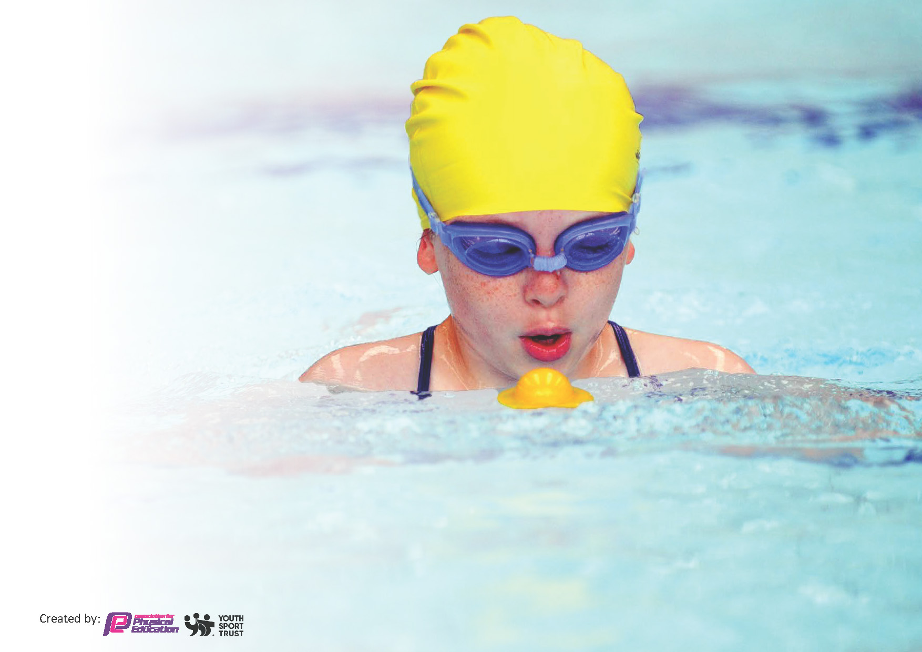
This template can be used for multiple purposes:
by:
- It enables schools to effectively plan their use of the Primary PE and sport premium
- It helps schools to meet the requirements (as set out in guidance) to publish information on their Primary PE and sport premium
- It will be an effective document to support Ofsted inspections enabling schools to evidence progress in Physical Education (PE) and evidence swimming attainment, which forms part of the PE National Curriculum. We would recommend schools consider
the Intent, Implementation and Impact of any spend, as examined within the Education Inspection Framework.

It is important that your grant is used effectively and based on school need.

Schools must use the funding to make additional and sustainable
improvements to the quality of the PE, School Sport and Physical Activity (PESSPA)
they offer. This means that you should use the Primary PE and sport premium to:

- Build capacity and capability within the school to ensure that improvements made now will benefit pupils joining the school in future years
- Develop or add to the PESSPA activities that your school already offers.

The Primary PE and sport premium should not be used to fund capital spend projects; the school’s core budget should fund these. Further detail on capital expenditure can be found in the updated Primary PE and sport premium guidance.

The Primary PE and sport premium guidance, outlines 5 key priorities that funding should be used towards. It is not necessary that spending has to meet all the key priorities, you should select the priorities that you aim to use any funding towards.

Although completing this template is not a requirement for schools, schools are required to publish details of how they spend this funding. Schools must also outline what the impact this funding has had on pupils’ PE and sport participation and attainment and how any spending will be sustainable in the future. All funding must be spent by 31st July 2024.

Review of last year’s spend and key achievements (2023/2024)

Action | Impact | Review and Next Steps
Staff to assist West Lancashire Sports Partnership Sports Coach and observe how to deliver activities which develops the physical ability of children. E.g. Throwing and catching stance. | Staff to build their knowledge and understanding of PE and sport development. | Staff have increased confidence in teaching PE and sport development. This will continue into 2024/25. School will then no longer need West Lancashire Sports to support them in the teaching of PE. School will then be able to deploy the money in a different way.
Teachers to use ‘Suceedin’ to plan lessons so that they are consistent with WLSP sport coach lessons. | Staff to have access to ‘Suceedin’ platform (developed by West Lancashire Sports Partnership) which provides teachers with online planning and assessment activities and access to online CPD. | Staff have a better understanding of the teaching of PE.
Lunchtime staff to play physical games with the children. | Children to be encouraged to undertake 30 minutes of physical activity during lunchtime. | Children are completing 30 -40 minutes of physical exercise during lunchtime. The welfare assistants encourage them to use the skills they have learnt in PE during lunch time. This is especially evident in the KS2 playground when the are playing games such as rounders and dodge ball. This is facilitated by the adult, although children are beginning to become independent when the adult moves away to deal with a situation.
To provide all children with an 8-week block of forest school. | To provide all children with an 8-week block of Forest School, so that they build resilience, problem solving skills and communication skills. | All children have had an 8-week block of forest school. When completing a monitoring exercise, it was evident that the children had widened their understanding of the world and their scientific knowledge through skills learnt in the forest school. The children were then able to apply the skills to other subject areas such as design technology. It became apparent how much forest school had impacted on children’s learning across all subject areas.
All children in Key Stage Two to have a weekly swimming lesson. | All children to be able to swim 25 m and more by the time they leave year six. | The school achieved 100% in relation to all Year Six children being about to swim 25m.
School is part of SHARES – A large group of school. The school takes part in competitions organised by SHARES such as e.g. swimming gala, athletics competition and football competition. | Children to attend competitions with other schools in the area. | Children from the school did take part in competitions when able. Unfortunately, the athletics competition took place when our Year Five and Six children went to Rock and River, so we were unable to attend.

Key priorities and Planning – 2024/5
Total amount carried over from 2023/24 | -£4,943
Total amount allocated for 2024/25 | £16600 (60 pupils)
How much (if any) do you intend to carry over from this total fund into 2024/25? | £0
Total amount allocated for 2024/5 | £16600
Total amount of funding for 2024/25 to be reported on by 31st July 2025 | £11657

Action – what are you planning to do | Who does this action impact? | Key indicator to meet | Impacts and how sustainability will be achieved? | Cost linked to the action
EYFS – Year Four Staff to assist West Lancashire Sports Partnership Sports Coach and observe how to deliver activities which develop the sports ability of children. E.g. Throwing and catching stance. | Staff to build their knowledge and understanding of PE and sport development. | Key indicator 1: Increase confidence, knowledge and skills of all staff in teaching PE and sport | Staff will have increased confidence in teaching PE and sport development. | £5,151
Teachers to use ‘Suceedin’ to plan lessons so that they are consistent with WLSP sport coach lessons. | Staff to have access to ‘Suceedin’ platform (developed by West Lancashire Sports Partnership) which provides teachers with online planning and assessment activities and access to online CPD. | Key indicator 1: Increase confidence, knowledge and skills of all staff in teaching PE and sport | Staff will have increased confidence in teaching PE and sport development. | £0
To provide all children with an 8-week block of forest school. | To provide all children with an 8-week block of Forest School, so that they build resilience, problem solving skills and communication skills. | Key indicator 4: Broader experience of a range of sports and physical activities offered to all pupils | Children will experience a broader range of sports and we build their resilience, problem solving skills and communication skills. | £5,550
All children in Key Stage Two to have a weekly swimming lesson. | All children to be able to swim 25 m and more by the time they leave year six. | Key indicator 4: Broader experience of a range of sports and physical activities offered to all pupils | All children will be able to swim competently. | £3522

Total of spend: £14,223

Overspend: £2566

Swimming Data 2023/24
Meeting National Curriculum requirements for swimming and water safety.
Priority should always be given to ensuring that pupils can perform safe self-rescue even if they do not fully meet the first two requirements of the National Curriculum programme of study

Question | Stats: | Further context  Relative to local challenges
What percentage of your current Year 6 cohort can swim competently, confidently and proficiently over a distance of at least 25 metres? | 100% | The majority of children attending the school do not have outside of school swimming lessons therefore when they enter Year Three they have no experience of swimming or being in water. It is important to us as a school to provide lessons so that our children are able to swim and keep themselves safe when near water.
What percentage of your current Year 6 cohort can use a range of strokes effectively [for example, front crawl, backstroke, and breaststroke]? | 100%

What percentage of your current Year 6 cohort are able to perform safe self-rescue in different water-based situations? | 100%
If your schools swimming data is below national expectation, you can choose to use the Primary PE and sport premium to provide additional top-up sessions for those pupils that did not meet National Curriculum  requirements after the completion of core lessons. Have you done this? | Yes
Have you provided CPD to improve the knowledge and confidence of staff to be able to teach swimming and water safety? | No

National Curriculum Levels
 | End of Summer 2023-24 | End of Autumn 2024-25 | End of Spring 2024-25 | End of Summer 2024-25
Year Three | -
Year Four | 9%
Year Five | 50%
Year Six | 70%
Head Teacher: | Annette Birmingham
Subject Leader or the individual responsible for the Primary PE and sport premium: | Michelle Nickson
Governor: | Angela Wright
Date: | 26.9.24
Signed off by:

