St Edmund’s Catholic Primary School

Mathematics Calculation Policy
March 22
This calculation policy has been taken and adapted to suit from White Rose Maths. The policy goes through: Addition, Subtraction, Times tables, Multiplication and Division. Each operation is broken down into skills for the year group and shows recommended models and visuals to support the teaching of the corresponding concepts alongside. Progression within each area of calculation is in line with the programme of study in the 2014 National Curriculum. This calculation policy should be used to support children to develop a deep understanding of number and calculation. This policy has been designed to teach children through the use of concrete, pictorial and abstract representations.
• Concrete representation— a pupil is first introduced to an idea or skill by acting it out with real objects. This is a ‘hands on’ component using real objects and is a foundation for conceptual understanding.
• Pictorial representation – a pupil has sufficiently understood the ‘hands on’ experiences performed and can now relate them to representations, such as a diagram or picture of the problem.
• Abstract representation—a pupil is now capable of representing problems by using mathematical notation, for example 12 x 2 = 24. It is important that conceptual understanding, supported by the use of representation, is secure for all procedures. Reinforcement is achieved by going back and forth between these representations.
Mathematics Mastery
At the centre of the mastery approach to the teaching of mathematics is the belief that all children have the potential to succeed. They should have access to the same curriculum content and, rather than being extended with new learning, they should deepen their conceptual understanding by tackling challenging and varied problems. Similarly, with calculation strategies, children must not simply rote learn procedures but demonstrate their understanding of these procedures through the use of concrete materials and pictorial representations. This policy outlines the different calculation strategies that should be taught and used in Year 1 to Year 6 in line with the requirements of the 2014 Primary National Curriculum.
How to use the policy:
This mathematics policy is a guide for all staff at St Edmund’s Catholic Primary School and has been adapted from work by White Rose Maths. All teachers have been given the scheme of work from the White Rose Maths Hub and are required to base their planning around their mixed year group’s modules. These modules use the Singapore Maths Methods and are affiliated to the workings of the 2014 Maths Programme of Study. Teachers can use any teaching resources that they wish to use and the policy does not recommend one set of resources over another, rather that, a variety of resources are used. For each of the four rules of number, different strategies are laid out, together with examples of what concrete materials can be used and how, along with suggested pictorial representations. The principle of the concrete-pictorial-abstract (CPA) approach [Make it, Draw it, Write it] is for children to have a true understanding of a mathematical concept, they need to master all three phases within a year group’s scheme of work.

Addition

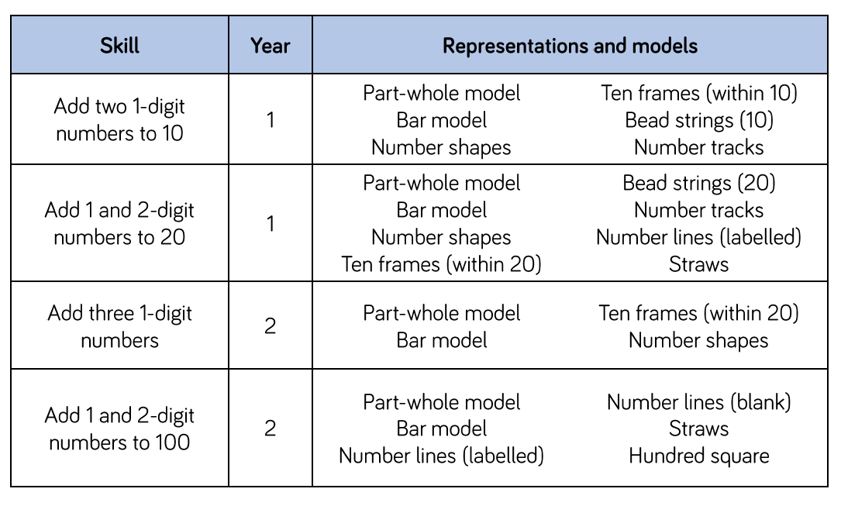
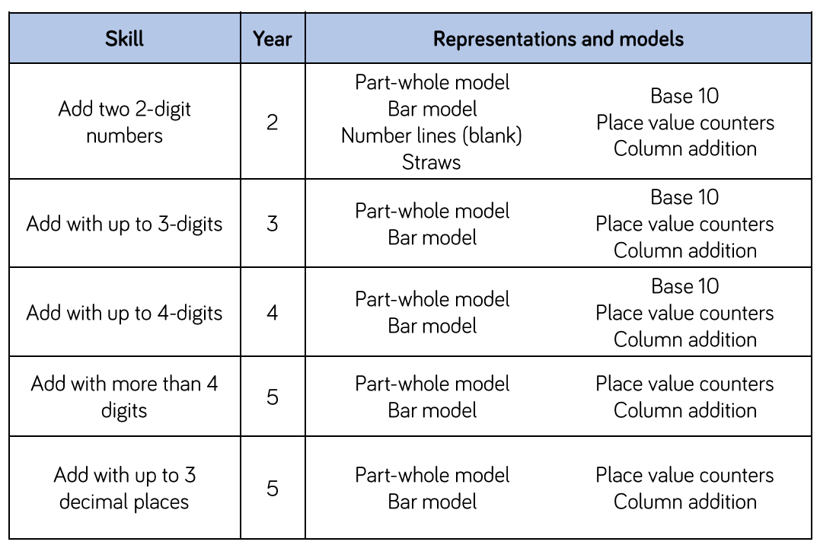
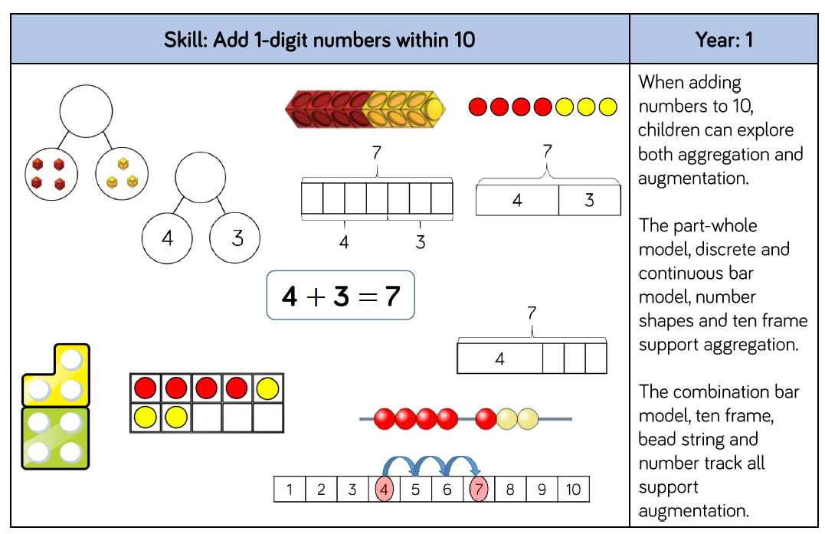
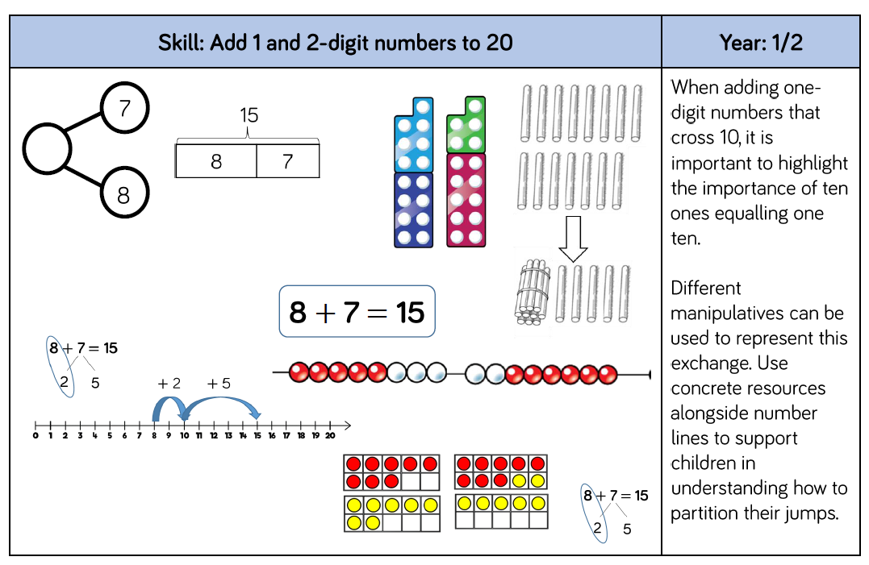
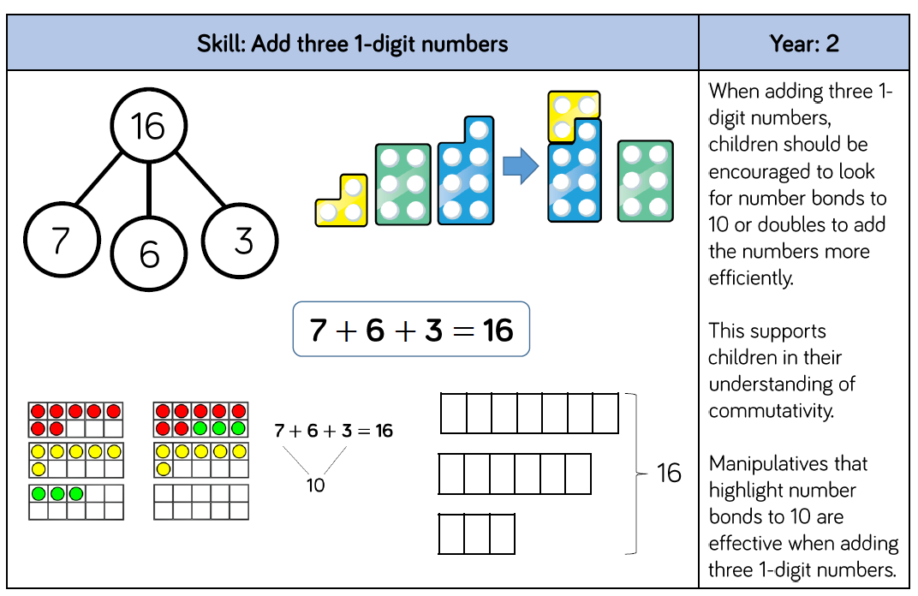
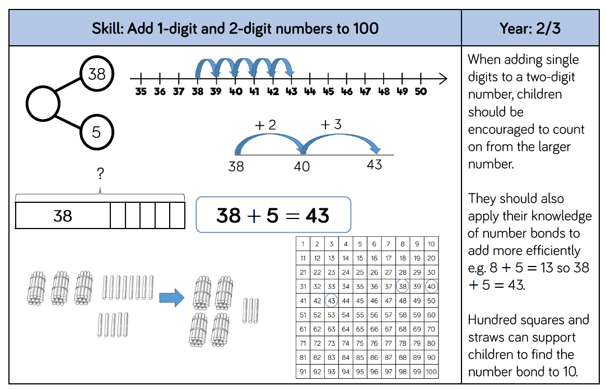
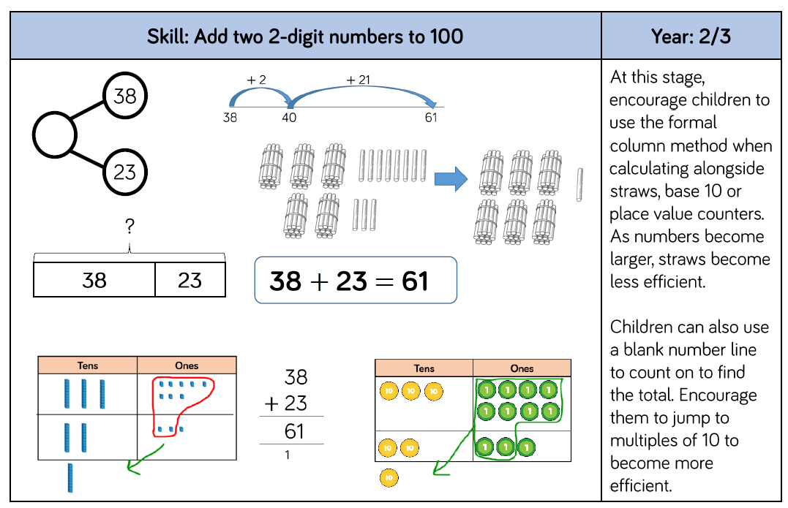
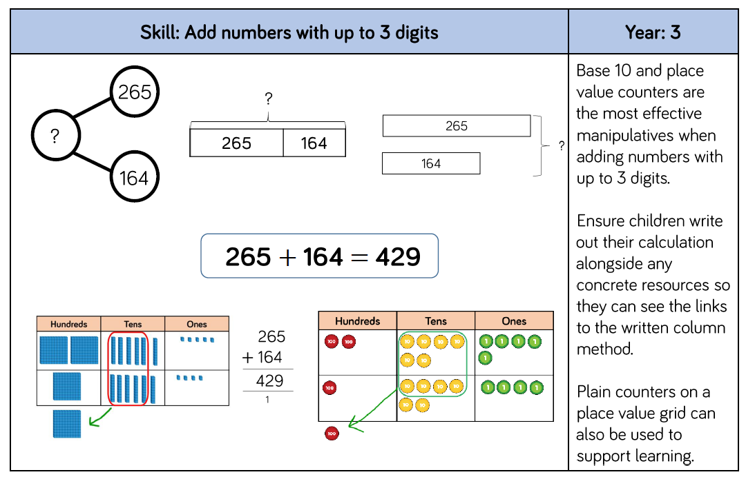
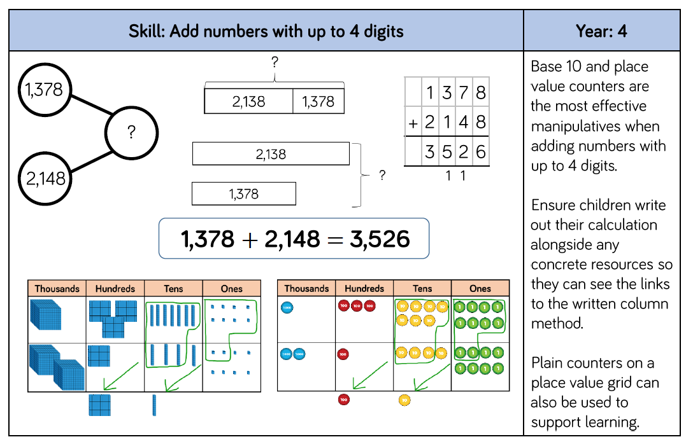
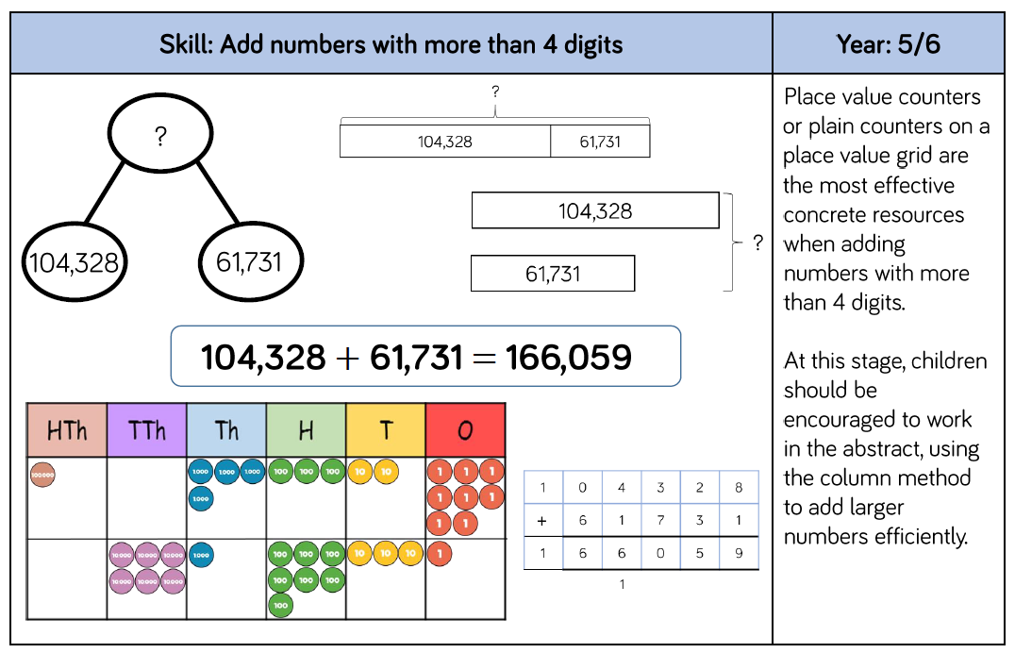
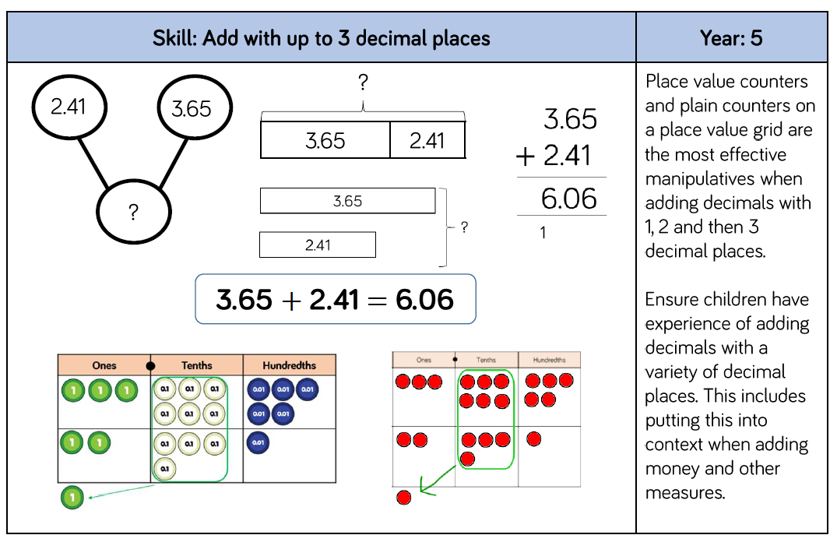

Subtraction
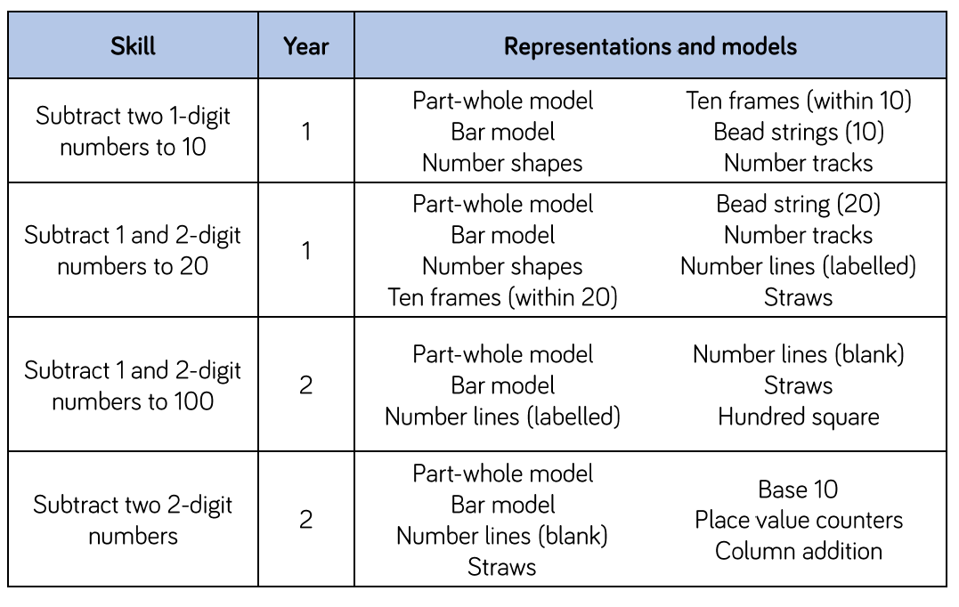
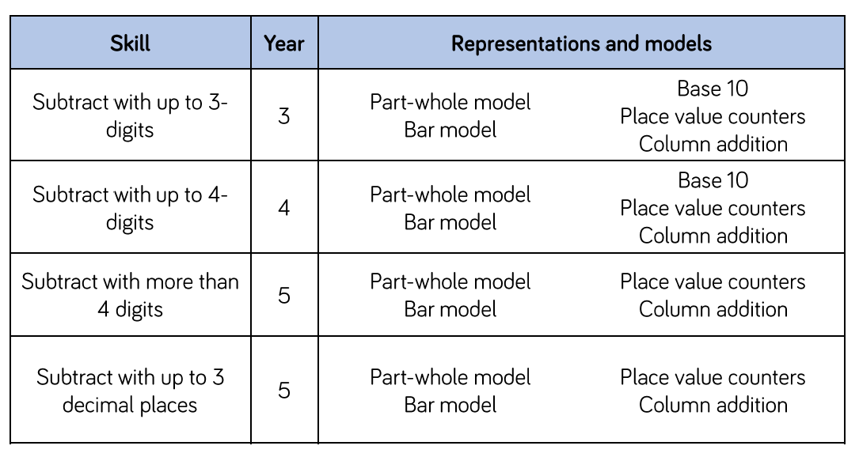

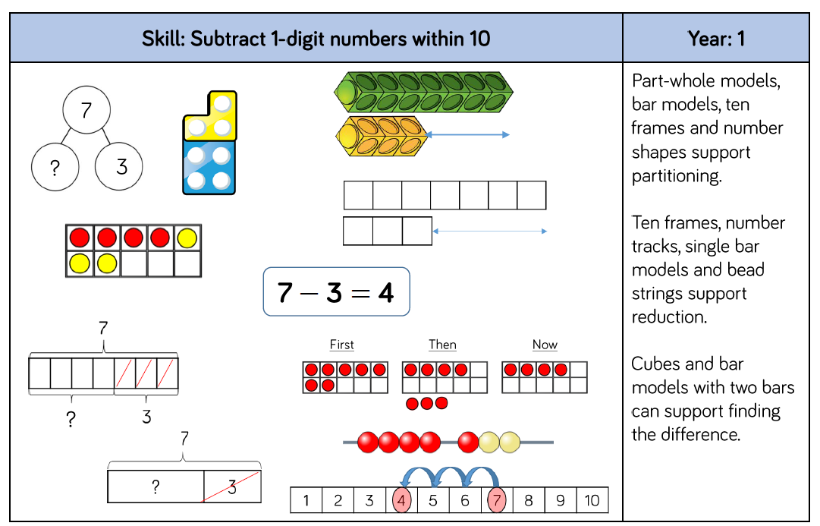
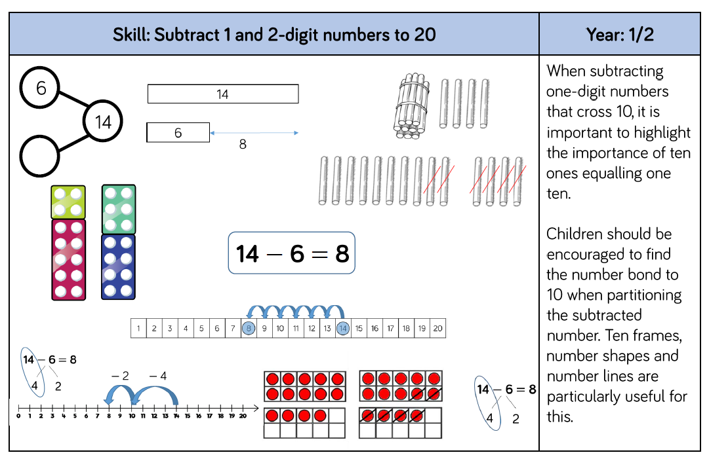
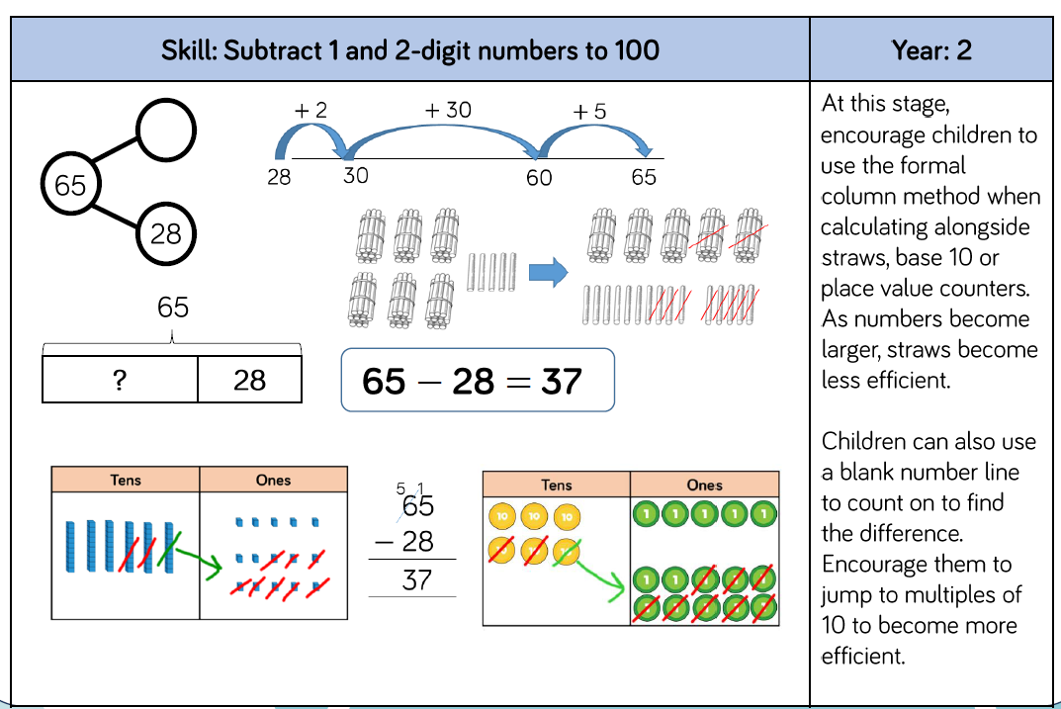
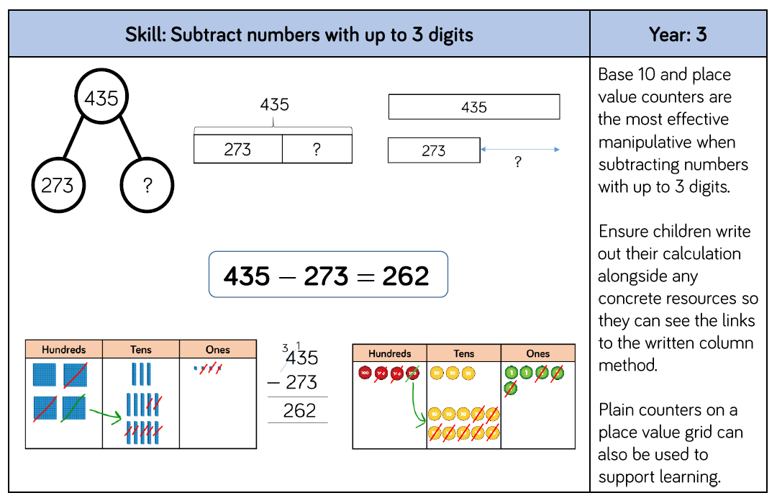
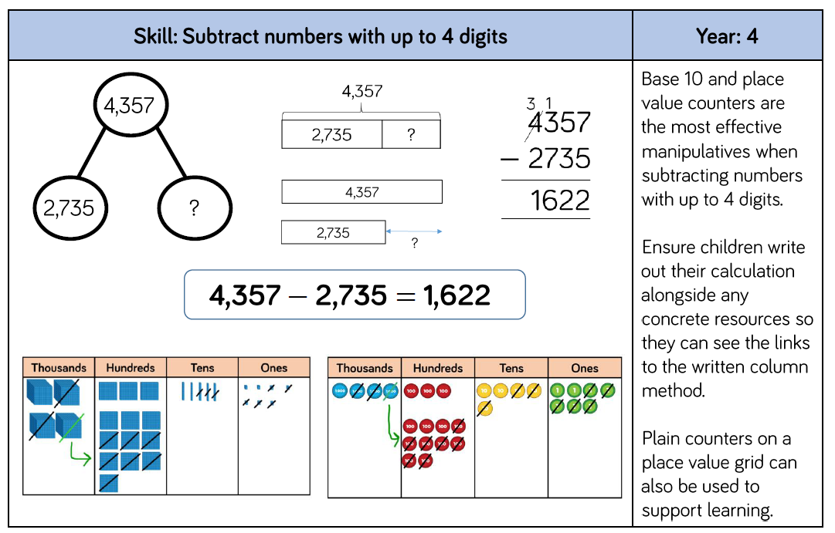
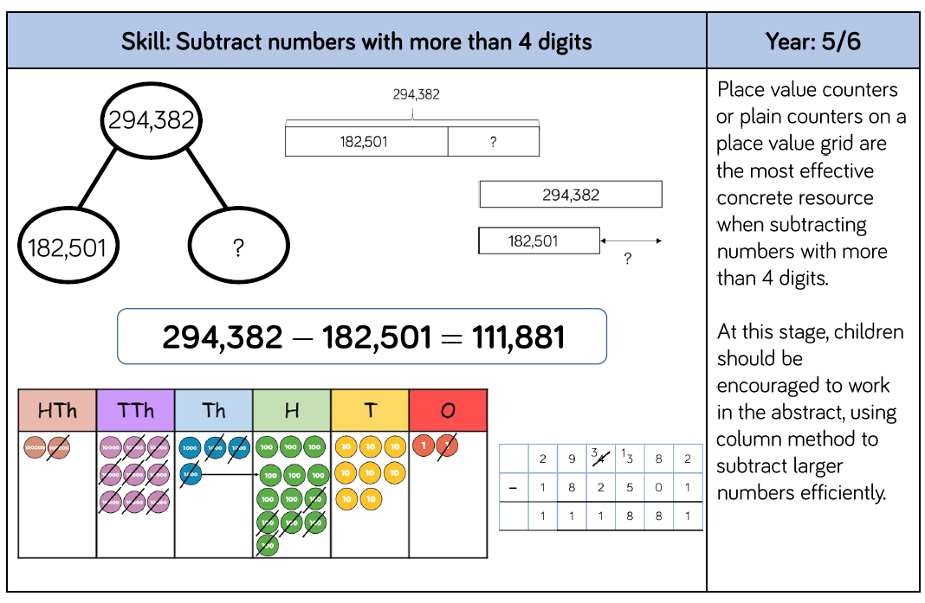
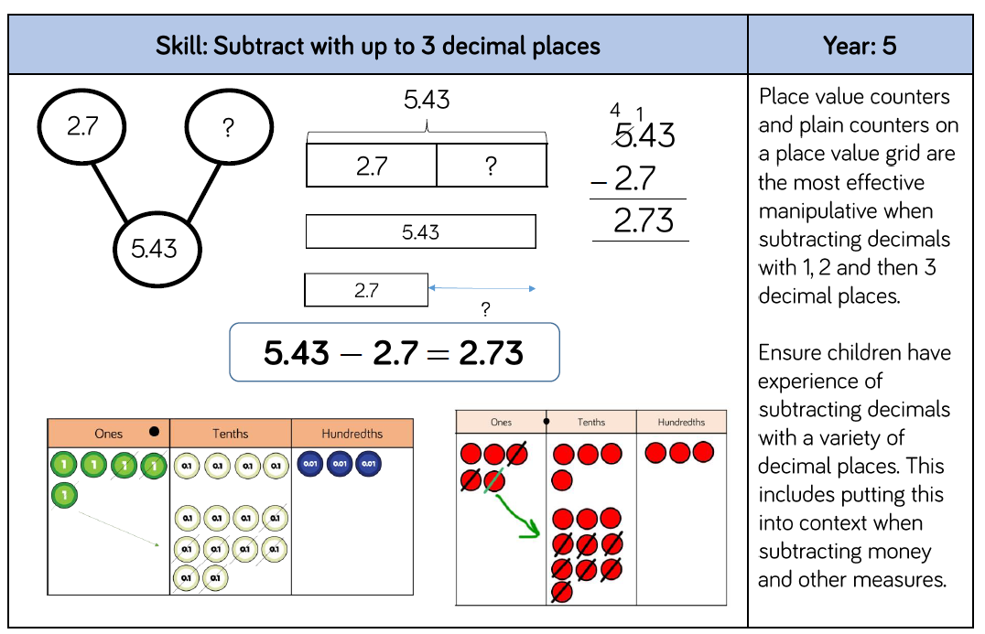

Times Tables
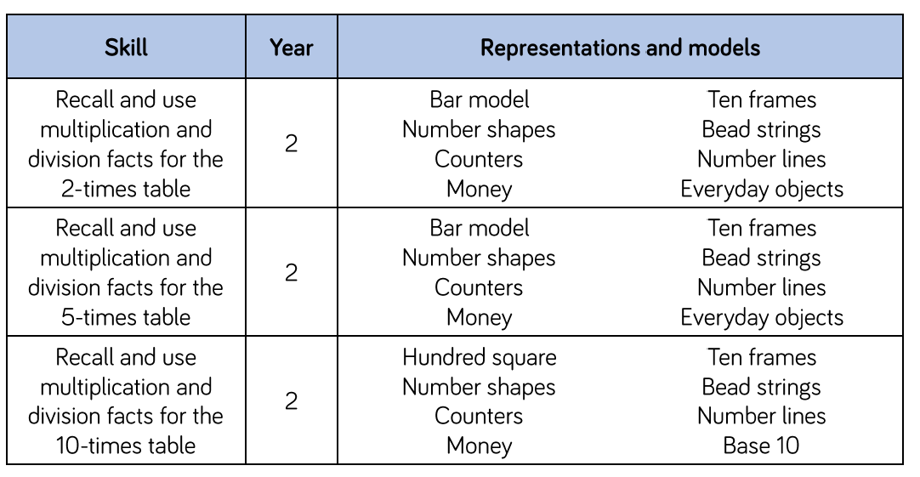

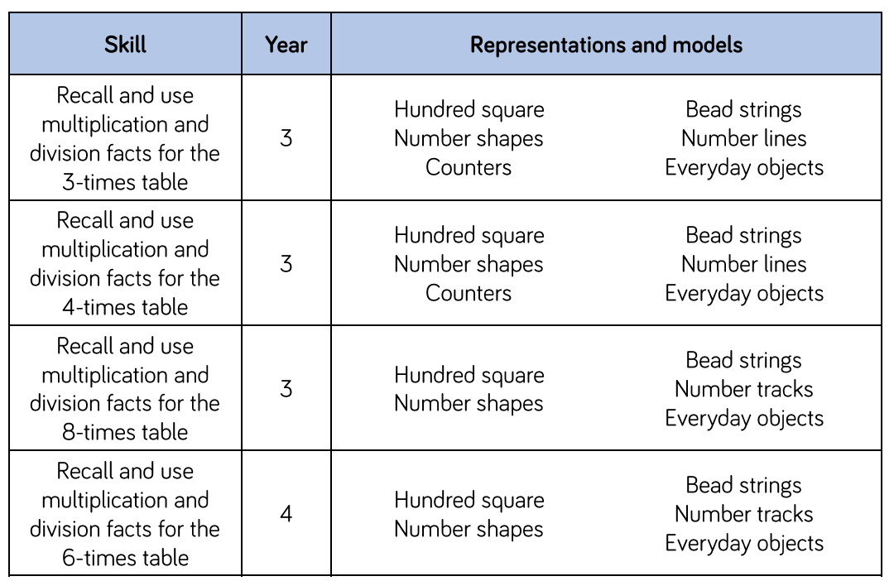
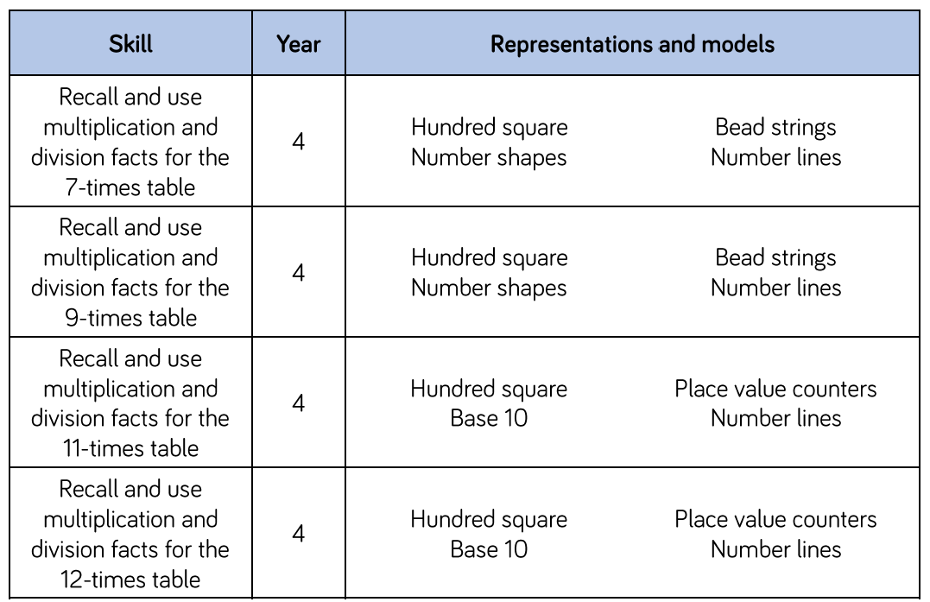
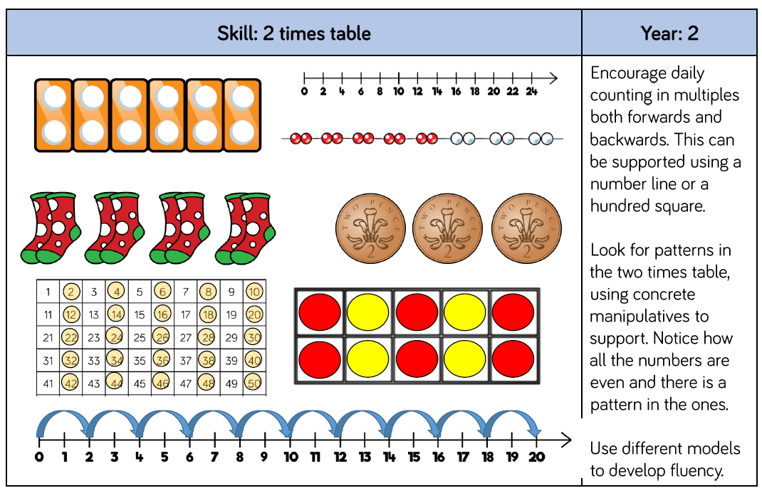
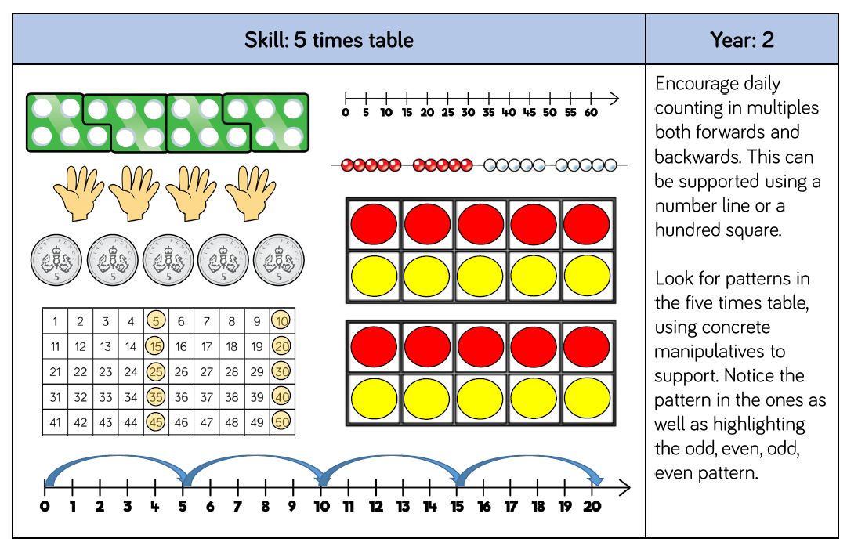
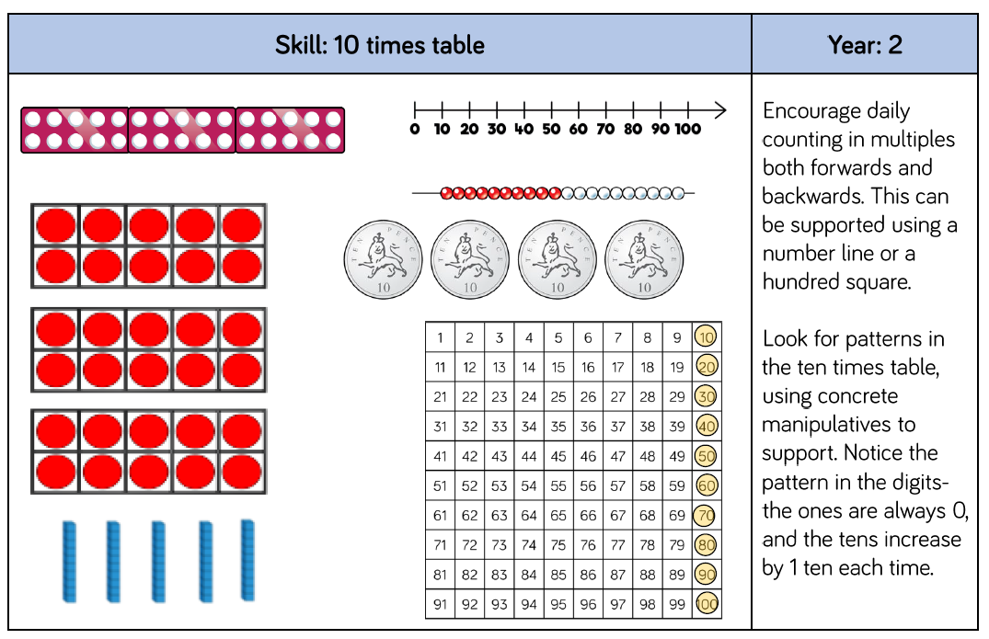
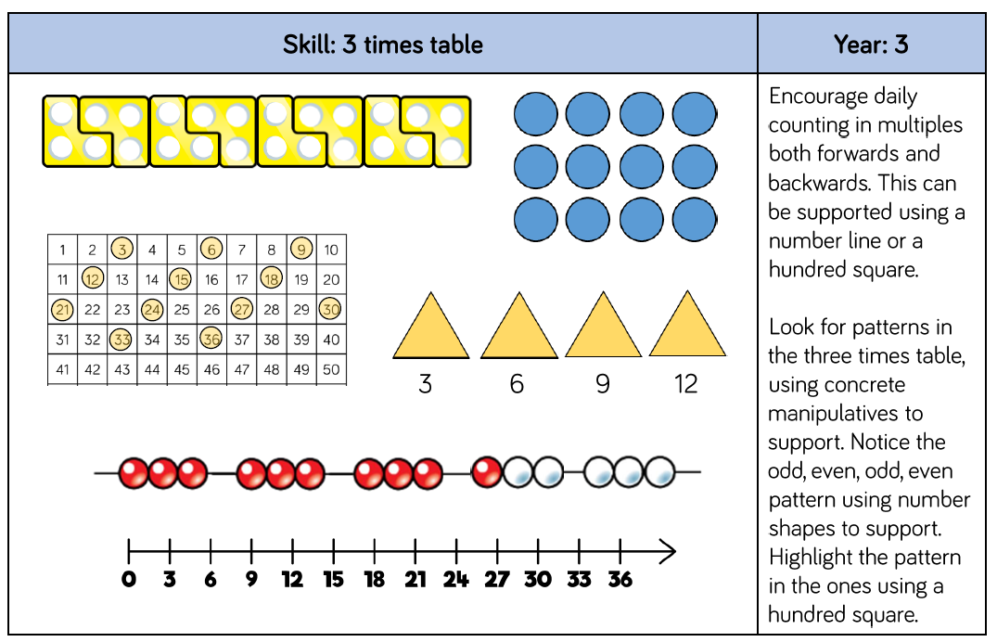
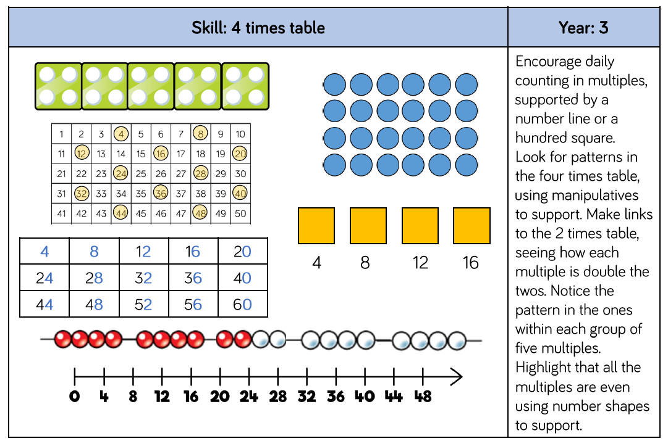
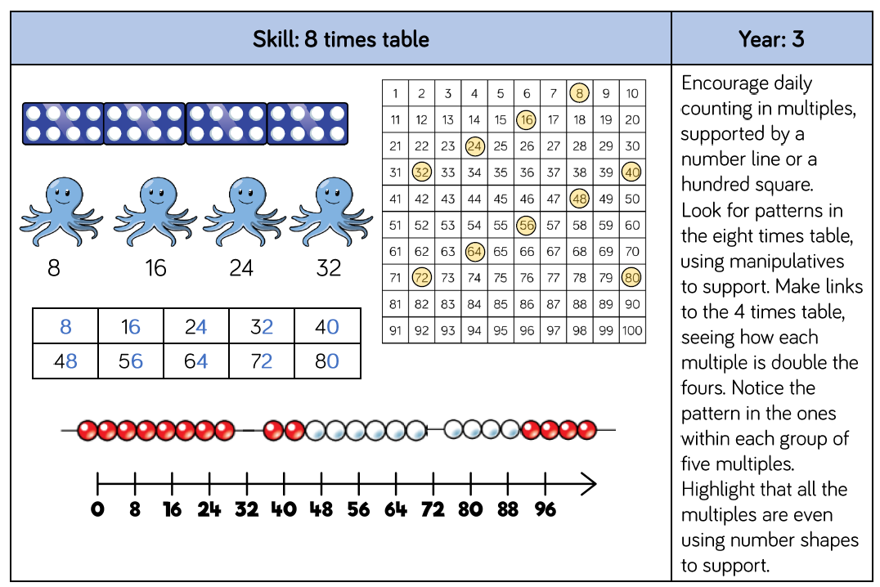
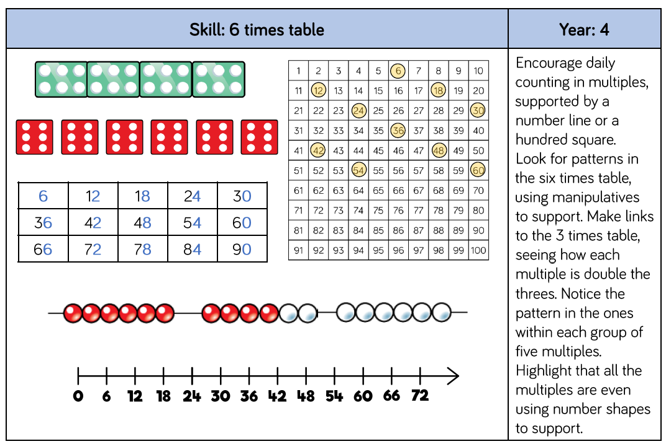
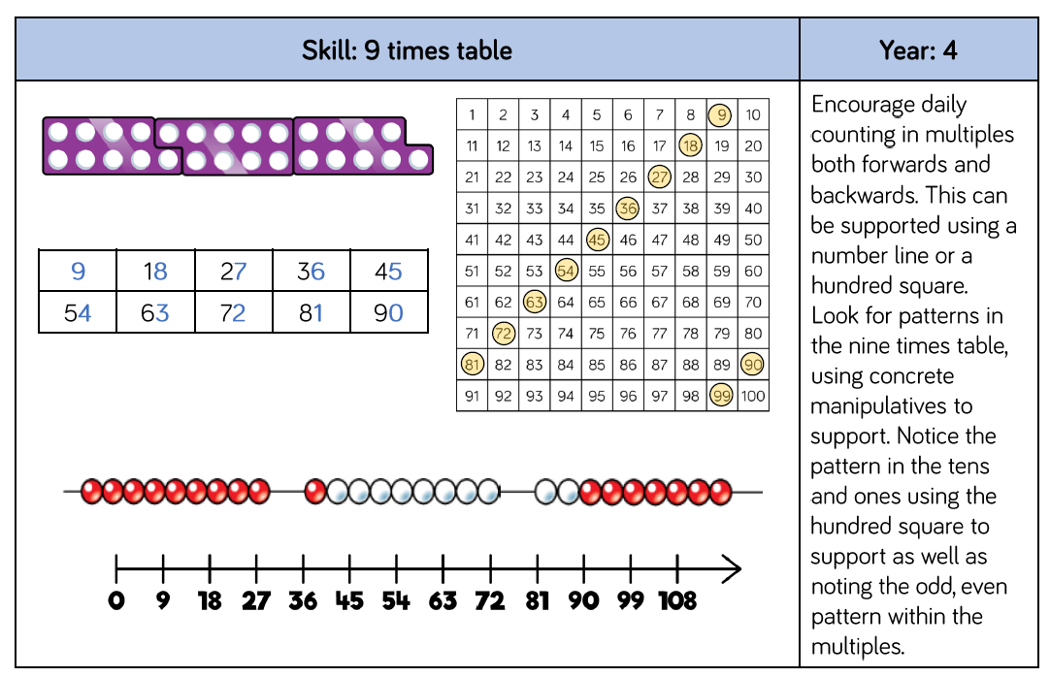
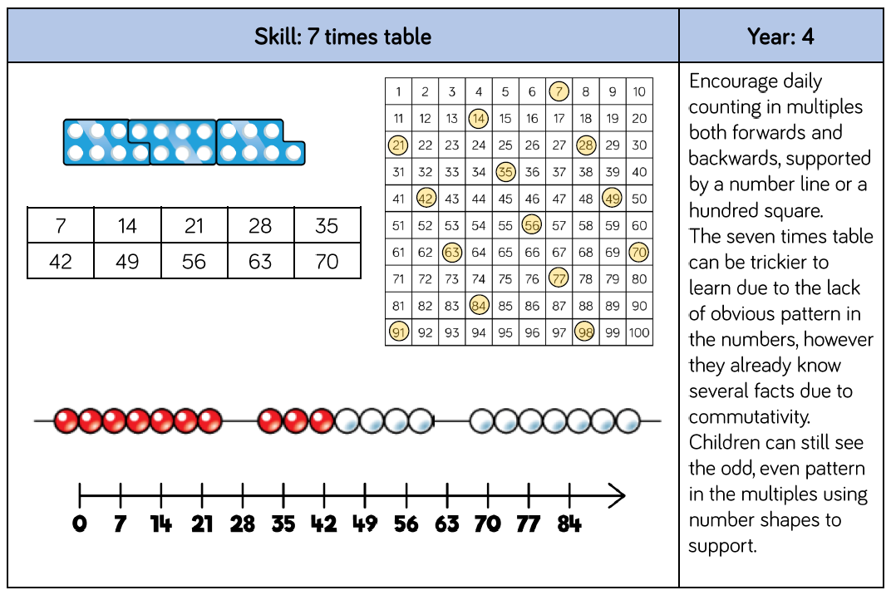
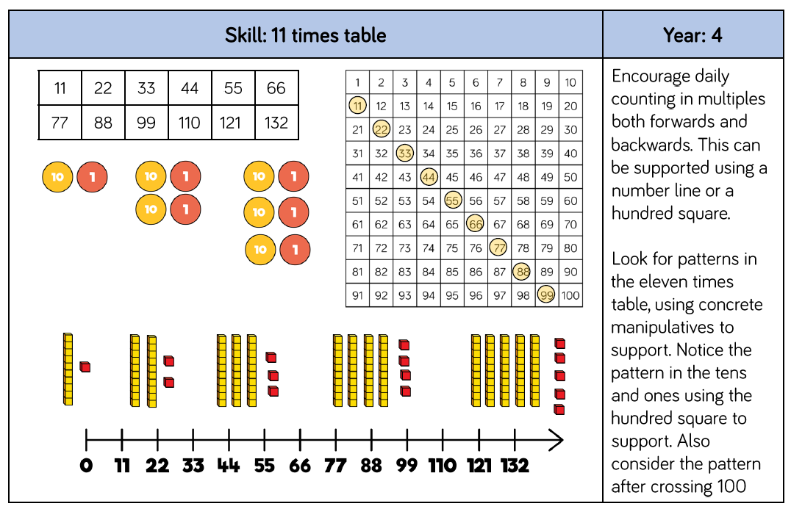
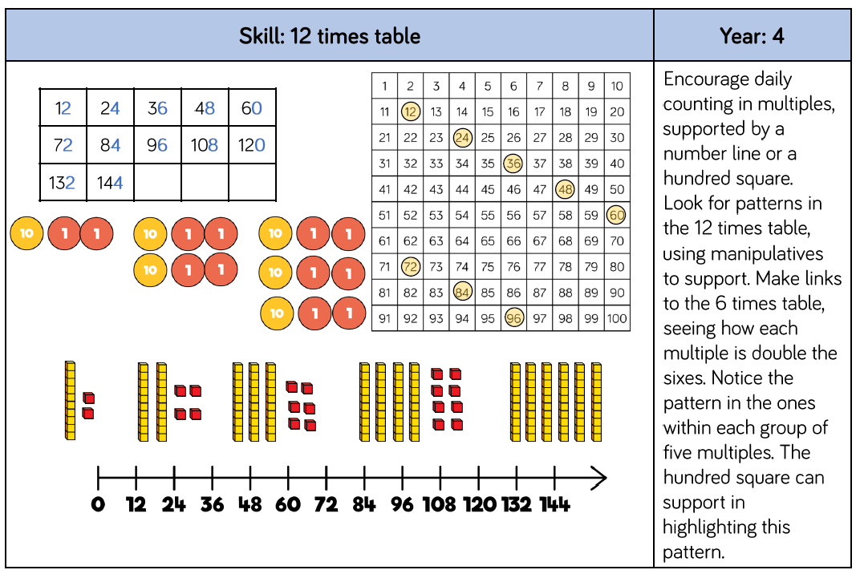

Multiplication
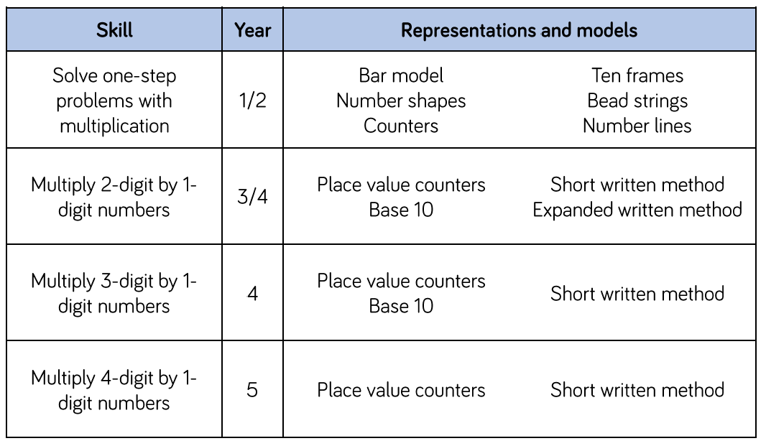
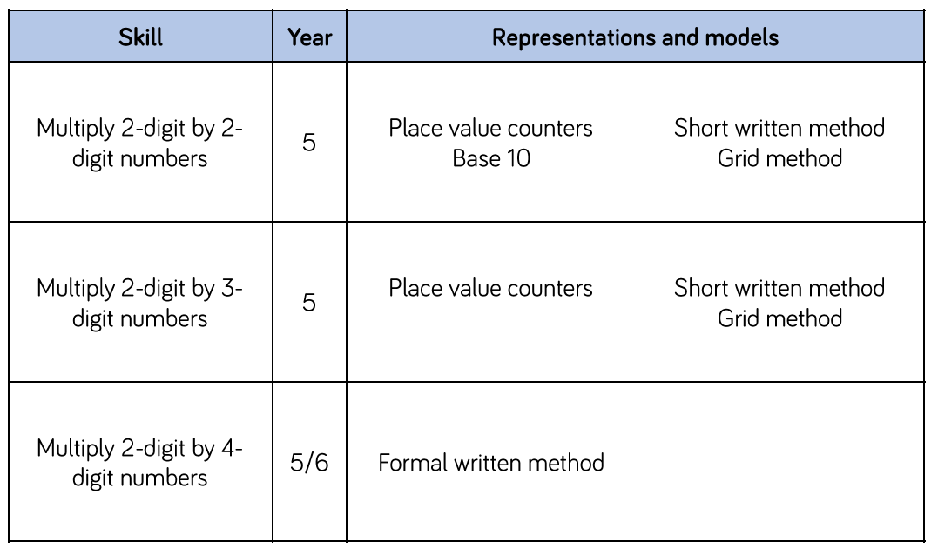

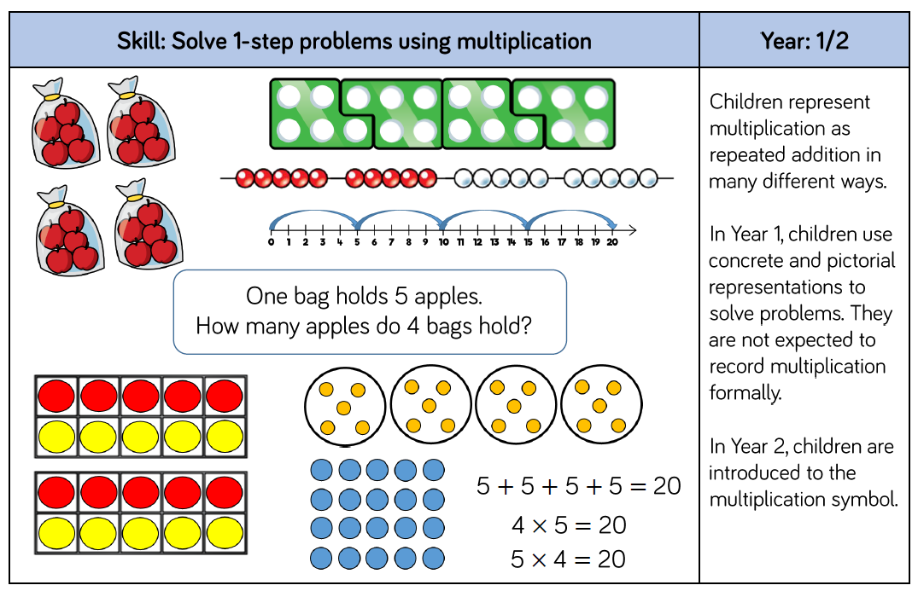
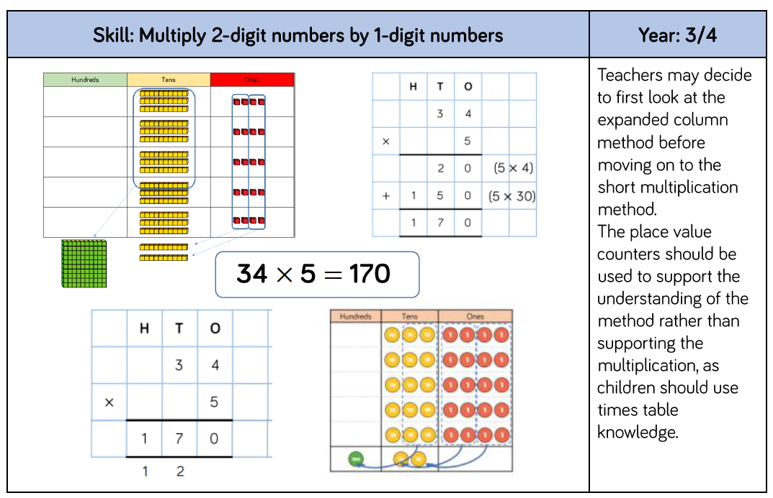
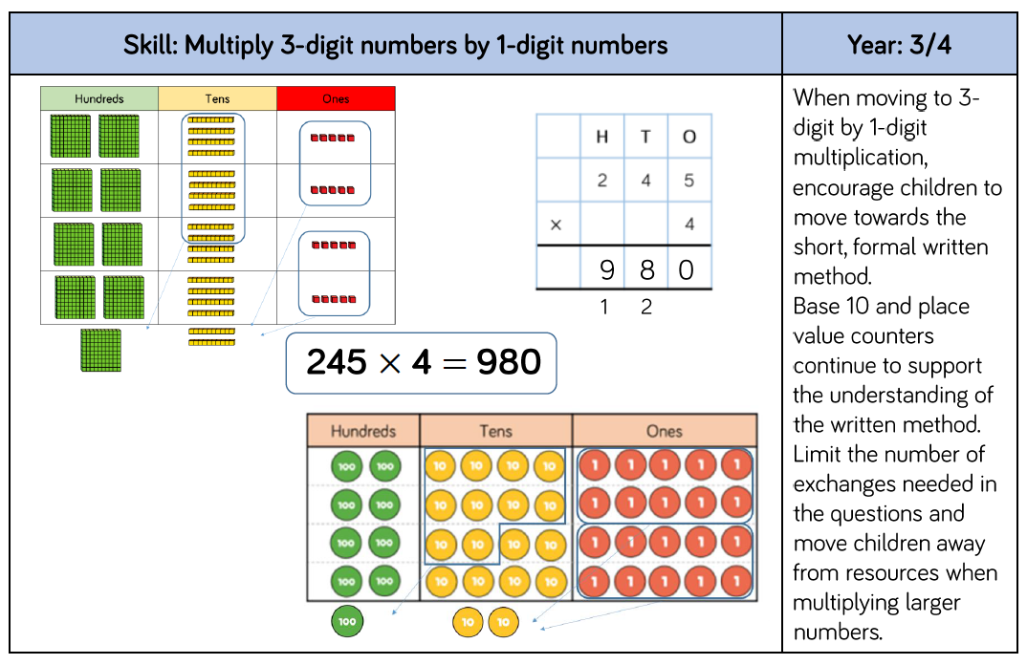
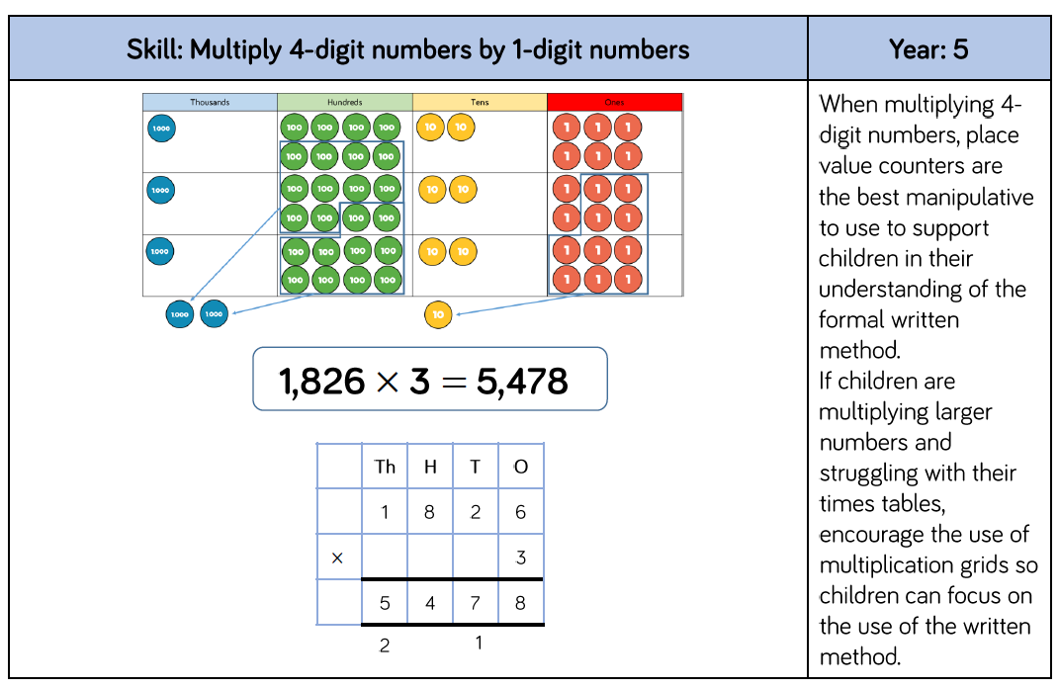
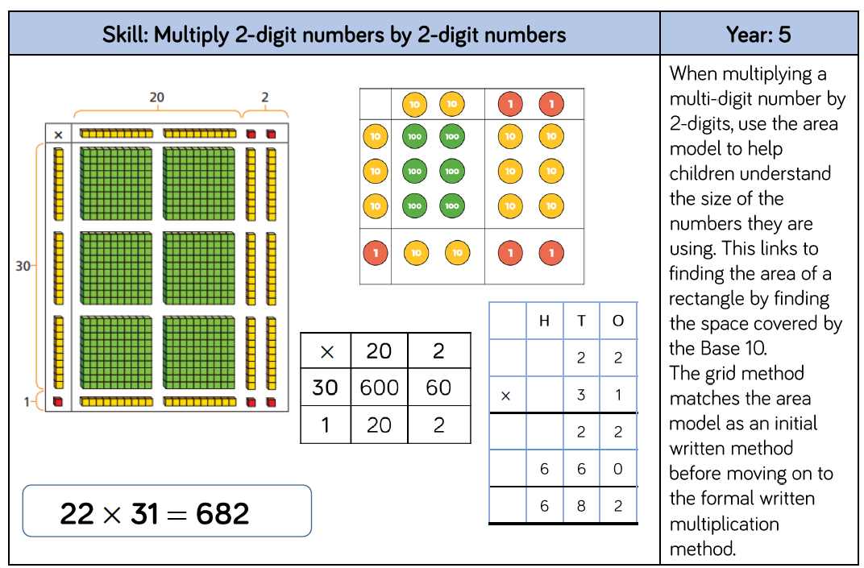
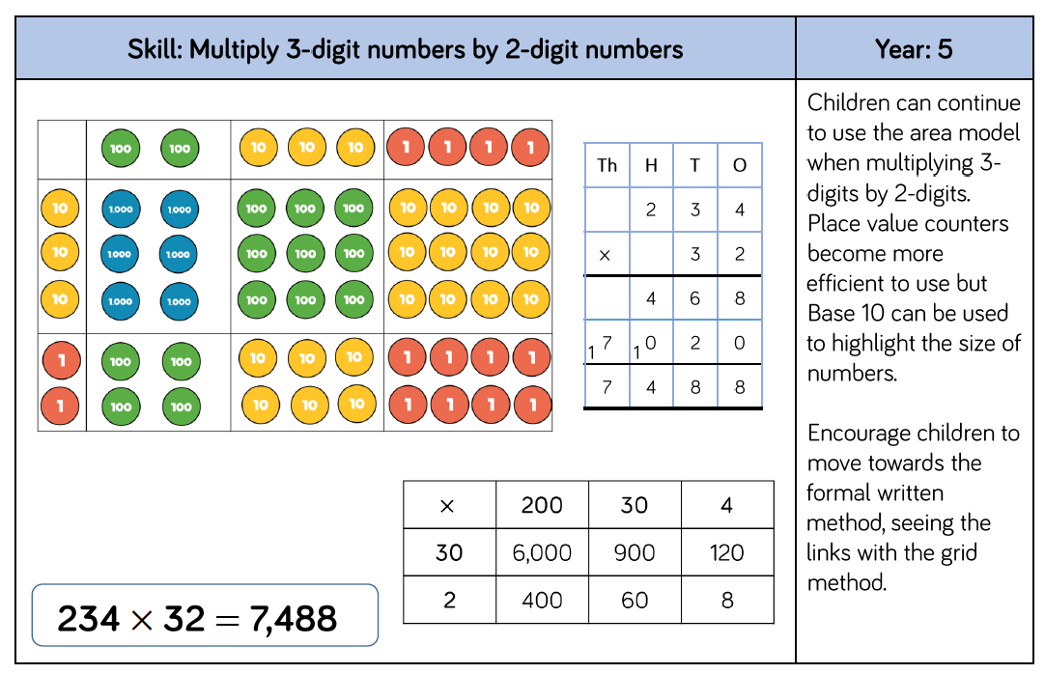
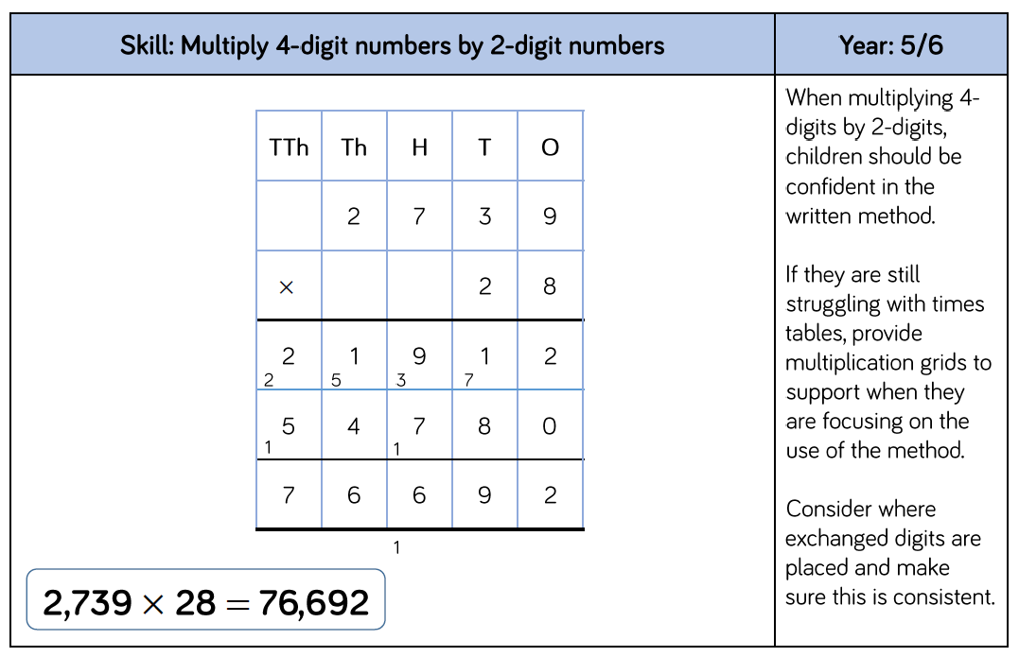

Division
