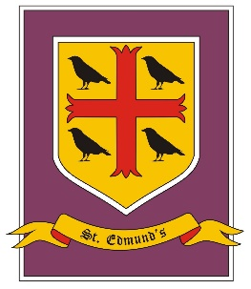
St. Edmund’s Catholic Primary School
Year 5-6 Curriculum Overview
Summer Term

Summer Term - Cycle A
Create
Driver Subjects: Art and Design/Design Technology/Music

Skills: Generate ideas and explore possibilities.
Experiment with different alternatives.
Adapt ideas as circumstances change.
Organise time and resources.
Work towards a goal.

 | Summer 1 | Summer 2
RE | Transformation- celebration of the spirit  Freedom and responsibility - Commandments enable Christians to be free & responsible | Stewardship – The Church is called to the stewardship of creation  Islam
PSHE/RSHE | Y5 Health and well-being: drugs, alcohol and tobacco | Year 5 Living in the wider world: Careers; aspirations; role models; the future
RSE | Year 5 : To celebrate the joy of growing physically and spiritually.  Year 6: To show an understanding of how being made in the image and likeness of God informs decisions and actions when building relationships with others, including life-long relationships.
English | NF – Chronological Reports - Y5  F- Myths - Y5 (Theseus and the Minotaur)  Poems with figurative language – Y5 Greek mythical monster | Information booklet - Y5 – Ancient Greece  Classic fiction - Y6 Who let the Gods out, Maz Evans
Maths | Geometry: Properties of Shape  Geometry: Position and Direction  Y6: SATS  Investigations and Consolidation - FDP, Four operations, Measures
Science | Living things – identify and classify (Year 6)  Grouping and classifying things - noticing similarities and differences (scientific enquiry)
Art and Design | Greek art history - mosaics
Design Technology | Clothing/materials: Greek tunic
Geography | Mapping skills
History | Ancient Greeks -
Computing | Year 5 - Information technology: Use and combine a variety of software and devices with increasing independence, to create a range of digital assets such as programs, databases, systems and multimedia content.
Music | Listening and reviewing – Music History – Charanga | Production /performance
PE
MFL - French | School life | Time Travelling

