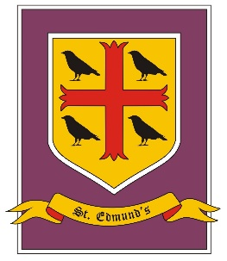
St. Edmund’s Catholic Primary School
Year 5/6 Curriculum Overview
Autumn Term

Summer Term - Cycle B
Create
Driver Subjects: Art and Design/Design Technology/Music

Skills: Generate ideas and explore possibilities.
Experiment with different alternatives.
Adapt ideas as circumstances change.
Organise time and resources.
Work towards a goal.

 | Summer 1 | Summer 2
RE | 1 witness  2 healing | 3 Common good  4 Islam
PSHE/RSHE | Relationships - Different relationships, changing and growing, adulthood, independence, moving to secondary school
RSE | Spiritual – likeness of God
English | Non- chronological reports - linked to humans/Darwin  Older literature - Oliver Twist Charles Dickens | Information text hybrid - On The Origin of Species, Sabina Redeva  Poems with imagery - Christina Rossetti—The Wind, etc
Maths | White rose Summer  Geometry: Properties of Shape  Geometry: Position and Direction  Y6: SATS  Investigations and Consolidation | White rose: Geometry: Properties of Shape  Geometry: Position and Direction  Y6: SATS  Investigations and Consolidation
Science | Evolution & inheritance  Sci En: Questioning | Y6: Animals including Humans  Sci En: Fair test
Art and Design | Human body – sculptors – clay work
Design Technology | Food – Healthy Diet | Punch and Judy – textiles (puppet)
Geography | Darwin theory /travels- mapping
History | Charles Darwin - Victorian – arts/music
Computing | Computer Science – research internet
Music | School performance | School performance
PE | West lancs SSP
MFL - French | Y6 Twinkl – holiday unit 5 | Y6 Twinkl – hobbies unit 6

