St Edmunds Catholic Primary School: Early Years Foundation Stage
Spring 1 – Once Upon a Time
Communication & Language |  | Physical Development |  | Personal, Social and Emotional Development
Focusing on a rich literacy environment. Create the Three Bears Cottage - role play Asking questions through hot seating. Establishing talking partners.  Continue to extend vocabulary/exploring the sound and meaning of new words  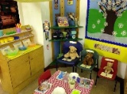  Continue to build on a repertoire of rhymes and songs and favourite stories and identify  new vocabulary. |  | Moving creatively to music – Chinese New Year. Stopping and starting on command. Balancing using different parts of their body.  Fine motor skills – using chopsticks, Finger Gym.  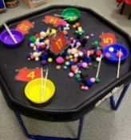  Talk about changes to their body after physical activity. |  | Try new activities.  Describe themselves in positive terms and to talk about abilities. Talk about experiences related to different feelings – manage feelings.  Continue to develop independence to speak to others.  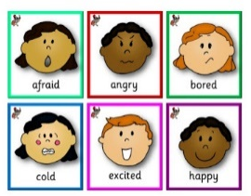  Continue to develop self-confidence, awareness and  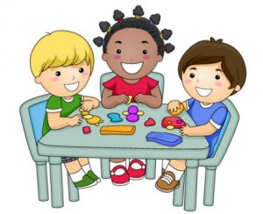  sharing.
Understanding the World | Expressive Arts and Design |  | Literacy |  | Mathematics
Know about similarities and differences between themselves and others. Feely bag - exploring and talking about different textures.  Testing materials – The Three Little Pigs  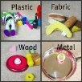  Label different body parts. Online – safety. Be safe. Planting daffodil bulbs. | Music — Charanga ‘Everyone’ Listen and Respond, explore, and create music, sing, play and perform.  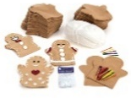  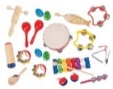  Collage work relating to theme, experimenting with texture. Exploring different techniques – printing. Learning how to use tools – join and fix materials together – hand puppet. |  | Reading and writing CVC, tricky and rhyming words. Daily Phonic sessions. Retelling, sequencing, and acting out traditional tales. Looking at story characters and hot seating. Form letters correctly. Writing words, captions, and sentences.  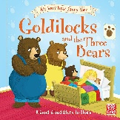  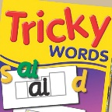 |  | 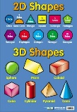  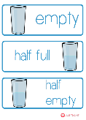  Counting, recognising, and ordering numbers to 10/20. Recording using marks and numerals. Naming and describing 2D and 3D shapes - shape hunt. Making more/less adding and subtracting. Capacity – full/half full/empty.
Religious Education: Come and See
N/R Celebrating:  Explore 4.1.21 - 8.1.21 Reveal 11.1.21 - 22.1.21 Respond 25.1.21 - 29.1.21  (Please see the attached unit planning within the Spring 1 folder) |  |  | N/R Gathering:  Explore 1.2.21 – 5.2.21 Reveal 8.2.21 – 26.2.21 (inc. half term) Respond 1.3.21 – 5.3.21

