St Edmunds Catholic Primary School: Early Years Foundation Stage
Spring 2 – Helping Hands
Communication & Language |  | Physical Development |  | Personal, Social and Emotional Development
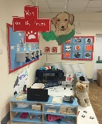  Focusing on a rich literacy environment. Create a vets - role play Asking questions through hot seating. (different jobs and roles within the community. Continue to establish talking partners. Continue to extend vocabulary/exploring the sound and meaning of new words related to the topic. Continue to build on a repertoire of rhymes and songs and favourite stories and identify new vocabulary. Further develop listening skills through circle time discussion in small groups and appropriate responses in relation to conversations.  NELI Programme to begin phase 2 x 10 weeks. Develop the use of curiosity cubes. |  | See west Lancashire PE sports partnership site for specific session focuses.  Balancing using different parts of their body.  Fine motor skills – Dough disco weekly sessions.  Playdough within provision daily.  Talk about changes to their body after physical activity.  Talk about eating a healthy range of food and the importance of this in relation to effects on our body as we grow and change.  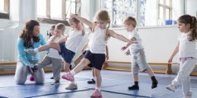  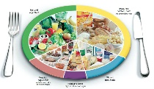 |  | Try new activities and show high levels of resilience when attempting new tasks. Trying again if at first it proves difficult.  Describe themselves in positive terms and to talk about abilities. Talk about experiences related to different feelings – manage feelings. Talking daily about our feelings and how we can show care, courtesy and consideration in everything we do.  Continue to develop independence to speak to others.  Continue to develop self-confidence, awareness and  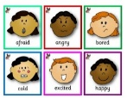  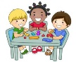  sharing.
Understanding the World | Expressive Arts and Design |  | Literacy | Mathematics
Discussing ways of life, occupations of family members and friends. Talking about and exploring roles within our local community and school community.  Observing and talking about our natural environment, encourage children to take care of our garden, clearing, tidying and helping others to do this. (Tidy story)  Online – safety. Be safe element in every computing session.  Using ipads to explore simple city and the variety of occupations which allow people to help others. Labelling equipment and accessing sort clips of people helping others in their job roles. | Unit 2 Charanga: Cross-curricular and topic-based focus: Our World - explore: animals, jungle, minibeasts, night and day, sand and water, seaside, seasons, weather, sea, space.  Learning how to use tools – join and fix materials together. Further develop the use of the class creative station, children independently planning what they are going to do and attempt to achieve their planned effect.  Using large boxes to create, shops, fire stations, homes etc create a helping hands village within the outdoor area as part of our role play enrichment. |  | Reading and writing CVC, tricky and rhyming words and developing simple sentence writing skills. Daily Phonics sessions. Hot seating roles within our school community. Form letters correctly using out formation phrases. Writing words, captions, and sentences.  Exerience new vocabulary related to the topic ‘Helping Hands’.  Generate vocabulary lists, boards and areas within the classroom. Explore new words with real life objects, pictures and modelling in context. | Counting, recognising, and ordering numbers to 10/20. Recording using marks and numerals. Forming numerals correctly, this will take place three times a week during our additional number time sessions in differentiated groups. Beginning to solve mathematical problems in a variety of ways with a variety of media. Explore the simple element of time, days of the week, daily routine, months of the year. See assertive mentoring assessments and reports to identify gaps in learning and plan for these throughout the week.  Number bonds to 5/10 and counting daily in 2’s to 20 and 10’s to 100.  Children will start each phonic session with a days of the week and months of the year introduction. (NELI link)
Religious Education: Come and See
N/R Good News: Explore 19.4.21 – 23.4.21 Reveal 26.4.21 – 7.5.21 Respond 10.5.21 – 14.4.21
(Please see attached unit within the Spring 2 curriculum folder)

