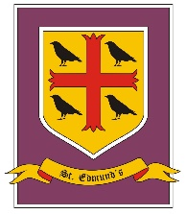
St Edmunds Catholic Primary School: Early Years Foundation Stage
Autumn 1: Home Sweet Home
Communication & Language |  | Physical Development |  | Personal, Social and Emotional Development
Listening to others when sharing information about our families and life at home.  Listening to a variety of stories with increasing levels of attention and recall.  Taking part in role play activities to develop vocabulary based on children’s first hand experiences at home.  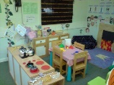  Developing the skill to follow simple two step instructions during the school day and new routines.  Role Play Area: Home corner. |  | Creating a 3D model of our own homes using fine and gross motor skills and simple tools to adapt and make changes to materials.  Enjoying a range of exercises and movements during our time in the EYFS garden. Developing special awareness and gross motor skills.  Throwing and catching large balls.  We will also focus on dressing ourselves for PE and putting on and zipping our own coats. |  | We will be focussing on settling into our new class and school this half term. Learning our new classroom routines and getting to know our new friends and teachers.  We will grow in confidence day by day and talk about what we enjoy in school.  We will work together to create a special class charter so that we can all work together happily.
Understanding the World | Expressive Arts and Design |  | Literacy |  | Mathematics
We will discuss our families and talk about our lives at home.  We will share our customs and routines and act them out within our role play area.  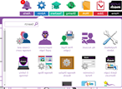  We will start to use electronic toys and be introduced to our class iPads, learning how to turn them on and access our purple mash activities. | We will explore lots of colours and colour mixing this half term.  We are ging to create our own 3D model of our house to create a community display in our classroom. We will also create a large box street within our garden area.  Charanga Music:  Unit 1 Me! - explore: growing, homes, colour, toys, how I look.  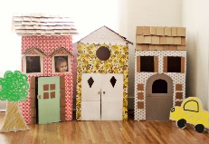 |  | This half term we will enjoy lots of rhyming and rhythmic activities.  We will begin to learn how to hear and say initial sounds in words and start to link sounds to letters, naming and sounding the letters of the alphabet.  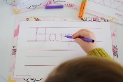  Children will be encouraged to make marks and give meaning to the marks they make as they draw, write and paint relating to our own family.  We will also practise writing own names every day and other simple words relating to our own family. |  | We will begin recognising numbers in the environment. What number is on my front door? What number is on our role play door? What numbers can you see around our classroom.  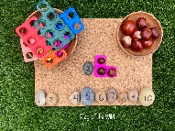  We will practise counting objects up to 10 and beyond using number songs and games and use 2d/3d shapes to create a picture of my house and family.  We will complete a simple maths quiz this half term to see what we already know and what we need to learn next.
Religious Education: Come and See
N/R Myself  Explore 3.9.20 – 11.9.20 Reveal 14.9.20 – 25.9.20 Respond 28.9.20 – 2.10.20 |  |  | N/R Welcome Explore 12.10.20 – 16.10.20 Reveal 19.10.20 – 6.11.20 (inc half term) Assessment week: 9.11.20 – 13.11.20 Respond 16.11.20 – 20.11.20

