St Edmund’s Catholic Primary School

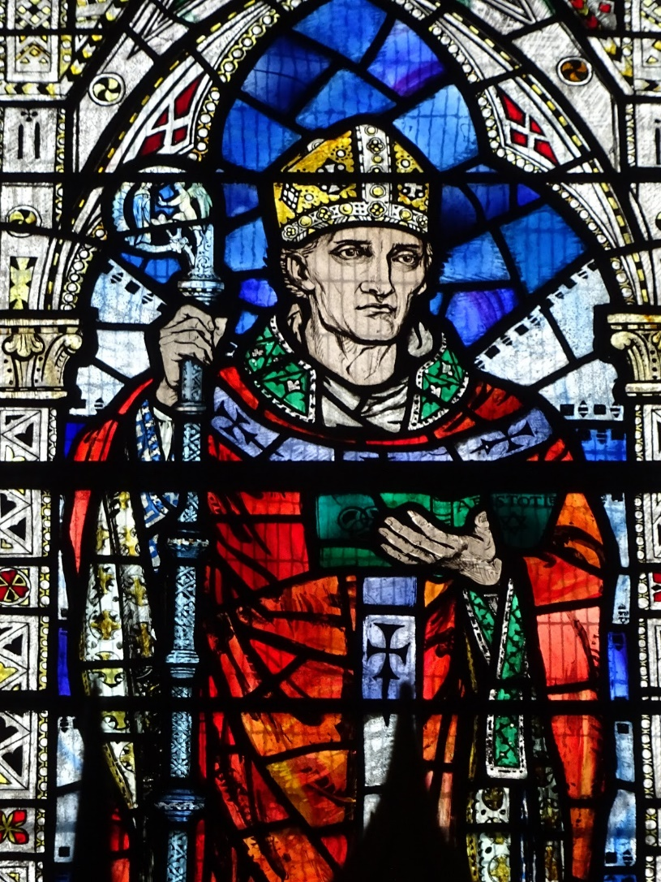

The Feast of St Edmund of Abingdon Mass
Thursday 16th November 2023

Entrance Hymn: Please stand
Verse 2:
When I am wrong
When I am wrong
Knowing what’s right
Knowing what’s right
When I’m lost and I can’t find the way
When the choices that I’ve made just don’t feel right

Chorus - repeat

VERSE 3:
Just as I am
Just as I am
I come to you
I come to you
When I'm lost and I cannot find the way
When the choices that I've made Just don't feel right
https://www.youtube.com/watch?v=NmAmk971ssI
Verse 1
When I stray far
When I stray far
Turning away
Turning away
When I'm lost and I cannot find the way
When the choices that I've made Just don't feel right
Chorus
My Shepherd-always there for me
My Shepherd-always leading me
My Shepherd to Your healing hands I come
One more step along the world I go​
One more step along the world I go​
From the old things to the new​
Keep me traveling along with you​
And it's from the old I travel to the new​
Keep me traveling along with you​
'Round the corners of the world I turn​
More and more about the world I learn​
And the new things that I see​
You'll be looking at along with me​
And it's from the old I travel to the new​
Keep me traveling along with you​
As I travel through the bad and good​
Keep me traveling the way I should​
Where I see no way to go​
You'll be telling me the way, I know​
And it's from the old I travel to the new​
Keep me traveling along with you

Father Kenny: In the name of the Father, and of the Son, and of the Holy Spirit. Amen.
The Lord be with you. And with your spirit
Welcome to the special feast day for the Patron saint – Saint Edmund of Abingdon. During this mass, we will celebrate the life of Saint Edmund and all the saints. Saint Edmund and all the saints were faithful unto death and now dwell in the heavenly kingdom for ever. As we celebrate their lives and witness, and remembering all in darkness and captivity, we bring before God our sins and all that separates us from him and each other.
Penitential Act
I confess to almighty God, and to you, my brothers and sisters, that I have greatly sinned, in my thoughts and in my words, in what I have done, and in what I have failed to do; and I ask blessed Mary, ever virgin, all the angels and saints, and you, my brothers and sisters, to pray for me to the Lord our God.
May almighty God have mercy on us, forgive us our sins, and bring us to everlasting life.
Kyrie
MADISON: During this part of the mass, we will think of Saint Edmund and all the saints, who were faithful unto death and now dwell in the heavenly kingdom for ever. As we celebrate their lives and witness, remembering all in darkness and captivity, we bring before God our sins and all that separates us from him and each other. Surrounded by the love of the saints, we ask God’s love, healing and mercy on us and on his world, as we pray.
Lord, you have shown us all that is loving, good and life giving, but we often show hardness of heart. Lord have mercy. All: Lord Have Mercy
We have not always learned from past mistakes, and do not always take care of those in need of wholeness and peace. Christ have mercy All: Christ have mercy
By ourselves we can do nothing; but with you all things are possible. O Lord turn us, set us on the path that leads to life, and make us new. Lord have mercy. All: Lord Have Mercy
Opening Prayer:
ISAK: God our Father, we here to celebrate our patron saint – Saint Edmund.
Help us to remember him – and celebrate all the saints that have come before and after him.
We make our prayer through Jesus your Son, who lives for ever with you.
Amen
Liturgy of the Word: Please sit for the first, reading, psalms and second reading)
Introduction to the first reading: (Father Kenny)
God chooses all of us to do a special job in life. Each job is different, and some people might feel they have a more difficult job to do than others. But, whatever God wants us to do, he promises to help us to do it well. We only have to ask.
Father Kenny: We will listen to KAINE to read our lesson. ADIN will read our psalm.
KAINE: The First Reading is from the Book of Revelation (7:2-4, 9-14)
I, John, saw another Angel ascending from the rising of the sun, having the Seal of the living God. And he cried out, in a great voice, to the four Angels to whom it was given to harm the earth and the sea, saying: “Do no harm to the earth, nor to the sea, nor to the trees, until we seal the servants of our God on their foreheads. And I heard the number of those who were sealed: one hundred and forty-four thousand sealed, out of every tribe of the sons of Israel.
ADIN: After these things, I saw a great crowd, which no one could number, from all the nations and tribes and peoples and languages, standing before the throne and in sight of the Lamb, clothed in white robes, with palm branches in their hands. And they cried out, with a great voice, saying: “Salvation is from our God, who sits upon the throne, and from the Lamb.” And all the Angels were standing around the throne, with the elders and the four living creatures. And they fell upon their faces in view of the throne, and they worshipped God, saying: “Amen. Blessing and glory and wisdom and thanksgiving, honor and power and strength to our God, forever and ever. Amen.” And one of the elders responded and said to me: “These ones who are clothed in white robes, who are they? And where did they come from?” And I said to him, “My lord, you know.” And he said to me: “These are the ones who have come out of the great tribulation, and they have washed their robes and have made them white by the blood of the Lamb.
The word of the Lord.
All: Thanks be to God

Responsorial Psalm:
MAYCIE The Response to the Psalm is: Lord, this is the people that longs to see your face.
(All): Lord, this is the people that longs to see your face.
DANNY The LORD’s are the earth and its fullness;
the world and those who dwell in it.
For he founded it upon the seas
and established it upon the rivers.
R. Lord, this is the people that longs to see your face.
MADISON Who can ascend the mountain of the LORD?
or who may stand in his holy place?
One whose hands are sinless, whose heart is clean,
who desires not what is vain.
R. Lord, this is the people that longs to see your face.
RONIN He shall receive a blessing from the LORD,
a reward from God his savior.
Such is the race that seeks him,
that seeks the face of the God of Jacob.
R. Lord, this is the people that longs to see your face.

Please stand up for the Alleluia and the Gospel.
Gospel Acclamation: Sing ‘Halle Halle’
Halle, halle, hallelujah!
Halle, halle, hallelujah!
Halle, halle, hallelujah!
Hallelujah, hallelujah! (2)

The Lord be with you
And with your spirit

Father Kenny: A reading from the Gospel according to Matthew (5: 1-12).
1 Jesus saw the crowds and went up a hill, where he sat down. His disciples gathered around him, 2 and he began to teach them: 3 "Happy are those who know they are spiritually poor; the Kingdom of heaven belongs to them! 4 "Happy are those who mourn; God will comfort them! 5 "Happy are those who are humble; they will receive what God has promised! 6 "Happy are those whose greatest desire is to do what God requires; God will satisfy them fully! 7 "Happy are those who are merciful to others; God will be merciful to them! 8 "Happy are the pure in heart; they will see God! 9 "Happy are those who work for peace; God will call them his children! 10 "Happy are those who are persecuted because they do what God requires; the Kingdom of heaven belongs to them11 "Happy are you when people insult you and persecute you and tell all kinds of evil lies against you because you are my followers. 12 Be happy and glad, for a great reward is kept for you in heaven. This is how the prophets who lived before you were persecuted.
The Gospel of the Lord
All: Praise to you Lord Jesus Christ

Homily Please sit for the Homily
Prayer of the Faithful - Bidding Prayers Please stand for the Creed and the Prayer of the Faithful
Father Kenny: Today, we join our prayers with all the saints in heaven, who are our great cloud of witnesses, interceding for us at the right hand of the Father. Let us now ask the Lord with renewed faith, for the needs of our Church and world.
CHARLEY-LEA
We pray for the Church on earth, may the saints in heaven be an example for all Christians, that they may serve God in the way he wishes. Lord, hear us.
All: Lord Graciously hear us
LEXI
We pray for peace on earth, that those in authority may follow the example of the saints who worked for peace and love. Lord, hear us. Lord, graciously hear us.
All: Lord Graciously hear us
LILI
God our Father,
We pray for those in need, and those who care for them, that they may see in the saints who suffered the love of Christ for them. Lord, hear us.
All: Lord Graciously hear us
MICHAEL G
God our Father,
We pray for those who have died in the hope of new life, may Christ bring them to share his glory with the Saints. Lord, hear us. Lord Hear Us.
All: Lord Graciously hear us
ROZA Let us ask Our Lady, Queen of the Saints, to pray with us and to be with us as we say:
Hail Mary full of Grace, the Lord is with thee.
Blessed are thou amongst women and blessed is the fruit of thy womb Jesus.
Holy Mary Mother of God,
pray for us sinners now and at the hour of our death
Amen.
Now let us think quietly of those we want to remember today, and say our own special prayer for them.

Liturgy of the Eucharist: Please sit for the offertory
Father Kenny: As POPPY and DIMITRINKA bring our gifts to the altar.
We will now sing our Offertory Hymn ‘Share the light of Jesus’
Share the smile of Jesus ​
Share the smile that shows the way ​
Share the smile of Jesus ​
Share God’s Spirit today ​(2)
​
Share the light of Jesus ​
Share the light that shows the way ​
Share the light of Jesus ​
Share God’s Spirit today ​(2)

Share the light of Jesus ​
Share the light that shows the way ​
Share the light of Jesus ​
Share God’s Spirit today ​(2)
​
Share the word of Jesus ​
Share the word that shows the way ​
Share the word of Jesus ​
Share God’s Spirit today ​(2)

Share the love of Jesus ​
Share the love that shows the way ​
Share the love of Jesus ​
Share God’s Spirit today ​(2)

Taking of the Gifts
All: Blessed be God for ever
Prayer over the gifts: Please stand for the gifts
Pray, brethren, that my sacrifice and yours may be acceptable to God, the almighty Father.
May the Lord accept the sacrifice at your hands for the praise and glory of his name, for our good, and the good of all his Church. Amen
Father Kenny: We ask you Lord to receive these gifts and ourselves with them. Keep us always safe in Your love. We make this prayer through Christ Our Lord.
All: Amen
Eucharistic Prayer
The Lord be with you.
And with your spirit
Lift up your hearts.
We lift them up to the Lord.
Let us give thanks to the Lord our God.
It is right and just

Holy, holy, holy Lord, God of hosts, heaven and earth are full of your glory. Hosanna in the highest. Blessed is he who comes in the name of the Lord. Hosanna in the highest.

Proclaim the mystery of faith
(All respond with one of the following)
- We proclaim your Death, O Lord, and profess your Resurrection until you come again.
- When we eat this Bread and drink this Cup, we proclaim your Death, O Lord, until you come again.
- Save us, Saviour of the world, for by your Cross and Resurrection you have set us free.
Through him, with him, in him, O God almighty Father, in the unity of the Holy Spirit, all glory and honour is yours, for ever and ever Amen
Rite of Communion:
Father Kenny: Let us pray with confidence to the Father in the words that Jesus gave us:
Our Father, who art in heaven, hallowed be thy name. Thy kingdom come. Thy will be done on earth, as it is in heaven. Give us this day our daily bread, and forgive us our trespasses, as we forgive those who trespass against us, and lead us not into temptation, but deliver us from evil.
Deliver us, Lord, from every evil, and grant us peace in our day. In your mercy keep us free from sin and protect us from all anxiety as we wait in joyful hope for the coming of our Saviour, Jesus Christ.
For the kingdom, the power, and the glory are yours, now and forever.
Lord Jesus Christ, you said to your apostles: I leave you peace, my peace I give you. Look not on our sins, but on the faith of your Church, and grant us the peace and unity of your kingdom where you live for ever and ever. Amen.
The peace of the Lord be with you always. And with your spirit.
Let us offer each other the sign of peace.
Peace be with you
Sign of the Peace
Lamb of God, you take away the sins of the world, Have mercy on us.
Lamb of God, you take away the sins of the world, Have mercy on us.
Lamb of God, you take away the sins of the world, Grant us peace.
Communion Hymn: Sing for Joy Please sit while people receive the gift of communion
Sing and shout for joy alleluia x 3 ​
Sing and dance for joy alleluia x 3 ​
Alleluia, Alleluia ​
​
Sing and shout for joy alleluia x 3 ​
Alleluia, Alleluia

Alleluia, Alleluia ​
​
Sing and clap your hands alleluiax 3 ​
Alleluia, Alleluia ​
​
Sing and jump for joy alleluia x 3 ​
Alleluia, Alleluia

Behold the Lamb of God, behold him who takes away the sins of the world. Blessed are those called to the supper of the Lamb.
Lord, I am not worthy that you should enter under my roof, but only say the word and I shall be healed.

Communion Procession

The Body of Christ
Amen

Prayer after Communion: Please sit or kneel after receiving communion
Father Kenny:
Let us pray
Lord almighty, we bring before you all our needs, trusting that you will hear and answer them, as we pray with all the saints., especially Saint Edmund.
We make this prayer through Christ our Lord. Amen.
All: Amen
Closing Prayer and Blessing
Father Kenny: The Lord be with you.
All: And with your spirit.
Father Kenny: May almighty God bless you, the Father, the Son and the Holy Spirit.
All: Amen
Go in peace
Thanks be to God.
Fire before us, You're the brightest
You will lead us through the storms
Fire before us, You're the brightest
You will lead us through the storms
Fire before us, You're the brightest
You will lead us through the storms
Fire before us, You're the brightest
You will lead us through the storms
My Lighthouse, my lighthouse (Oh-oh-oh-oh-oh)
Shining in the darkness, I will follow You (Oh-oh-oh-oh-oh)
My Lighthouse, my lighthouse (Oh-oh-oh-oh-oh)
I will trust the promise,
You will carry me safe to shore (Oh-oh-oh-oh-oh)
Safe to shore (Oh-oh-oh-oh-oh)
Safe to shore (Oh-oh-oh-oh-oh)
Safe to shore

Recessional Hymn: My Lighthouse
In my wrestling and in my doubts
In my failures You won't walk out
Your great love will lead me through
You are the peace in my troubled sea, oh oh
You are the peace in my troubled sea
In the silence, You won't let go
In the questions, Your truth will hold
Your great love will lead me through
You are the peace in my troubled sea, oh oh
You are the peace in my troubled sea
My Lighthouse, my lighthouse
Shining in the darkness, I will follow You
My Lighthouse, my lighthouse (oh oh)
I will trust the promise,
You will carry me safe to shore (Oh-oh-oh-oh-oh)
Safe to shore (Oh-oh-oh-oh-oh)
Safe to shore (Oh-oh-oh-oh-oh)
Safe to shore
I won't fear what tomorrow brings
With each morning I'll rise and sing
My God's love will lead me through
You are the peace in my troubled sea, oh oh
You are the peace in my troubled sea, oh oh
You are my light
My Lighthouse, my lighthouse (Oh-oh-oh-oh-oh)
Shining in the darkness, I will follow You (Oh-oh-oh-oh-oh)
My Lighthouse, my lighthouse (Oh-oh-oh-oh-oh)
I will trust the promise,
You will carry me safe to shore (Oh-oh-oh-oh-oh)
Safe to shore (Oh-oh-oh-oh-oh)
Safe to shore (Oh-oh-oh-oh-oh)
Safe to shore

