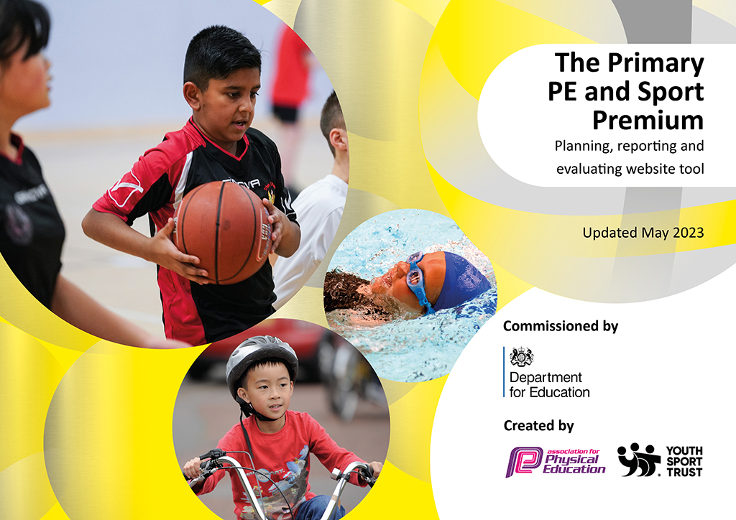
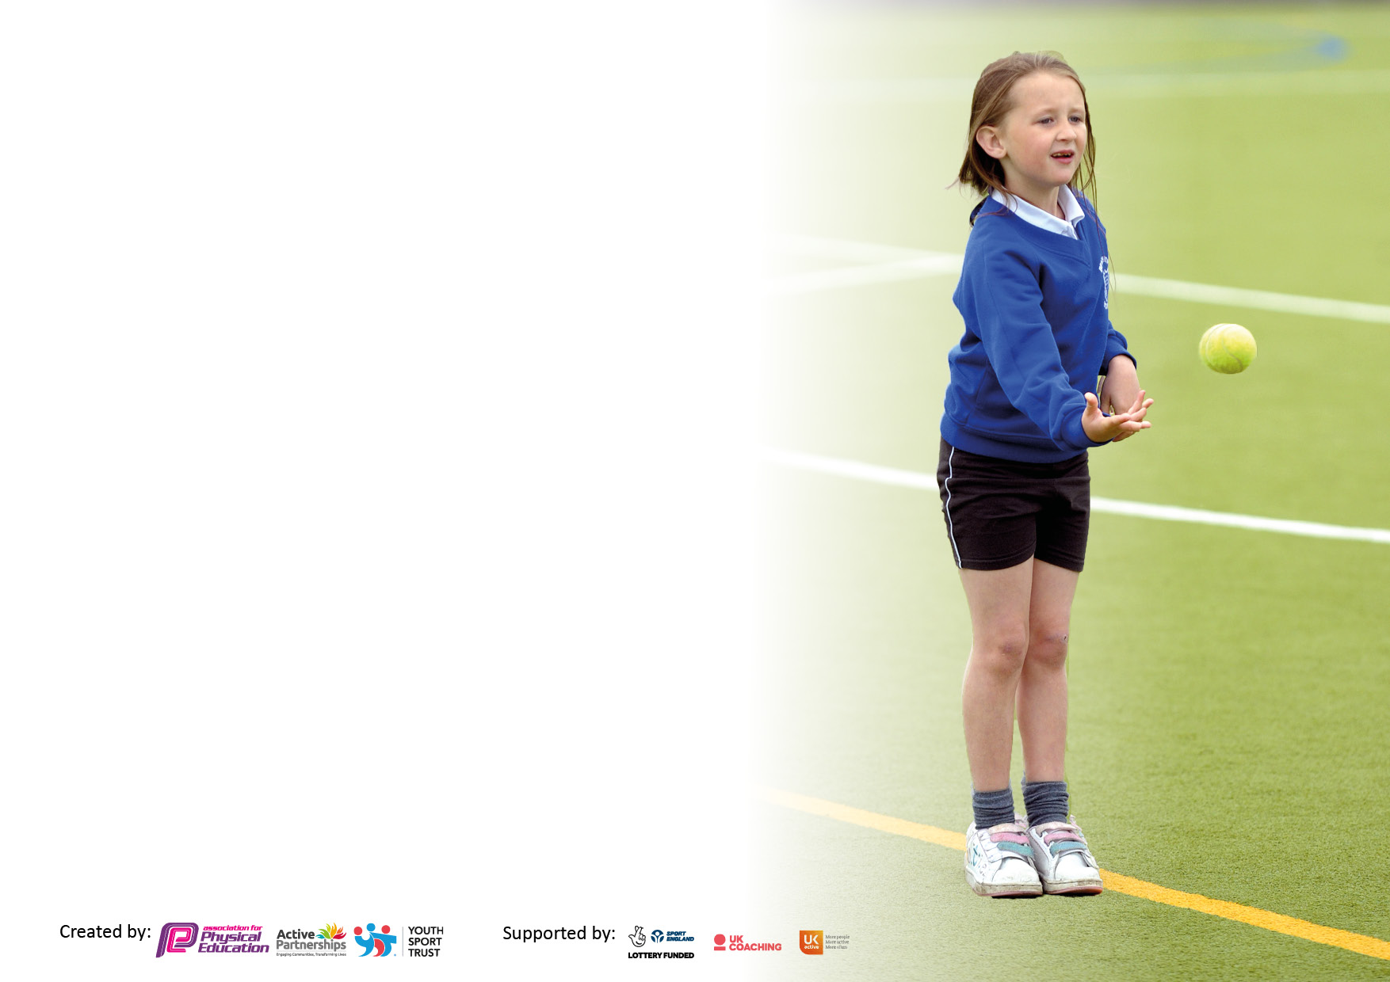

It is important that your grant is used effectively and based on school need. The Education Inspection Framework makes clear there will be a focus on ‘whether leaders and those responsible for governors all understand their respective roles and perform these in a way that enhances the effectiveness of the school’.

Under the Quality of Education Ofsted inspectors consider:
Intent - Curriculum design, coverage and appropriateness
Implementation - Curriculum delivery, Teaching (pedagogy) and Assessment
Impact - Attainment and progress

To assist schools with common transferable language this template has been developed to utilise the same three headings which should make your plans easily transferable between working documents.

Schools must use the funding to make additional and sustainable improvements to the quality of Physical Education, School Sport and Physical Activity (PESSPA) they offer. This means that you should use the Primary PE and sport premium to:

- Develop or add to the PESSPA activities that your school already offer
- Build capacity and capability within the school to ensure that improvements made now will benefit pupils joining the school in future years
- The Primary PE and sport premium should not be used to fund capital spend projects; the school’s budget should fund these.

Pleasevisitgov.ukfortherevisedDfEguidanceincludingthe5keyindicatorsacrosswhichschoolsshoulddemonstrate animprovement.Thisdocumentwillhelpyoutoreviewyourprovisionandtoreportyourspend.DfEencouragesschools to use this template as an effective way of meeting the reporting requirements of the Primary PE and Sport Premium.

We recommend you start by reflecting on the impact of current provision and reviewing the previous spend.

Schools are required to publish details of how they spend this funding, including any under-spend from 2021/2022, as well as on the impact it has on pupils’ PE and sport participation and attainment. All funding must be spent by 31st July 2023.

We recommend regularly updating the table and publishing it on your website throughout the year. This evidences your ongoing self-evaluation of how you are using the funding to secure maximum, sustainable impact. Final copy must be posted on your website by the end of the academic year and no later than the 31st July 2023. To see an example of how to complete the table please click HERE.
Created by: Supported by:

Details with regard to funding
Please complete the table below.

Total amount carried over from 2021/22 | £6,852
Total amount allocated for 2021/22 | £17,855
How much (if any) do you intend to carry over from this total fund into 2022/23? | £4,495
Total amount allocated for 2022/23 | £17,837
Total amount of funding for 2023/23. To be spent and reported on by 31st July 2023. | £22,213
Swimming Data
Please report on your Swimming Data below.

Meeting national curriculum requirements for swimming and water safety.

N.B. Complete this section to your best ability. For example you might have practised safe self-rescue techniques on dry land which you can then transfer to the pool when school swimming restarts.
Due to exceptional circumstances priority should be given to ensuring that pupils can perform safe self rescue even if they do not fully meet the first two requirements of the NC programme of study
What percentage of your current Year 6 cohort swim competently, confidently and proficiently over a distance of at least 25 metres?  N.B. Even though your pupils may swim in another year please report on their attainment on leaving primary school at the end of the summer term 2022.  Please see note above | 43%
What percentage of your current Year 6 cohort use a range of strokes effectively [for example, front crawl, backstroke and breaststroke]?  Please see note above | 43%
What percentage of your current Year 6 cohort perform safe self-rescue in different water-based situations? | 100%
Schools can choose to use the Primary PE and sport premium to provide additional provision for swimming but this must be for activity over and above the national curriculum requirements. Have you used it in this way? | Yes/No

Action Plan and Budget Tracking
Capture your intended annual spend against the 5 key indicators. Clarify the success criteria and evidence of impact that you intend to measure to evaluate for pupils today and for the future.

Academic Year: 2022/23 | Total fund allocated: | Date Updated:
Key indicator 1: The engagement of all pupils in regular physical activity – Chief Medical Officers guidelines recommend that primary school pupils undertake at least 30 minutes of physical activity a day in school |  |  |  | Percentage of total allocation:
 |  |  |  | 41.22%
Intent | Implementation |  | Impact
Your school focus should be clear what you want the pupils to know and be able to do and about  what they need to learn and to  consolidate through practice: | Make sure your actions to achieve are linked to your intentions: | Funding allocated: | Evidence of impact: what do pupils now know and what can they now do? What has changed?: | Sustainability and suggested next steps:
To encourage more children to become more active.  To be more active at playtimes.  To improve overall pupil health and fitness. | Change4Life club tailored to target ‘inactive’ pupils and those identified as not reaching age-related expectations.  Change4Life club to promote sport, health and fitness across Key Stage 2.  Daily Mile for all pupils on school running track.  PALS training for Year 5 pupils. | £7,209  £150 | Assessment of pupils in PE lessons shows improvement in FMS and fitness.  Termly timings for Change4Life pupils taken on school running track – all pupils have achieved better times since starting the programme.  Observations of pupils on the playground and in lessons show pupils are more active for longer periods.  More pupils engaged in regular physical activity and show an improved attitude towards sport and physical activity. | Continue to fund the Change4Life programme.  Continue to refine selection process for children directed towards the Change4Life programme.  Refine assessment of pupils taking part in Change4Life clubs.  Train the next Year 5 cohort in PALS.  Work with lunchtime supervisors to enable and engage PALS during lunch breaks.
Key indicator 2: The profile of PESSPA being raised across the school as a tool for whole school improvement |  |  |  | Percentage of total allocation:
 |  |  |  | 3.77%
Intent | Implementation |  | Impact
Your school focus should be clear what you want the pupils to know and be able to do and about  what they need to learn and to  consolidate through practice: | Make sure your actions to achieve are linked to your intentions: | Funding allocated: | Evidence of impact: what do pupils now know and what can they now do? What has changed?: | Sustainability and suggested next steps:
Pupil achievements in inter-school and intra-school competitions are celebrated.  Pupil achievements in PE lessons are shared with parents.  Improved pupil voice  Improved transition between primary and secondary school. | Promote sporting success through the school website, newsletters and Twitter.  Sports achievements are displayed on the PE board and in the trophy cabinet.  Record evidence of pupil achievements in PE lessons through the PE Passport App and Seesaw.  PE Ambassadors voted for by their peers to act as pupil voice to staff and on the School Council.  Ambassadors to attend Bronze level training.  Secondary PE teacher delivering sessions to Year 5 and 6. | £0  £50  £622.50 | Parents and pupils respond positively to whole school sporting achievements.  An increase in pupils sharing sporting achievements completed at home and in after-school clubs.  Evidence is recorded by staff on Seesaw and PE Passport App.  PE Ambassadors attended training with fellow ambassadors from local schools and brought back ideas to share and implement in school.  PE Ambassadors have attended sports competitions in a coaching role.  Children feeling more confident and prepared for Secondary school PE lessons. Relationships built with staff at the school. | Continue to positively promote school sport.  Continue to encourage pupils to share their sporting achievements from home.  Encourage PE Ambassadors to take a more active role – attend more events (even when not competing), support other children, write match reports and support staff in training children for events.

Key indicator 3: Increased confidence, knowledge and skills of all staff in teaching PE and sport |  |  |  | Percentage of total allocation:
 |  |  |  | 35.60%
Intent | Implementation |  | Impact
Your school focus should be clear | Make sure your actions to | Funding | Evidence of impact: what do | Sustainability and suggested
what you want the pupils to know | achieve are linked to your | allocated: | pupils now know and what | next steps:
and be able to do and about | intentions: |  | can they now do? What has
what they need to learn and to |  |  | changed?:
consolidate through practice:
Improve subject knowledge and upskill teachers.  Implement support in improving teaching of PE in Key Stage One.  Use of a specialist coach to deliver Afterschool clubs to model good practise in each year group.  To raise confidence and knowledge in delivery of the PE curriculum. | Training for all staff in using the PE Passport App.  PE subject leader to attend local PLT meetings.  PE subject leader to attend the Lancashire Health Conference.  Specialist coach to deliver PE lessons in Key Stage 1.  Specialist coach to deliver termly afterschool sports clubs for each year group across the year.  Membership/ Partnership with Lancashire County Council PE | £800  £5,105  £450 | Staff are more confident in using the PE Passport App and assessments are being recorded for each year group.  PE subject leader is implementing a new sport discovered at the Lancashire Health Conference.  Specialist coach has delivered high quality PE lessons in Key Stage 1, improving FMS.  Teaching staff have gained new activity ideas based on observations from the high quality after school clubs. | Ensure teachers are consistent in completion of assessments on the PE Passport App.  Training to be held for whole school in new sport.  Monitor lessons and discuss with staff their confidence in different aspects of PE and identify training needs.  Continue to use a specialist coach to deliver high quality PE lessons.
Key indicator 4: Broader experience of a range of sports and activities offered to all pupils |  |  |  | Percentage of total allocation:
 |  |  |  | 22.29%
Intent | Implementation |  | Impact
Your school focus should be clear | Make sure your actions to | Funding | Evidence of impact: what do | Sustainability and suggested
what you want the pupils to know | achieve are linked to your | allocated: | pupils now know and what | next steps:
and be able to do and about | intentions: |  | can they now do? What has
what they need to learn and to |  |  | changed?:
consolidate through practice:
Additional achievements:  Introduction of Quidditch to the PE curriculum.  Development of Forest School.  Develop school games values of Trust, Resilience and Team Work through the Commando Joe’s programme  Identify and track pupils in PE, including those who are ‘Gifted and Talented’.  Children to improve in cycling ability and safety as well as showing a knowledge of road safety. | Equipment, training and a Harry Potter launch day to introduce Quidditch to our PE curriculum.  All classes to take part in regular Forest School activities.  All classes regularly accessing Commando Joe’s sessions  Year 6 pupils to attend a 3 day residential trip to to complete OAA activities.  SSP to complete Year 2 and Key Stage 2 FMS and ‘Gifted and Talented’ assessments.  Bikeability Level 2 for Year 5, Level 1 for Year 4 and Balance Bike Training for EYFS. | £1,867  £4000 (final installment)  £210  £2,730 | All pupils developing new skills in Forest School, focussing on resilience and teamwork.  During the residential trips Year 6 developed teamwork and resilience skills as well as taking part in a range of activities such as canoeing, climbing and orienteering.  Increased cycling confidence in Y5, Y4 and EYFS. More pupils cycling to school.  ‘Gifted and Talented’ pupils identified and directed towards specialist clubs to support development.  Higher proportion of pupils meeting the end of Key Stage 2 expectations in swimming. | Return to having a wider range of extra-curricular clubs available for all pupils.  Monitor pupils’ interests and look into local clubs and agencies to see what they have to offer.  Look at other residential trips and opportunities for pupils.  Continue to look for opportunities to share cultural learning and engage with our local community.  Continue to support cycling, encourage more pupils to cycle to school and educate in road safety.

Key indicator 5: Increased participation in competitive sport |  |  |  | Percentage of total allocation:
 |  |  |  | 4.49%
Intent | Implementation |  | Impact
Your school focus should be clear | Make sure your actions to | Funding | Evidence of impact: what do | Sustainability and suggested
what you want the pupils to know | achieve are linked to your | allocated: | pupils now know and what | next steps:
and be able to do and about | intentions: |  | can they now do? What has
what they need to learn and to |  |  | changed?:
consolidate through practice:
Ensure pupils are given the chance to compete in both inter and intra school competitions.  Promote more intra-school competitions within all year groups through core tasks and Level 1 games.  Ensure that less able pupils are given the chance to take part in competition.  Sports clubs specifically directed at girls to increase participation in competitions. | Staff meetings about intra-school competitions.  Whole school competitions i.e. sports days.  Monitor intra-school competitions and use these to select pupils for some inter-school competitions.  Use the PE Passport App to track pupil involvement in competitions.  Enter CSSP delivered Level 1 competitions for whole classes.  Take part in CSSP delivered skills festivals.  Re-introduce girls’ football training and enter the girls’ football league. | £0  £800 | Staff are implementing some competitions in PE lessons.  Pupils are using more competitive language in describing and evaluating their own achievements and are driven to achieve their best.  A mix of identifying strongest pupils for competitions and open for all for skills festivals.  More pupils taking part in a range of inter-school competitions across the year. | Monitor and encourage the use of intra-level competitions as a way to identify pupils for inter-school competitions.  Continue to use the PE Passport App to record pupil participation in competitions.  Continue to focus on encouraging more girls to enter competitions through girls only clubs/ training.

Signed off by
Head Teacher:
Date:
Subject Leader: | G Mair
Date: | 07.07.23
Governor:
Date:

