Summer Term

* This term our PE days will be Tuesday afternoons and Thursday mornings. We hope to be able to more PE lessons outside so please ensure your child has an outdoor PE kit, with trainers in school.
* You may wish to send into school a labelled bottle of sun cream this term. We will supervise the children in applying suncream when needed.

Thank you

Friday 10th May

Over the last couple of weeks we have been enjoying books from the ‘Supertato’ series and thinking of different ways to capture the Evil Pea. This week we have focussed on the book ‘Supertato: Veggies Assemble’ and have been creating our very own vegetable superhero. We have been learning all about different types of vegetable and thinking about different super powers they might have. This lead to us completing an investigation this afternoon looking at magnets and finding out what different objects in our classroom are magnetic. In our maths work this week the children have blown my socks off…we have been developing our understanding of the word ‘double’ and the chidlren have grasped this concept really well.

From The Reception Team

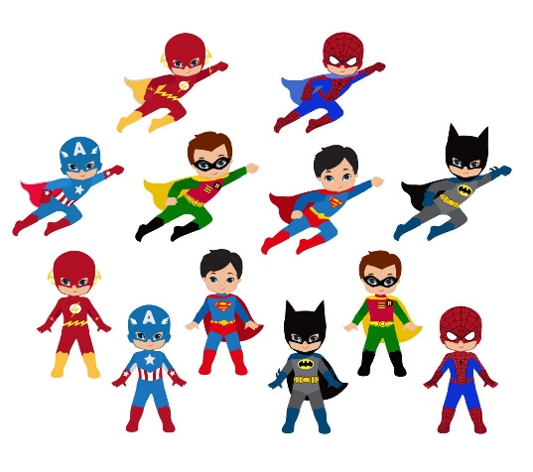o

This week we have enjoyed…

*Playing in our new supermarket role play area, with real fruit and vegetables!

*Training in our superhero gym outside

* Creating our own vegetable superhero

* Telling our own Avengers stories in our small word

This week we have been learning…

* About different healthy vegetables
* About the word double
* How to find the double of numbers to 10
* About what is ‘Good News’ as part of our Come and See Work

Reading Books

Your child will have brought home another reading book tonight. These first books have no words but you can use the sheet provided to ask questions and follow the story together. Please keep this sheet in with your child’s book in their bag. They will also have a key ring of ‘tricky words’ we would like the children to read independently. Please try to practise these daily with your child – let us know when they are able to read all the words and we will add the next set.

**Please ensure you write in your child’s diary to let us know when they have read their books and how they have been getting on with them.**

☺ Thank you ☺

Keep in touch

*Follow us on twitter @stgregorys_EYFS

*You can also contact me directly by email if you have any concerns or questions:

[eyfs@st-gregorys-pri.lancs.sch.uk](NULL)

*Send observations of your child’s learning at home by replying to the 2Simple report you have already received.

* You can also use ClassDojo to send quick messages.

**Homework**

The children will have until **Thursday 23rd May** to complete as many of the challenges as possible. Thank you for support in completing the challenges so far, your contributions are really valuable to us.

Snack

In order to be able to provide a daily snack, we ask for a donation of £1 per week, per child.

Thank you for your contributions.