School Trip

On Monday 25th March we will be going on our school trip to Blue Planet Aquarium. You should have received a letter this week with all the important details as well as information about how to set up ‘Parent Pay’ to pay for the trip.

Friday 15th March

This week we have enjoyed reading and acting out the story ‘Tiddler’ by Julia Donaldson, we have been learning about the structure of a story and created our own three part re-telling. In our maths work we have been focussing on shapes, learning to identify and describe both 2D and 3D shapes and using them to create our own under the sea image. As part of our topic we have especially enjoyed learning about the different layers of the ocean and creating images of some of the weird and wonderful creatures you would find deep into the abyss.

From The Reception Team

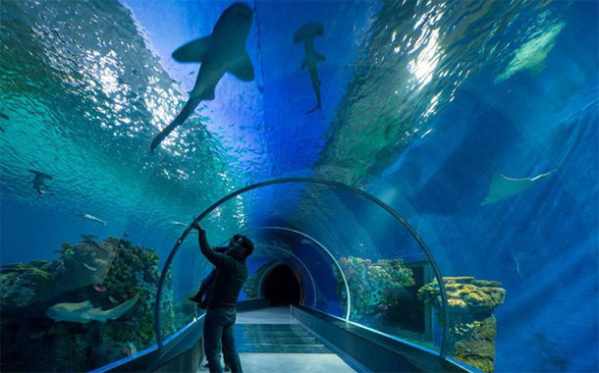

This week we have enjoyed…

*Count and measure water beads in our water tray

*Make shapes using loom bands and hammer boards

* Painting sea creatures

* Taking a dive into the deep in our role play area

This week we have been learning…

* Write a simple three part story
* Identify and describe 2D and 3D shapes
* About different creatures that live deep in the ocean
* To think about what we can do to ‘grow closer to God’ during Lent as part of our Come and See work.

Reading Books

Your child will have brought home another reading book tonight. These first books have no words but you can use the sheet provided to ask questions and follow the story together. Please keep this sheet in with your child’s book in their bag. They will also have a key ring of ‘tricky words’ we would like the children to read independently. Please try to practise these daily with your child – let us know when they are able to read all the words and we will add the next set.

**Please ensure you write in your child’s diary to let us know when they have read their books and how they have been getting on with them.**

☺ Thank you ☺

Keep in touch

*Follow us on twitter @stgregorys_EYFS

*You can also contact me directly by email if you have any concerns or questions:

[eyfs@st-gregorys-pri.lancs.sch.uk](NULL)

*Send observations of your child’s learning at home by replying to the 2Simple report you have already received.

* You can also use ClassDojo to send quick messages.

**Homework**

The children will have until **Wednesday 3rd April** to complete as many of the challenges as possible. Thank you for support in completing the challenges so far, your contributions are really valuable to us.

Snack

In order to be able to provide a daily snack, we ask for a donation of £1 per week, per child.

Thank you for your contributions.