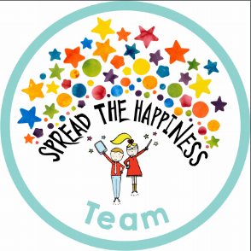www.cl

PE

Next week we will be doing PE for the first time. PE lessons for Reception will take place on Monday and Tuesday afternoons. If PE kits are not yet in school please make sure they are next week.

For PE the children will get changed in groups of 7/ 8 with an adult supporting them. This weekend please practise with your child being as independent as possible when getting changed and the importance of looking after their own items and keeping them safe. We will of course support them when needed but as much as they can do themselves is both important and greatly appreciated.

When we ask the children to get changed they are asked to take out their PE kits and put them on a chair then as soon as they take an item of their uniform off put it straight into their PE bag.

Occasionally items of uniform may get muddled up so please ensure that all items are clearly labelled.

Friday 21st September

This week we have been learning about birthdays, we have spoken about the different things people do to celebrate their birthday and what makes them special. We have had lots of fun writing party invitations, making birthday cards, wrapping presents and putting up decorations. We have also been focussing our learning on numbers 1 -5. We have enjoyed watching ‘Number Blocks’ and have been trying to accurately count, recognise and write these numbers. Next week we will learning all about our bodies and changing our home corner into a hospital. Any donations of bandages, plasters etc. would be very welcome. From The Reception Class Team

This week we have enjoyed…

*Having birthday parties in our home corner and outdoors

*Exploring numbers and shapes on our light table

*Building amazing towers in our ‘Despicable Designs’ construction site

* Creating masterpieces in our workshop

This week we have been learning…

* To learn to recognise numbers
* To hold a pencil correctly
* To recognise and order numbers to 5 and discuss which number is ‘bigger’
* To practise our ‘good sitting’ and ‘good listening’ on the carpet.

Reading Books

Your child will have brought home another reading book tonight. These first books have no words but you can use the sheet provided to ask questions and follow the story together. Please keep this sheet in with your child’s book in their bag. They will also have a key ring of ‘tricky words’ we would like the children to read independently. Please try to practise these daily with your child – let us know when they are able to read all the words and we will add the next set.

Please ensure you write in your child’s diary to let us know when they have read their books and how they have been getting on with them.

Keep in touch

*Follow us on twitter @stgregorys_EYFS

*You can also contact me directly by email if you have any concerns or questions:

[eyfs@st-gregorys-pri.lancs.sch.uk](NULL)

*Send observations of your child’s learning at home by replying to the 2Simple report you have already received.

* You can also use ClassDojo to send quick messages.

**Homework**

The children will have until **Wednesday 17th OCTOBER** to complete as many of the challenges as possible. Thank you for support in completing the challenges so far, your contributions are really valuable to us.

Snack

In order to be able to provide a daily snack, we ask for a donation of £1 per week, per child.

Thank you for your contributions.