School Trip

We are all very excited for our school trip to Blue Planet Aquarium on Monday. We will be getting picked up at 9am, with this in mind please can the children try to be in school for 8.45am. Children do not need to bring book bags or water bottles to school on this day.

Lunches

If children are bringing their own packed lunch please can these be in a labelled plastic bag and if possible be completely disposable. As after lunch we have no where to store lunch boxes or bottles for the afternoon.

Goody Bags

For those who have requested I have ordered goody bags priced at £2 each. Please bring this in cash in a labelled envelope on Monday morning.

Friday 22nd March

This week we have been learning about a whole range of different sea creatures who we are hoping to meet on our visit to Blue Planet Aquarium next week including, star fish, crabs, seahorses and octopus. We have learned some fascinating facts about each of the animals and used them to create our own sea creature factfiles. In our maths work this week we have been focusing on the ‘tricky tens’ numbers learning about place value (tens and ones) using tens frames and Numicon as well as carefully practising our number formation. Also this week we have enjoyed learning about rock pools, how they are formed and the animals that live there, we have even made our own paper plater rock pools teeming with life!

From The Reception Team

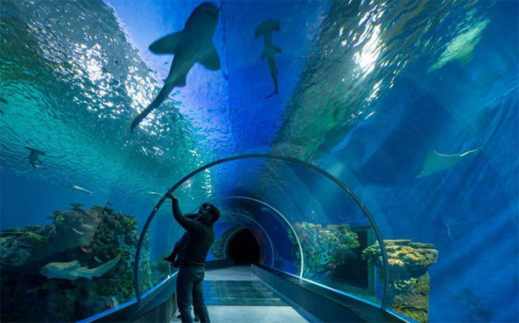

This week we have enjoyed…

*Count and measure water beads in our water tray

*Painting rainbows to celebrate St. Patrick’s Day

* Making paper plate rock pools

* Taking a dive into the deep in our role play area

This week we have been learning…

* Write factual sentences about sea creatures
* Build, describe and write teens numbers
* About different creatures that live in rock pools
* About the Easter Story and what happened to Jesus during Holy Week.

Reading Books

Your child will have brought home another reading book tonight. These first books have no words but you can use the sheet provided to ask questions and follow the story together. Please keep this sheet in with your child’s book in their bag. They will also have a key ring of ‘tricky words’ we would like the children to read independently. Please try to practise these daily with your child – let us know when they are able to read all the words and we will add the next set.

**Please ensure you write in your child’s diary to let us know when they have read their books and how they have been getting on with them.**

☺ Thank you ☺

Keep in touch

*Follow us on twitter @stgregorys_EYFS

*You can also contact me directly by email if you have any concerns or questions:

[eyfs@st-gregorys-pri.lancs.sch.uk](NULL)

*Send observations of your child’s learning at home by replying to the 2Simple report you have already received.

* You can also use ClassDojo to send quick messages.

**Homework**

The children will have until **Wednesday 3rd April** to complete as many of the challenges as possible. Thank you for support in completing the challenges so far, your contributions are really valuable to us.

Snack

In order to be able to provide a daily snack, we ask for a donation of £1 per week, per child.

Thank you for your contributions.