Summer Term

* You may wish to send into school a labelled bottle of sun cream this term. We will supervise the children in applying suncream when needed.
* I have had a few messages this week about missing jumpers/cardigans or children coming home with the wrong jumpers/cardigans – Please can you help us with this by ensuring all items of clothing have your child’s name in, some may have washed/ fallen off over time. We try our best everyday to send home the correct items with children at the end of the day but this is somethimes made difficult by a lack of name in clothes.

Thank you

Friday 24th May

This week has been very exciting as we joined the school in celebrating our Languages Fesitval. We have had lots of fun learning about France, Italy and Spain, focussing on some of the famous buildings such as the Eiffel Tower, the Colosseum and Camp Nou Stadium and building them outside. We have also enjoyed learning to speak some basic words and sing ‘Brother John’ in each language. We even tasted some Spanish Paelella and learned a Spanish dance called the Paso Doble. We have had a very active week turning our playground into the streets of Italy, whizzing round the famous landmarks in a giant game of Mario Kart and then on Thursday taking part in the whole school Tour de France on our big track.

From The Reception Team

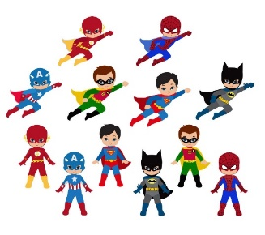o

This week we have enjoyed…

*Building different famous European structures

*Learning to speak French, Italian and Spanish

* Tasting Palella

* Playing Mario Kart on our bikes

This week we have been learning…

* About famous buildings from France, Italy and Spain
* To dance the Paso Doble
* To sing ‘Brother John’ in 4 languages!
* About the importance of Pentecost as the church’s birthday

Reading Books

Your child will have brought home another reading book tonight. These first books have no words but you can use the sheet provided to ask questions and follow the story together. Please keep this sheet in with your child’s book in their bag. They will also have a key ring of ‘tricky words’ we would like the children to read independently. Please try to practise these daily with your child – let us know when they are able to read all the words and we will add the next set.

**Please ensure you write in your child’s diary to let us know when they have read their books and how they have been getting on with them.**

☺ Thank you ☺

Keep in touch

*Follow us on twitter @stgregorys_EYFS

*You can also contact me directly by email if you have any concerns or questions:

[eyfs@st-gregorys-pri.lancs.sch.uk](NULL)

*Send observations of your child’s learning at home by replying to the 2Simple report you have already received.

* You can also use ClassDojo to send quick messages.

**Homework**

Thank you for support in completing this half term’s homework challenges, your contributions are really valuable to us.

Snack

In order to be able to provide a daily snack, we ask for a donation of £1 per week, per child.

Thank you for your contributions.