**Sun cream and hats**

If possible please send into school a bottle of sun cream (labelled) for your child. On hot days we will supervise the children in applying their own sun cream. We also request that you send in a sun hat on sunny days, again labelled. Please no sunglasses, as these can be a hazard and easily broken when playing outside.

Thank you ☺

**Diary Dates**

Friday 8th June – Tombola/ cakes donation

Saturday 9th June – Summer Fair

Friday 25th May

This week we received a special parcel in the post from Hattie Peck, she sent us a new book ‘Hattie Peck: The Journey Home’. In this book Hattie’s house was in chaos so she decided it was time for all of her baby animals to go out and find a new home for themselves. The children then imagined they were one of these animals and wrote a postcard back to their mummy Hattie Peck to tell her all about their new homes. The children showed fantastic imagination and great creativity in their writing. This week we also got to meet our two little ducklings, they are very lively and we loved watching them splashing in the water. Check out our blog for more photos.

From The Reception Class Team

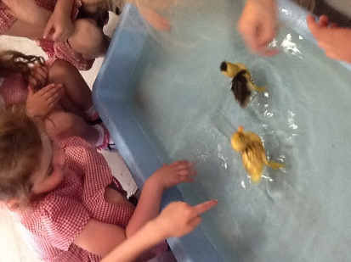

This week we have been learning…

* To use exciting describing words in our writing
* To read and write tricky high frequency words
* To solve addition and subtraction number sentences
* About different jobs and what we might want to be when we grow up
* About Jesus’ friends and how we are friend’s of Jesus too

Reading Books

Please continue to practise your child’s key ring of ‘tricky words’ and let us know when they are able to read all the words and we will add the next set. Once they are confident with these we will be able to send home more books with words.

**Please ensure you write in your child’s diary to let us know when they have read their books and how they have been getting on with them. Books should be read each night if possible to support your child’s confidence and fluency**

Phonics

This week children began working in their new phonics groups. The children have really benefitted from working in smaller groups which are targeting their needs. A particular area of need we have noticed is in ‘blending’ letters to read longer words. Please use the sheets sent home in previous weeks to practise this at home.

This week we have enjoyed…

*Exploring storytelling in our deconstructed role play area

* Watering our plants to help them grow

*Threading number sentences

*Decorating scarves for Hattie Peck

Keep in touch

*Follow us on twitter @stgregorys_EYFS

*You can also contact me directly by email if you have any concerns or questions:

[eyfs@st-gregorys-pri.lancs.sch.uk](mailto:eyfs@st-gregorys-pri.lancs.sch.uk)

*Send observations of your child’s learning at home by replying to the 2Simple report you have already received.

* You can also use ClassDojo to send quick messages.

**Homework**

Thank you for your support completing the homework challenges for this half term. All books have been collected in and will be returned with new challenges after the half term break.

Snack

In order to be able to provide a daily snack, we ask for a donation of £1 per week, per child.

Thank you for your contributions.