Summer Term

* This term our PE days will be Tuesday afternoons and Thursday mornings. We hope to be able to more PE lessons outside so please ensure your child has an outdoor PE kit, with trainers in school.
* You may wish to send into school a labelled bottle of sun cream this term. We will supervise the children in applying suncream when needed.

Thank you

Friday 26th April

Welcome back! The children have been so excited to chat to us about all of the wonderful things they have done over the Easter break, it sounds as though everyone has had a fantastic time. Now as we move into the summer term we will be stepping up the amount of work we expect the children to do independently and start to think about making the transition into Year 1. Our topic for this half term is ‘Superheroes’ with a focus on keeping healthy. This week we have started to think about what a superhero is like and how we can be hero in school. Next week we are are going to begin to look at the ‘Supertato!’ story books as a focus for our learning.

From The Reception Team

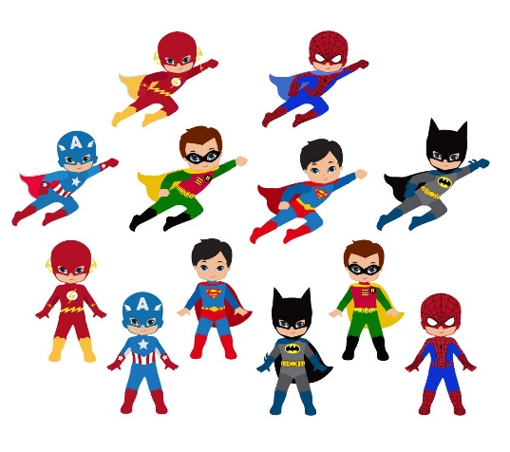o

This week we have enjoyed…

*Playing in our new supermarket role play area, with real fruit and vegetables!

*Training in our superhero gym outside

* Solving problems and rescuing people in our superhero roleplay

* Building superhero vehicles and a superhero headquarters

This week we have been learning…

* To think about how we can effectively express our thoughts and ideas to others
* Write teens numbers, focussing on correct orientation
* To say ‘one more’ or ‘one less’ than a given number to 20
* About what is ‘Good News’ as part of our Come and See Work

Reading Books

Your child will have brought home another reading book tonight. These first books have no words but you can use the sheet provided to ask questions and follow the story together. Please keep this sheet in with your child’s book in their bag. They will also have a key ring of ‘tricky words’ we would like the children to read independently. Please try to practise these daily with your child – let us know when they are able to read all the words and we will add the next set.

**Please ensure you write in your child’s diary to let us know when they have read their books and how they have been getting on with them.**

☺ Thank you ☺

Keep in touch

*Follow us on twitter @stgregorys_EYFS

*You can also contact me directly by email if you have any concerns or questions:

[eyfs@st-gregorys-pri.lancs.sch.uk](NULL)

*Send observations of your child’s learning at home by replying to the 2Simple report you have already received.

* You can also use ClassDojo to send quick messages.

**Homework**

The children will have until **Thursday 23rd May** to complete as many of the challenges as possible. Thank you for support in completing the challenges so far, your contributions are really valuable to us.

Snack

In order to be able to provide a daily snack, we ask for a donation of £1 per week, per child.

Thank you for your contributions.