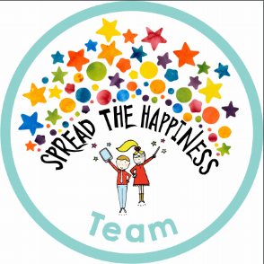

Phonics

This week we have started Phase 2 phonics – which means we will now be learning 4 new letter sounds per week. This week we have learned ‘s a t p’ and listening for these sounds at the start of words. Next week I will be sending home some words to practise reading.

PE

This week the children enjoyed their first PE lessons in the school hall. We had lots of fun balancing along benches, jumping over hurdles and throwing beanbags into hoops.

Please support your child at home by encouraging independence when getting changed, staff are on hand to help the children with tricky buttons but they are encouraged to ‘have a go’ first and to be responsible for looking after their items of uniform.

As you can imagine 30 sets of identical uniform can be quite tricky to keep an eye on whilst the children are changing and so I cannot emphasise enough the importance of making sure ALL items of clothing have names in.

Thank you

Friday 28th September

This week we have been learning about our bodies, how to stay healthy and finding out about our skeletons. We have had lots of fun retelling the ‘Funny Bones’ story and making our own skeletons inside and outside the classroom. We have also started to learn some letter sounds in our phonics lesson – please let me know if you would like any information about how to support your child with this. A great website to use is ‘Teach Your Monster to Read’ login details can be found on your child’s diary bookmark.

From The Reception Class Team

This week we have enjoyed…

*Looking after the dolls in our baby clinic

*Exploring numbers and shapes on our light table

*Making skeletons from a variety of different materials

* Painting self-portraits in our workshop

This week we have been learning…

* To learn to recognise letters
* To hold a pencil correctly
* To recognise and order numbers to 10 and discuss which number is ‘bigger’
* To practise our ‘good sitting’ and ‘good listening’ on the carpet.

Reading Books

Your child will have brought home another reading book tonight. These first books have no words but you can use the sheet provided to ask questions and follow the story together. Please keep this sheet in with your child’s book in their bag. They will also have a key ring of ‘tricky words’ we would like the children to read independently. Please try to practise these **daily** with your child – let us know when they are able to read all the words and we will add the next set.

Please ensure you write in your child’s diary to let us know when they have read their books and how they have been getting on with them.

Keep in touch

*Follow us on twitter @stgregorys_EYFS

*You can also contact me directly by email if you have any concerns or questions:

[eyfs@st-gregorys-pri.lancs.sch.uk](NULL)

*Send observations of your child’s learning at home by replying to the 2Simple report you have already received.

* You can also use ClassDojo to send quick messages.

**Homework**

The children will have until **Wednesday 17th OCTOBER** to complete as many of the challenges as possible. Thank you for your support in completing the challenges so far, your contributions are really valuable to us.

Snack

In order to be able to provide a daily snack, we ask for a donation of £1 per week, per child.

Thank you for your contributions.