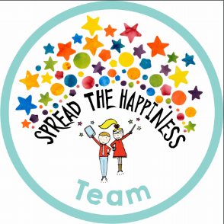

Phonics

This week we have started Phase 2 phonics – which means we will now be learning 4 new letter sounds per week. This week we have learned ‘i n e m’ and listening for these sounds at the start of words. I have sent home some words for the children to practise reading at home. Underneath each letter is a ‘sound button’ for the child to press and say each sound, they should then be encouraged to try and say the sounds quicker until they blend together and they can read the whole word. This is a tricky skill and can take a lot of time to master and so please take the time to support your child in this.

Photograph

Our class photograph is due to appear in the Chorley Guardian newspaper on **Tuesday 9th Oct**.

Friday 5th October

This week we have also been learning about our senses and made our own senses book drawing and labelling our favourite things to see, hear, smell, touch and taste. Next week we will be focussing our learning on people who help us, especially the emergency services. The children have really enjoyed our hospital role play area and police role play outside and so we are going to link this into our work next week. We have also been learning all about how to keep our teeth strong, eating healthily and taking care of our bodies.

From The Reception Class Team

This week we have enjoyed…

*Looking after the dolls in our baby clinic

*Exploring numbers and shapes on our light table

*Being Police Officers outside

* Learning how to brush our teeth

This week we have been learning…

* To learn to recognise letters
* To hold a pencil correctly
* To use measures terminology such as ‘long, short, tall, big, small’ to compare and describe objects.
* To practise our ‘good sitting’ and ‘good listening’ on the carpet.

Reading Books

Your child will have brought home another reading book tonight. These first books have no words but you can use the sheet provided to ask questions and follow the story together. Please keep this sheet in with your child’s book in their bag. They will also have a key ring of ‘tricky words’ we would like the children to read independently. Please try to practise these **daily** with your child – let us know when they are able to read all the words and we will add the next set.

Please ensure you write in your child’s diary to let us know when they have read their books and how they have been getting on with them.

Keep in touch

*Follow us on twitter @stgregorys_EYFS

*You can also contact me directly by email if you have any concerns or questions:

[eyfs@st-gregorys-pri.lancs.sch.uk](NULL)

*Send observations of your child’s learning at home by replying to the 2Simple report you have already received.

* You can also use ClassDojo to send quick messages.

**Homework**

The children will have until **Wednesday 17th OCTOBER** to complete as many of the challenges as possible. Thank you for your support in completing the challenges so far, your contributions are really valuable to us.

Snack

In order to be able to provide a daily snack, we ask for a donation of £1 per week, per child.

Thank you for your contributions.