School Trip

On Monday 25th March we will be going on our school trip to Blue Planet Aquarium. You should have received a letter this week with all the important details as well as information about how to set up ‘Parent Pay’ to pay for the trip.

Friday 8th February

This week we have enjoyed reading the story ‘The Snail and The Whale’ by Julia Donaldson. We have put ourselves in the role of the snail and done some fabulous writing imagining we are the snail returning home to tell our friends about our amaing adventures. Also this week we have learned about different types of whales, we found out that a blue whale can measure up to 33m! That’s from our classroom all the way into the carpark! We have also been finding out about the impact of plastic on our oceans – we listened to the story ‘Somebody swallowed Stanley’ and thought about ways we can reduce the amount of plastic we use. We then made some information posters to put up around school.

From The Reception Team

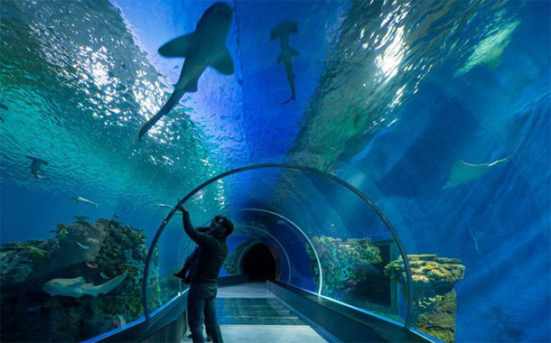

This week we have enjoyed…

*Measuring the size and scale of different whales

*Writing phonics words with our ‘snail trail’ glitter glue pens

* Investigating gloop

* Printing scales on a fish

This week we have been learning…

* Write sentences using finger spaces and a full stop.
* Solving subtraction problems
* About different types of whale, their features and their size
* To identify signs of new life and growth in our school grounds in our Come and See work.

Reading Books

Your child will have brought home another reading book tonight. These first books have no words but you can use the sheet provided to ask questions and follow the story together. Please keep this sheet in with your child’s book in their bag. They will also have a key ring of ‘tricky words’ we would like the children to read independently. Please try to practise these daily with your child – let us know when they are able to read all the words and we will add the next set.

**Please ensure you write in your child’s diary to let us know when they have read their books and how they have been getting on with them.**

☺ Thank you ☺

Keep in touch

*Follow us on twitter @stgregorys_EYFS

*You can also contact me directly by email if you have any concerns or questions:

[eyfs@st-gregorys-pri.lancs.sch.uk](NULL)

*Send observations of your child’s learning at home by replying to the 2Simple report you have already received.

* You can also use ClassDojo to send quick messages.

**Homework**

The children will have until **Wednesday 3rd April** to complete as many of the challenges as possible. Thank you for support in completing the challenges so far, your contributions are really valuable to us.

Snack

In order to be able to provide a daily snack, we ask for a donation of £1 per week, per child.

Thank you for your contributions.