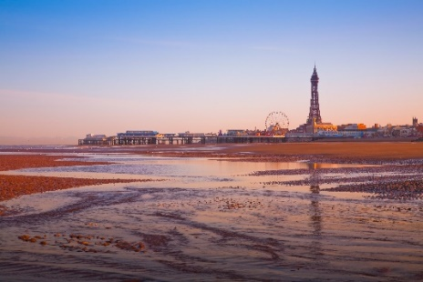
Year 2 Project Homework for Summer 2

Our topic this half term is Buckets and Spades
Choose any of the following tasks. You MUST do at least 2 of the tasks.
You have to the end of this half term to complete and you can hand them in at any time.
Read 5 times a week for 5 to 10 minutes each session.  Week 1, 2, 3, 4, 5, 6, 7  You must have your diary signed  2 Dojos per week | GEOGRAPHY  Make a poster or a leaflet about visiting the seaside. Try to make other people want to visit. Include things that you can do there and things that you can see.  3 Dojos | History  Find out about the seaside in Victorian times. Choose how to present your information. This could be a labelled picture of the Victorian seaside or maybe make a model of the seaside in a box. Be creative.  5-10 Dojos
DESIGN TECHNOLOGY/ART  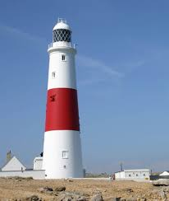  Make/build a model of a lighthouse. You can make it light up if you like.  5-10 Dojos | ENGLISH  Visit the seaside. Take photographs and record things that you see and do. Make a scrapbook or treasure chest that includes the photographs and writing about what you did.  5-10 Dojos | ICT RESEARCH  Use a computer to research a seaside town in the UK. Decide how to present your information using purple mash or even a powerpoint presentation  3 Dojos

