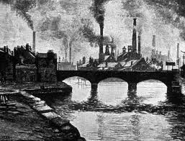  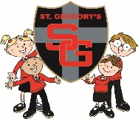  jo0l9  Coal, Cotton, Canal |  | Year 4  Autumn Term 2 2018 Newsletter

Welcome back to an exciting second half of the Autumn Term in Year 4!
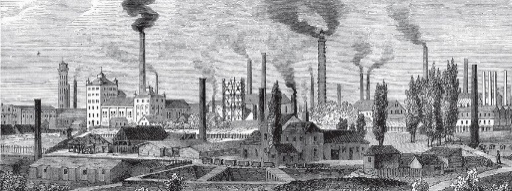
This half term’s topic is called ‘Coal, Cotton, Canal’ our main focus will be History. We will be learning about the Victorian era and the industrial revolution. In addition, we will be mapping the UK in Geography. Our educational visit to Quarry Bank Mill will support and enhance our learning in this topic.

In P.E. we will be learning and developing gymnastic skills. We will also be focusing on developing and improving fundamental skills. P.E. kits need to be in school every day.
In English we will be studying how Newspaper reports are written and using our knowledge from our History lessons to write a Victorian Newspaper report. We will also be studying ‘Street Child’ a novel by Berlie Doherty. From this novel we will write diary entries, stories and playscripts using this as our inspiration.
In Computing we will be using spreadsheets.
.

R.E. Topics:
Called
Islam
Gifts

Homework:
- Reading should be done every night and the diaries brought in every day. They will be checked every Friday. Please ensure you sign your child’s diary when they have read their book.
- Spellings are tested every Wednesday.
- Mathletics Homework is set weekly. Pupils have several tasks to complete.
- A project is set for the children to complete that links to our topic on the industrial revolution. The details of this homework are attached below.

.

.
Mrs Molyneux and Mrs Oldham

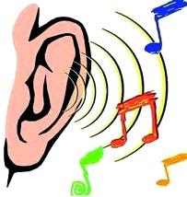
Science this half term is investigating sound, learning how sound travels and carrying out investigations

In Art. this term we will be developing our skills in drawing, painting and printing when we create pieces relating to the industrial revolution
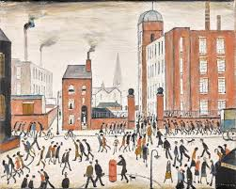

Autumn Term 2 Homework: The Industrial Revolution
Choose ONE of the famous people below or another person who had on impact on the industrial revolution and write a fact file about them. This could be in the form of a biography, a poster or a ‘book’ with chapters/sections.
This project should be handwritten. Please feel free to include pictures/drawings/diagrams. No 3D models or other artwork this time!
Be prepared to stand up in class and talk about your chosen person/ talk us through your project!
Please ask if you need any materials from school to complete your homework.
Due date: Wednesday 12th December

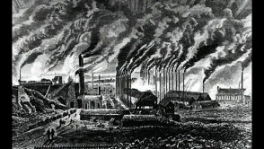
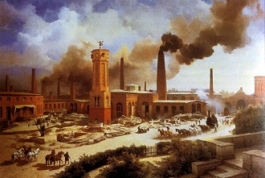
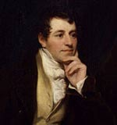
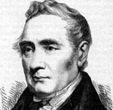
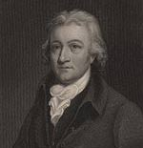
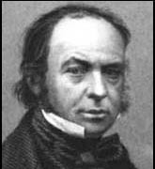
Sir Humphrey Davy (1778 – 1829) – English chemist and inventor. He invented the Davy lamp used by miners to help detect gas and improve safety.
George Stephenson (1781 – 1848) Mechanical engineer, who developed the steam engine for use in trains. He was a key figure in building the 25 mile Stockton and Darlington railway. Stephenson also built the first intercity railway between Liverpool and Manchester – ushering in the ‘railway age’.
Edmund Cartwright (1743-1823) – English inventor, and member of the Anglican church. Cartwright invented the power loom which significantly increased the speed of textile production. He also developed a wool combing machine.
Isambard Kingdom Brunel (1806 – 1859) English engineer. Brunel was at the heart of many of the key building projects of the British industrial revolution. He built the Great Western Railway from Bristol to London and also developed powerful steamships. He also built the first tunnel under a river.

