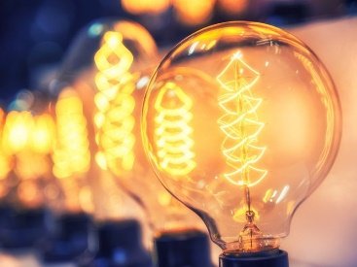  jo0l9  Sparks might fly |  | Year 4  Autumn Term 1 2018 Newsletter
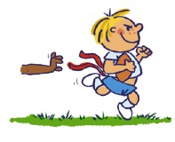
Welcome back to a jam-packed Autumn Term in Year 4!
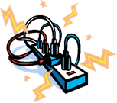
This term’s topic is called ‘Sparks might fly’ our focus will be Science, we will be learning about electricity and circuits. We will link this with our Design technology work on designing our own electronic games.

In P.E. we will be learning and developing dance skills. We will also be focusing on raising our fitness levels with some high energy fitness work. P.E. kits need to be in school every day.
In English we will be reading and writing ‘Fantasy’ fiction. We will be studying The Firework Maker’s Daughter by Phillip Pullman. We will also be writing Playscripts and Explanation Texts.
In Computing we will be learning how to code.
In D.T. this term we will be applying the skills that we have learnt in Science to create electronic games.

R.E. Topics:
People
Called
Gift

Homework:
- Reading should be done every night and the diaries brought in every day. They will be checked every Friday. Please ensure you sign your child’s diary when they have read their book.
- Spellings are tested every Wednesday.
- Mathletics Homework is set regularly. Pupils have several tasks to complete.
- A project is set for the children to complete that links to our topic on electricity. The details of this homework are attached below.

Educational visits
Next half term we will be visiting Quarry Bank as part of our learning. Details to follow shortly.

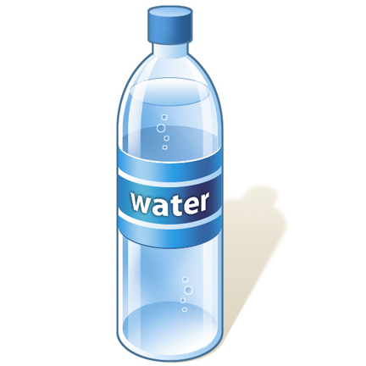
Please can all children have a water bottle in school. Please note that juice is not permitted.
Please come and see us if you have any questions.
Mrs Molyneux and Mrs Oldham

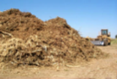
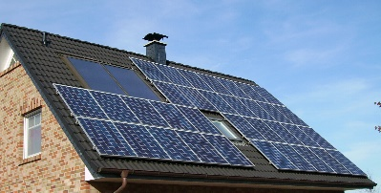

Year 4 Electricity Project

Your task is to produce a project about energy! I would like you to find out some more about renewable forms of energy.
Pick either wind, solar, hydro-electric or biomass (if you know any others you can use them too!). Find out more about your chosen form of energy and write some facts about.
You can choose to do more than one type of energy if you like!
• Your project must include some factual information.
• Your project must include some type of writing
• Your project COULD include: artwork, 3D models, collage etc.
• Your project can be presented in any way you like e.g. in a book, a large poster, in a file etc.
• I would like it to be handwritten, but you can (and should!) use the internet to help you with your research.
• Adults at home can help you with your project, but it should be your own handwriting, artwork and ideas.
Some suggestions/ideas:
You could make a map of the location of wind/solar farms in the UK
You could visit a local wind farm and take photographs for your project
You could create a graph of rainfall/ wind speed etc.
You could write a poem about your chosen energy source.
You could pretend you have interviewed people who live near the solar/wind farm and ask them their opinions.

You can do some drawings/ diagrams to demonstrate how things work. (Don’t try to go into too much detail—some of the explanations are very complicated for how things work!)

Project to be handed in on: Wednesday 17th October

There will be prizes for 1st, 2nd and 3rd places. I will be looking for the most creative, interesting and well-presented projects. Good Luck!!

