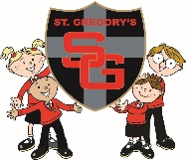  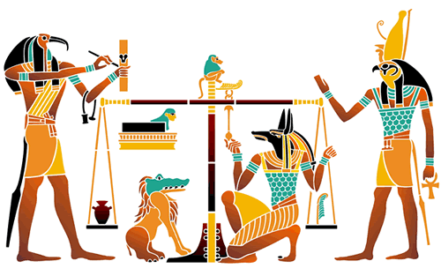  jo0l9  Flowing down the Nile |  | Year 4  Summer Term 1 2018 Newsletter
Welcome back to a jam-packed Summer Term in Year 4!
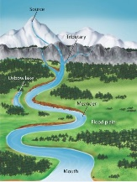
This term’s topic is called ‘Flowing down the Nile’ our focus will be Science, we will be learning about Solids/Liquids/Gases and the Water Cycle. We will link this with our Geography work on Rivers and the Water Cycle. This will also link with our work in History when we learn about how the Egyptians used the Nile. 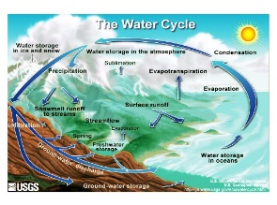
We have organized a school trip, linked to this topic, to The World Museum, Liverpool. This trip will be on 17th May. Please see the separate letter.

In P.E. we will be learning striking and fielding skills to help us with games We will also be focusing on raising our fitness levels with some high energy fitness work. P.E. kits need to be in school every day.
On Tuesday nights after school, we are lucky to be working with Chorley School Sports Partnership to learn Tag Rugby skills. Please see the after school club letter for start and finish dates for this club.
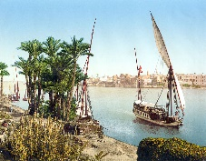
In English we will be writing information booklets linked to Egypt and writing stories. We will also be exploring river poetry. There will be many other opportunities for writing including writing an explanation of the water cycle, thank you letters and recounts from our trip, diary entries for a day in the life of a rich and poor Ancient Egyptian.
In I.T. we will be researching the Ancient Egyptian Pharoahs and different Gases. We will be using publishing programmes to produce posters and leaflets about our learning.
In D.T. this term, we will exploring textiles and how they can be fastened together for a purpose.

R.E. Topics:
New Life
Building Bridges
God’s People
We will be continuing to prepare for the sacrament of Holy Communion after school with the team from the parish.

Homework:
- Reading should be done every night and the diaries brought in every day. They will be checked every Friday. Please ensure you sign your child’s diary when they have read their book.
- Spellings are tested every Wednesday. There is quite a lot of words for the children to learn this term, so please help them with this.
- Mathletics Homework is set regularly. Pupils have several tasks to complete.

Summer HOMEWORK PROJECT:
Maths Focus:
In addition to Mathletics online homework, I have sent home a Mathletics booklet to be completed this half term. I have included the answers so that the work can be checked at home and corrected if necessary.
Science/ R.E./ P.S.H.E. Focus:
Water Poverty
Find out about communities around the world that don’t have access to clean water. The CAFOD website is a great place to start:
https://cafod.org.uk/Education/Primary-teaching-resources
Produce a poster or leaflet explaining the issues and how people have been trying to help. This can be handwritten or typed.
All homework to be handed in on/by: Tuesday 22nd May

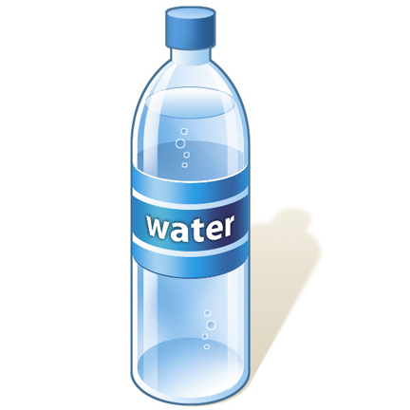
Please can all children have a water bottle in school. Please note that juice is not permitted.
Please come and see me if you have any questions.
Mrs Molyneux.

