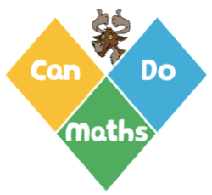
CanDoMaths
Calculation Policy

Intent

An appreciation of number and number operations, which enable mental calculations and written procedures to be performed efficiently, fluently and accurately is key to children being successful in mathematics.

We aim for all children to be:
able to recall quickly and accurately basic number facts
(e.g. number bonds, multiplication and division facts)
fluent in applying quick, efficient written and mental methods of calculation.

Implementation

Before doing a calculation, all teachers and pupils look at a calculation and think ‘What do I notice? ’and ‘Can I do it in my head, with jottings or do I need to use a written method? ’
All teachers use concrete and pictorial representations to teach conceptual understanding of mental and written calculation methods
The Mathematics Curriculum prioritises time for developing conceptual understanding of calculation methods and learning facts (Maths Lessons) and time for deliberate practice of calculation methods and recalling facts.

Impact

All teachers are confident and skilled to teach mental methods (in your head or with jottings) and written calculation methods
All children have a secure understanding of mental and written methods of calculation suitable for their stage of learning.
All children choose appropriate calculation methods depending on the numbers.
All children can recall, understand and make connections using facts suitable for their stage of learning.

Age Related Expectations:

Year
1 | 2 | 3 | 4 | 5 | 6
Read, write and interpret mathematical statements involving addition (+), subtraction (–) and equals (=) signs  Solve one-step problems that involve addition and subtraction, using concrete objects and pictorial representations, and missing number problems such as 7 = ☐ – 9 | Add and subtract two two-digit numbers using concrete objects, pictorial representations progressing to formal written methods  Add and subtract numbers using concrete objects, pictorial representations, and mentally, including:  - a two-digit number and ones  - a two-digit number and tens  - two two-digit numbers  adding three one-digit numbers | Add and subtract numbers with up to three digits, using formal written methods of columnar addition and subtraction  Add and subtract numbers mentally, including:  - a three-digit number and ones  - a three-digit number and tens  a three-digit number and hundreds | Add and subtract numbers with up to 4 digits using the formal written methods of columnar addition where appropriate  signs  Solve addition and subtraction two-step problems in contexts, deciding which operations and methods to use and why | Add and subtract whole numbers with more than 4 digits, including using formal written methods (columnar addition and subtraction)  Add and subtract numbers mentally with increasingly large numbers | Solve addition and subtraction multi-step problems in contexts, deciding which operations and methods to use and why  Perform mental calculations, including with mixed operations and large numbers
Mental and Written Methods (Addition and Subtraction)

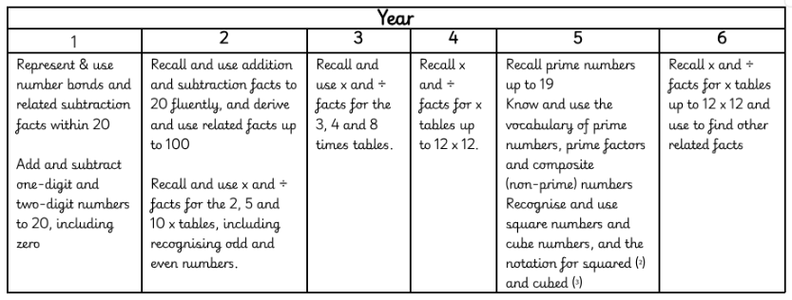
Number Facts

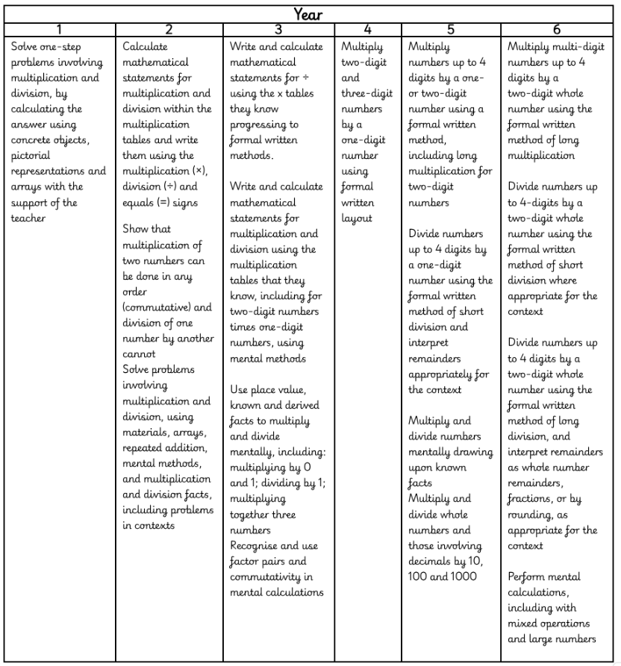

Mental and Written Methods (Multiplication and Division)

