St Joseph’s Catholic Primary School
Pupil Premium
Strategy Statement
Report
2018-2019
The pupil premium is additional funding for publicly funded schools in England to raise the attainment of disadvantaged pupils of all abilities and to close the gaps between them and their peers.
Funding for the Financial Year 2017-2018
In the 2017 to 2018 financial year, schools will receive the following funding for each child registered as eligible for free school meals at any point in the last 6 years:
- £1320 for pupils in reception year to year 6
- £935 for pupils in year 7 to year 11
Schools will also receive £1900 for each pupil identified in the spring school census as having left local authority care because of one of the following:
- Adoption
- A Special guardianship
- A child arrangements order
- A residence order
More information can be found on the government website: www.gov.uk/guidance/pupil-premium-information-for-schools-and-alternative-provision-settings.

Pupil Premium Strategy Statement
- Summary information
School | St Joseph’s Catholic Primary School
Academic Year | 2018-2019 | 2018-2019 Budget |  | Date of most recent PP Review | Sept 2018
Total number of pupils | 372 | Total PP Carried Forward |  | Date for next internal review of this strategy | Jan 2019
 |  | Total PP Budget | £69200
Number of pupils eligible for PP | 48 | Total Number of PP+SEN | 7/48 | Total Number of PP+EAL | 6/48

- Current attainment Year 6
Pupils Eligible 55 Pupils |  |  |  | Pupils eligible for PP  4 | Pupils not eligible for PP  51
% Achieving Average Scaled Score in reading, writing & maths |  |  |  | 0% | 0%
% Making Average Scaled Score of progress in reading |  |  |  | 0% | 0%
% Making Average Scaled Score of progress in writing |  |  |  | 0% | 0%
% Making Average Scaled Score of progress s in maths |  |  |  | 0% | 0%
- Barriers to future attainment (for pupils eligible for PP)
In-school barriers (issues to be addressed in school, such as poor oral language skills)
 |  | Improve attainment and Progress in writing for all Pupil premium children across the school
 |  | Improve standards in reading for all Pupil Premium Children
C. |  | Ensure rigorous monitoring of the attainment and progress of Pupil Premium is effective by Subject Co-Ordinator’s and Teachers
External barriers (issues which also require action outside school, such as low attendance rates)
E. |  | Lack of Parental engagement with school
- Desired outcomes (Desired outcomes and how they will be measured) |  |  | Success Criteria |  |  | Monitoring
 | Ensure all pupil premium achieve the same attainment and progress inline with the national figure. |  | Improved progress and attainment for ALL pupil premium pupils will be apparent and in specific cases accelerated progress will be made |  |  | Monitored termly through: data analysis; Pupil Progress meetings, Pupil interviews and Learning Walks by the Senior Leadership Team.  Half termly in Key Stage progress meetings and weekly at classroom level
 | Progress and attainment in reading and writing for the more able Pupil premium children.
 | Engage the disillusioned to have academic belief enabling them to aspire to further their education in the future. |  | Tracking of more able pupil premium will be clearly defined and evidence of impact in progress visible.
 | Further develop the impact of the Wellbeing Curriculum through improving children’s attitudes, behaviour and participation. |  | Create a positive influence on our children’s lives helping them to grow and flourish and support the school’s mental health and well-being curriculum. |  |  | Pupil interviews  Children SEF  Learning walks by the senior leadership team.

Planned expenditure Academic Year 2018-2019
Desired outcome | Provision Provided |  |  |  |  |  |  |  | Objective |  |  |  | Evaluation  How will you ensure it is implemented well?
For a greater number of children to make good progress from their starting points in Reading Writing and Mathematics. | High Quality First Teaching’ allowing access to a broad and balanced curriculum. Teachers will differentiate to enable pupils of different abilities and learning styles to fulfil their potential; plan and deploy TA support for whole class interventions.  There are three principles that are essential to developing a more inclusive curriculum. |  |  |  |  |  |  |  | Evidence of Impact:  Attainment Evidence refer to section 7  Pupil Interviews and Lesson Observations carried out by SLT  Pupil Progress meeting reviews carried out by SLT |  |  |  | Continue to provide training and support for all staff to ensure high quality first teaching continues across the school.  Improved moderation and formal assessments throughout the academic year.
Staff lead All |  |  |  | Cost |  |  |  | £ Staffing Expenditure – not EPPG
Desired outcome | Provision Provided |  |  | Objective |  |  |  |  |  |  |  |  | Evaluation  How will you ensure it is implemented well?
To help children develop their mathematical skills and help remove any potential barriers to their mathematical learning. | Small Group Intervention:  1st Class @number targeting Y1-Y2 children.  Small group interventions in class working alongside the class teacher |  |  | Evidence of Impact:  Attainment Evidence all pupils on the intervention made 1-2 APs across the year.  Pupil Interviews and Lesson Observations carried out by SLT  Pupil Progress meeting reviews by SLT |  |  |  |  |  |  |  |  | Recommendation:  Small group interventions in class working alongside the class teacher in line with more effective deployment of TAs to impact on pupil’s strategies and subsequent progress.
Staff lead Trained TA J Kuzimska |  |  |  | Cost |  | £ TA (3 afternoons)
Desired outcome | Provision Provided |  |  | Objective |  |  |  |  |  |  |  |  | Evaluation  How will you ensure it is implemented well?
To help children develop their phonemic awareness- their ability to hear, identify and manipulate phonemes in order to remove any barriers | Small Group Intervention:  Phonics / Reading targeting Y1-Y2 children |  |  | Evidence of Impact:  Attainment Evidence 100% of all pupils on the invention successfully passed the phonics screening.  Pupil Interviews and Pupil progress meetings carried out by SLT |  |  |  |  |  |  |  |  | Recommendation:  Interventions in the classroom in line with school development of TA deployment
Staff Lead Trained TA C Ratkovic |  |  |  | Cost |  |  | £ TA (3 afternoons)
Desired outcome | Provision Provided |  |  | Objective |  |  |  |  |  |  |  |  | Evaluation  How will you ensure it is implemented well?
To help children develop their academic abilities and desire for learning through computing.  Developing self awareness skills to safe when using social media through the delivery of the school’s computing curriculum. | IT resources laptops |  |  | To provide computing equipment for access to software (Century, Purple Mash and the reading Cloud) to help raise attainment and progress across all subjects.  To develop self awareness of the dangers facing modern society involving CSE, Social media and targeted advertising. |  |  |  |  |  |  |  |  | Attainment and progress to be monitored termly through data analysis; Pupil Progress meetings, Pupil interviews and learning Walks by the Senior Leadership
Staff lead W Bowring L Malpass |  |  |  | Cost |  |  | £ 20,025.90 One off cost
Desired outcome | Provision Provided |  |  | Objective |  |  |  |  |  |  |  |  | Evaluation  How will you ensure it is implemented well?
To support the school’s mental health and well-being curriculum and create a positive environment for our children and increase academic progress for targeted children. | Trained member of staff  Resources for the room |  |  | All pupils on the programme have a nurture assessment tracker which is completed weekly and monitored by SENCo |  |  |  |  |  |  |  |  | Provision to be continued in the light of progress and beginning of the impact of ‘soft’ data on pupil’s academic progress
Staff Lead Mrs Barker |  |  |  | Cost |  |  | Staffing Expenditure – not EPPG
Desired outcome | Provision Provided |  | Objective |  |  |  |  |  |  |  |  |  | Evaluation  How will you ensure it is implemented well?
To improve home / school communication particularly at KS 1 to enable parents to better support their children with phonics and reading at home | Development of a parent partnership programme and events / activities / workshops to help parental skills. |  | Sessions were attended by several parents and the resources created are now being used by all children during their lessons  Do we want this to continue with Sandra? |  |  |  |  |  |  |  |  |  | Reduced to 3 afternoons per week, focus on developing the parent group and supporting those children in Years1 / 2 with reading and writing
Staff Lead Trained Teaching Assistant |  |  | Cost |  |  | £ TA (1 afternoon)
Desired outcome | Provision Provided |  | Objective |  |  |  |  |  |  |  |  |  | Evaluation  How will you ensure it is implemented well?
To create a positive environment for our children, promote self-esteem, self-confidence, communication skills and leadership skills | WBA Outreach Programme |  | To support the school’s mental health and well-being curriculum and create a positive environment for our children, promote self-esteem, self-confidence , communication skills and leadership skills. |  |  |  |  |  |  |  |  |  | Attainment and progress to be monitored termly through data analysis; Pupil Progress meetings, Pupil interviews and learning Walks by the Senior Leadership
Staff lead: L Dean N Boswell |  |  | Cost |  |  | £ awaiting Invoice
Desired outcome | Provision Provided |  | Objective |  |  |  |  |  |  |  |  |  | Evaluation  How will you ensure it is implemented well?
To support a child who has social, emotional difficulties and whose behaviour is creating a barrier to his learning and that of his peers | TA behavioural and learning support for two pupils |  | Monitoring of participation in curriculum resulting in progress and improved attainment |  |  |  |  |  |  |  |  |  | 1 Child still requires a part time table an EHCP is currently being agreed  2nd child has made 2-3 aps in writing, Reading and Maths,
Staff Lead: Mrs Homer/Mrs Willis |  |  | Cost |  |  | £ 10,006.75 TA Grade 1 (26.25 hours per week; 5.25 per day)x2 =£20,013.50
Desired outcome | Provision Provided |  | Objective |  |  |  |  |  |  |  |  |  | Evaluation  How will you ensure it is implemented well?
To support the school’s mental health and well-being curriculum by delivering an outdoor curriculum programme to Key Stage 1 and 2 | Woodland Warriors’ sessions  With Mrs Barker and Mrs Davies –Hale.  Provided focused interventions by the class teacher using Century |  | Pupil interviews, Teacher staff interviews  Monitoring of Class room interventions by SLT |  |  |  |  |  |  |  |  |  | Attainment and progress to be monitored termly through data analysis; Pupil Progress meetings, Pupil interviews and learning Walks by the Senior Leadership Team.
Staff Lead:J McDoangh/ SBarker |  |  | Cost |  |  | 2X TA (4 afternoons)
Review of expenditure Academic Year 2017-2018
Desired outcome | Provision Provided |  |  |  | Evidence of impact: |  |  |  |  |  |  |  | Lessons learned
Improve attainment and progress in writing for ALL children across the school. Ensure a +ve progress score at end of KS2. Progress and attainment in reading and writing are more in line across the school. Transference of skills within non-core subjects is evident | High Quality First Teaching’ allowing access to a broad and balanced curriculum. Teachers will differentiate to enable pupils of different abilities and learning styles to fulfil their potential; plan and deploy TA support for whole class interventions.  There are three principles that are essential to developing a more inclusive curriculum |  |  |  | High Quality First Teaching:  Attainment and progress monitored termly through: data analysis; Pupil Progress meetings, Pupil interviews and Learning Walks by the Senior Leadership Team.  Training in house and Monitoring of TA deployment by SLT. |  |  |  |  |  |  |  | Pupil premium for attainment 23% for reading and 35% below the national 2017 figure.  Pupil premium for progress  Although attainment is below the national 2017 figure 52% of Pupil premium children made 3+ APS points in writing and 54% for reading  Continuing for 2018-2019  SMT to monitor and report to SLT
Staff lead All |  |  |  |  | Cost |  |  | £ Staffing Expenditure – not EPPG
Desired outcome | Provision Provided |  |  |  | Evidence of impact: |  |  |  |  |  |  |  | Lessons learned
To help children develop their mathematical skills and help remove any potential barriers to their mathematical learning. | To team teach with the class teacher and provided intervention support across Key Stage Two for four days a week. |  |  |  | Attainment and progress monitored termly through data analysis; Pupil Progress meetings, Pupil interviews and Learning Walks by the Senior Leadership Team. Evidencing that intervention strategies are transferred into everyday classroom practice |  |  |  |  |  |  |  | Pupil Premium for attainment 41% below the national 2017 figure  Although attainment is below the national 2017 figure 52% of Pupil premium children made 3+ APS  Continuing for 2018-2019  SMT to monitor and report to SLT
Staff lead Trained TA |  |  |  |  | Cost |  |  | £3042.41 TA GRADE 4 SCP 26 (4.5 hrs per week)
Desired outcome | Provision Provided |  |  |  | Evidence of impact: |  |  |  |  |  |  | Lessons learned
To help children develop their phonemic awareness- their ability to hear, identify and manipulate phonemes in order to remove any barriers. | Small Group Intervention:  Phonics / Reading targeting Y1-Y2 children |  |  |  | Attainment and progress monitored termly through data analysis; Pupil Progress meetings, Pupil interviews. Learning Walks by the Senior Leadership Team |  |  |  |  |  |  | 2/12 KS1 children did not achieve KS1 Phonic Screening 2017-2018  Continuing for 2018-2019
Staff Lead Trained TA |  |  |  |  | Cost |  |  | £1571.30 TA GRADE 2 (3 hrs per week)
Desired outcome | Provision Provided |  |  |  | Evidence of impact: |  |  |  |  |  |  |  | Lessons learned
To support the school’s mental health and well-being curriculum and create a positive environment for our children and increase academic progress for targeted children. | Trained member of staff  Resources for the room |  |  |  | Attainment and progress monitored termly through data analysis; Pupil Progress meetings, Pupil interviews and learning Walks by the Senior Leadership Team.. |  |  |  |  |  |  | Writing: 2/7 just below expected progress 5/7 at or above expected.  Reading: 5/7 just below expected progress 2/7 at or above expected.  Maths: 3/7 just below expected progress 4/7 at or above expected.  Continuing for 2018-2019 With new development of assessment for wellbeing and mental health.
Staff Lead: Mrs Barker, Mrs McDonagh |  |  |  |  | Cost |  | £ Staffing Expenditure – not EPPG
Desired outcome | Provision Provided |  |  |  | Evidence of impact: |  |  |  |  |  | Lessons learned
To create a positive environment for our children, promote self-esteem, self-confidence, communication skills and leadership skills | Commando Joe Programme |  |  |  | Attainment and progress monitored termly through data analysis; Pupil Progress meetings, Pupil interviews and learning Walks by the Senior Leadership Team. Independent evaluative report provided by Commando Joes in line with school assessment. |  |  |  |  |  | Sessions have prompted team work and problem solving activities. The sessions have also provided teachers the opportunity to timetable further intervention time.  The Company can no longer provide a service to this area of Worcestershire.
Staff lead: Mrs McDonagh and SLT |  |  |  |  | Cost |  |  | £11,000.00
Desired outcome | Provision Provided |  |  |  | Evidence of impact: |  |  |  |  |  |  |  | Lessons learned
To improve home / school communication  KS 1 to enable EAL parents to better support their children with phonics and reading at home | Bilingual Teaching assistant to provide support to children and parents in phonics. |  |  |  | Evidenced through timetabling of events and parent surveys / feedback and pupil progress / confidence |  |  |  |  |  |  |  | Awaiting evidence from EAL Co-ordinator  Parent feedback- good. Further development with Mathematics workshops.
Staff Lead:Mrs Piercy/Mrs J Kuzimska |  |  |  |  | Cost |  |  |  | £1848.69 TA Grade 2 ( 4½ hours per week)
Desired outcome | Provision Provided |  |  |  | Evidence of impact: |  |  |  |  |  |  |  | Lessons learned
To support a child who has social, emotional difficulties and whose behaviour is creating a barrier to his learning and that of his peers | TA behavioural and learning support for two pupils |  |  |  | Monitoring of participation in curriculum resulting in progress and improved attainment |  |  |  |  |  |  |  | 1 Child still requires a part time table an EHCP is currently being agreed  2nd child has made 2-3 aps in writing, Reading and Maths,
Staff Lead: Mrs Homer/Mrs Willis |  |  |  |  | Cost |  |  |  | £ 10,006.75 TA Grade 1 (26.25 hours per week; 5.25 per day)x2  =£20,013.50
Desired outcome | Provision Provided |  |  |  | Evidence of impact: |  |  |  |  |  |  |  | Lessons learned
To support the school’s mental health and well-being curriculum by delivering an outdoor curriculum programme to Key Stage 1 and 2 | Woodland Warriors’ sessions  With Mrs Barker and Mrs Davies –Hale.  Provided focused interventions by the class teacher and TA |  |  |  | Pupil interviews, Teacher staff interviews  Monitoring of Class room interventions by SLT |  |  |  |  |  |  |  | The pilot trail of Century has enabled more structured interventions and 1-1 feedback sessions.  Core subject co-ordinators to monitor intervention sessions
Yearly Cost of Century |  |  |  |  | Cost |  |  |  |  | £2400
Desired outcome | Provision Provided |  |  |  | Objective |  |  |  |  |  |  |  | Evaluation  How will you ensure it is implemented well?
To support the more able pupil premium children achieve greater depth | To move an interactive white-board into the Oldcorne/Garnet meeting rooms. |  |  |  | Monitoring of interventions  Monitoring of parental workshops.  Parental interviews |  |  |  |  |  |  |  | .-Requires action  Year 6 intervention: weekly interventions- 10 pupils all achieved greater depth in the KS2 2017-18. SATs.
Staff Lead Mrs J McDonagh |  |  |  |  | Cost |  | £1300
Total Spend for 2017-2018 |  | £41 175.90

- Additional detail :Attainment and Progress across the school
Pupil Premium Progress 2017-2018

WRITING

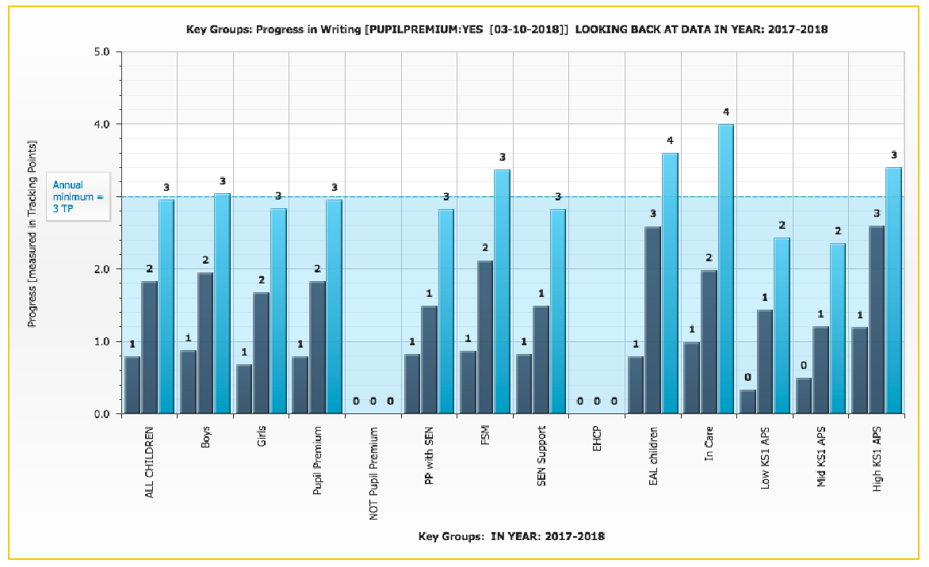

READING
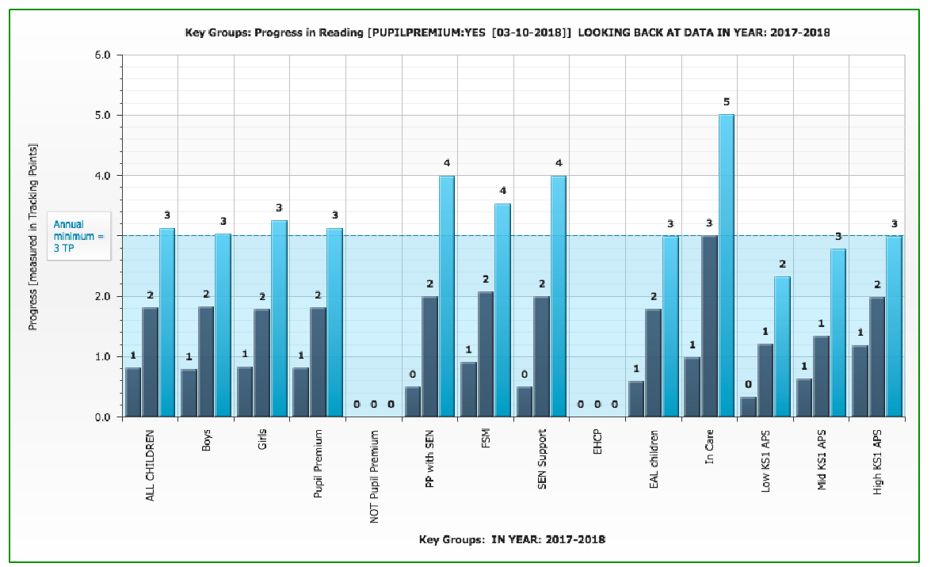

MATHEMATICS
