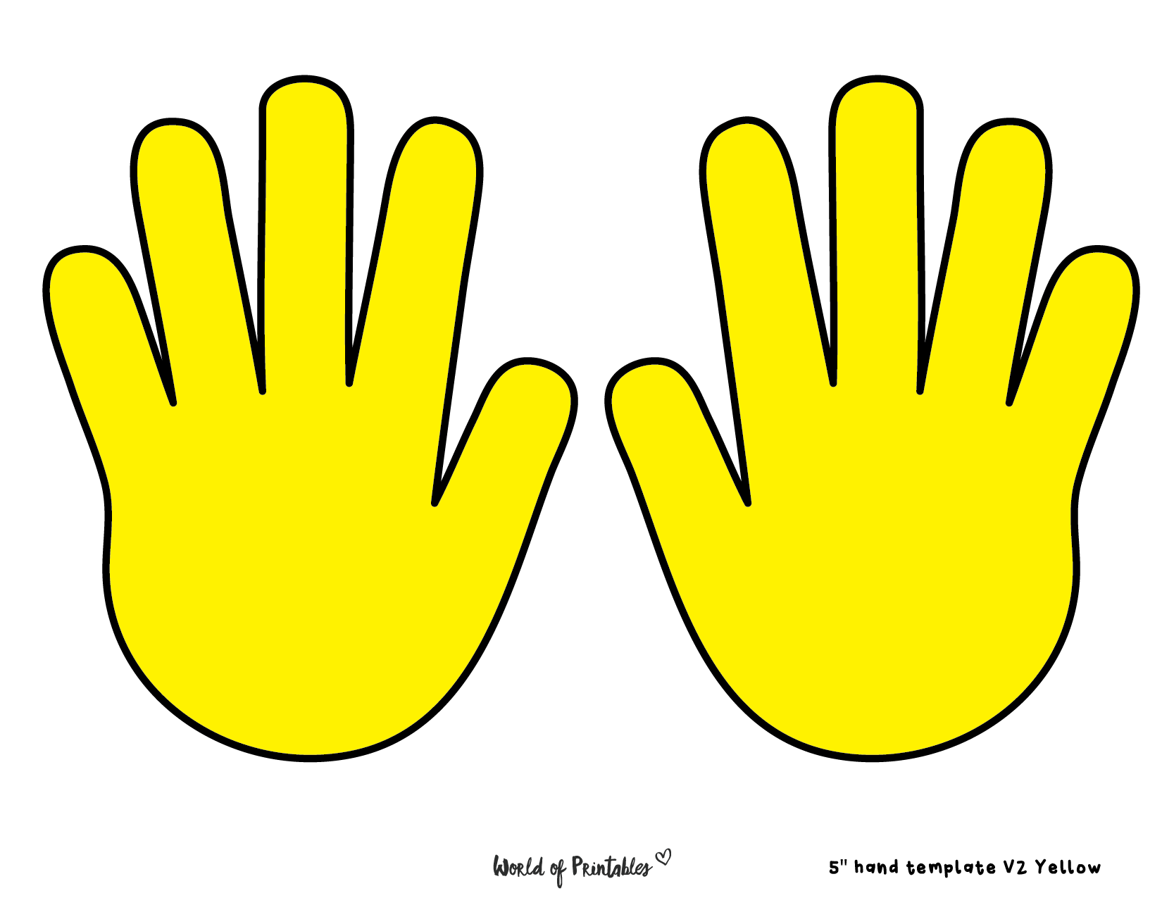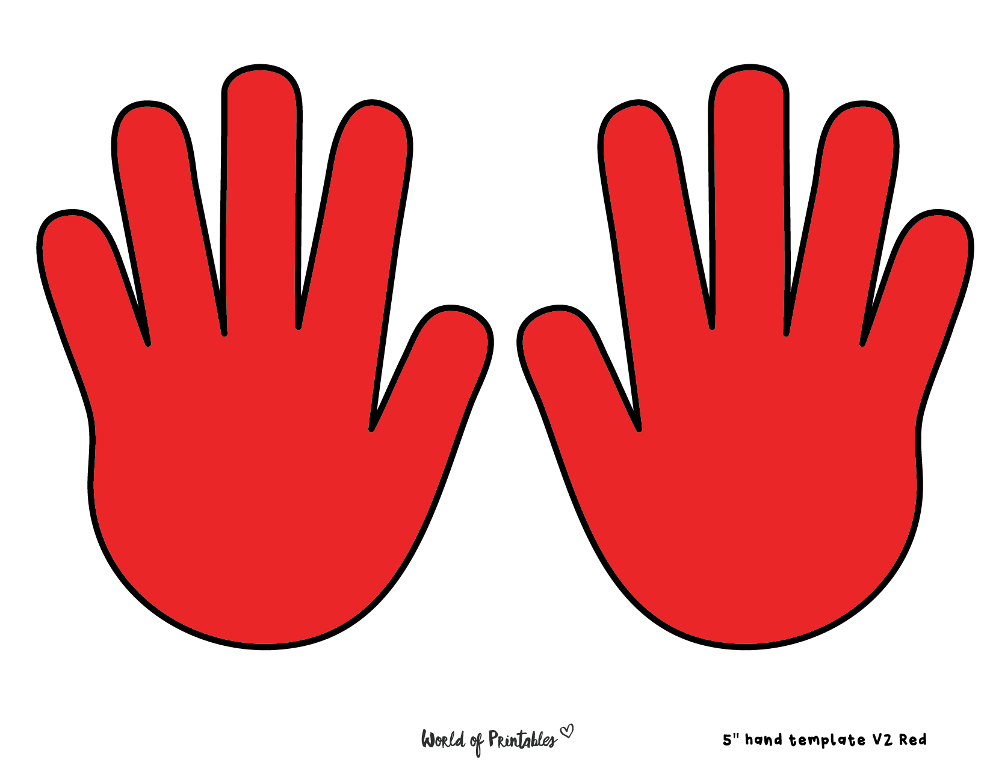

FIRST AID

**LOCATION**

BEHAVIOUR

**LOCATION**