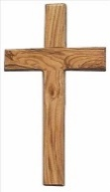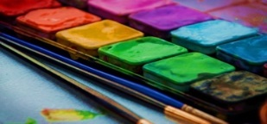

**Science**

**Living Things & States of Matter**

We will look at teeth and the digestive system as well as the properties of solids, liquids and gases.

**ICT**

We will look at recording and

manipulating sounds using

software.

**RE**

* Christmas
* Love and relationships curriculum
* Old Testament - Moses
* Living as followers of Jesus
* Holy Week

**Prayers**

During Year 4 we will continue with our daily prayers (morning, lunch time & end of day prayers) plus we will learn the Magnificat and the Memorare.

**PE**

* Tri Golf & key skills

Children will work on their own skills as well as developing their team work and determination.

**Maths**

* Written methods of multiplying & dividing
* Length (including conversions)
* Fractions
* Decimals

Children will continue to complete weekly times table tests. Please continue to practice times tables at home to support the classroom learning.

**History & Geography**

We will be doing a European Study focussing on Italy. We will be looking at the mountainous regions of Italy and any similarities and differences between here and Italy.

**Art and DT**

We will be carrying out an artist study on Leonardo Da Vinci this term.

**Spring**

**Year 4**

**English**

* Handwriting – children will continue to learn to join their letters.
* We will use the book The Great Chocoplot as our writing stimulus for the first half term.
* We will use non-fiction books for our topic research.
* We will continue to focus on our spelling, punctuation and grammar.