

**Friends of St. Joseph’s**

**September 2024**

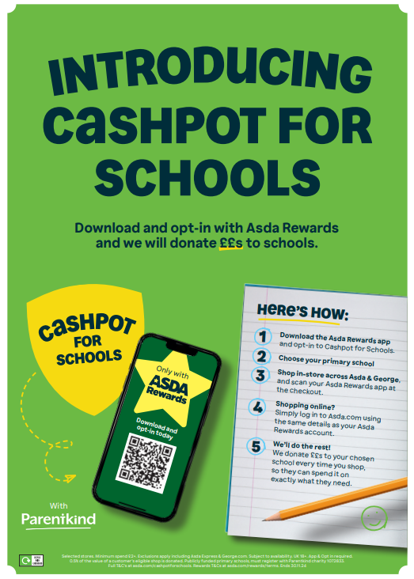

Please help us raise money by shopping at Asda with their ‘Cashpot for Schools’ initiative

– all you have to do is, opt in through the Asda Rewards app, choose St Joseph’s Catholic Primary School WR4 9PG, then shop and scan in store or shop online at Asda.com, between 2nd September and 30th November 2024.

Asda will donate 0.5% of the value of your shop to school. Also, every time somebody opts in, Asda will give an additional £1 to the school Cashpot.

Asda are also giving £50 to every school to get us started.

