Friends Father’s Day Shop June 2022

Gifts for the marvellous men in their lives will be on sale for the children to buy week beginning 13th June.
Gifts are £5 each
The children will choose gifts during the day, safely in line with the school COVID policy.
If you would like your child to buy gifts, please complete the booking form below and return it with the correct money in an envelope clearly marked with
'Friends Father’s Day Shop'.
The children will give their envelope to their class teacher.
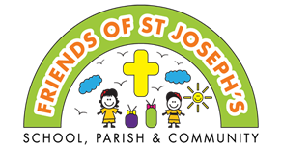
Gifts will need to be pre-booked by Friday 27th May

Thank you for your support.
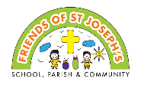
Father’s Day Shop

Child's name: | Class:
Number of gifts £ ______ enclosed

