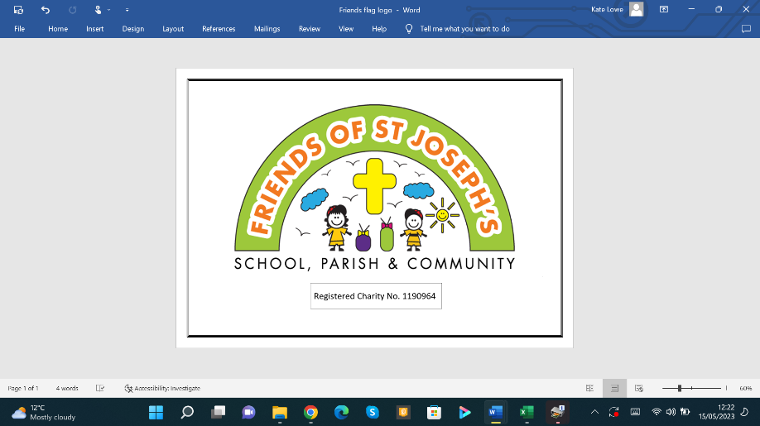
Friends Newsletter
September 2024
Our Autumn Fete is on Saturday 12th October 2024, 12 - 3 pm
A family afternoon with stalls, games, entertainment and food for everyone to enjoy. We hope you will come and support our fundraising. If you are able to help at the fete, please speak to a member of the Friends team.
Fete donations
Please continue to bring in second hand items and prizes for the Autumn fete; Children's toys, games and books, teddies and soft toys, party bag items, bottles of drink, jam jars, gift bags and more. Please leave at the office or give to class teachers. Thank you to those who have already kindly donated. If you need help getting items to school, please contact us.

Wear non-uniform in exchange for donating a bottle day
Friday 27th September
Please donate bottles of wine, beer, cider, fizzy pop etc. for the fete in exchange for wearing your own clothes to school. Please carefully bring to class Friday morning.
Let’s make our bottle tombola the biggest and best yet!
Autumn Raffle
The Autumn Raffle will be drawn at the Fete on Saturday 12th October.
Each ticket is £1, books of 5 tickets will be sent home shortly. Please return counterfoils with name and contact information on and money as soon as possible. If you are able to help sell more tickets, please collect additional books of tickets from the office or Church.
1st prize £100 CASH!
2nd prize Skirmish Paintball Day for 10 people (T&C's apply)
3rd prize Afternoon Tea for two at the Worcester Whitehouse Hotel
And many more …
Foodbank donations
During the week beginning 30th September, we are collecting items for the foodbank so we can fill Mrs Bury’s car with as many items as possible. Such as; pasta, cereal, teabags, toilet roll, etc.
There will be a Mighty Mini competition to guess the number of items at the fete, with a prize for the lucky winner. Please give generously for this amazing cause.

Bake off decorating competition
If your child would like to enter, please bring in on Friday 11th October, clearly labelled with name, class and list of ingredients. Judging will take place during the school day and the winner will be notified and awarded their prize. Flyer to follow.
Cakes donations needed
If you are not entering the competition, we still need your help with lots of lovely homemade or shop-bought cakes, cupcakes or biscuits for the fete sale. Please bring to school on Friday 11th October.
Please label clearly with the ingredients – so we can display possible allergens.
Pumpkin competition
We are asking children to design a pumpkin, either 2D or 3D. Draw, paint or craft a picture, carve or decorate an actual pumpkin or create a pumpkin another way. The more creative the better.
If your child would like to enter, please bring entries in on Friday 11th October, clearly labelled with their name and class. Judging will take place and the winning entries will be displayed at the fete.
Flyer with full information to follow.

WE NEED YOUR HELP!
Our Friends of St Joseph’s fundraising group needs more volunteers!
We would like to run more events for the children but we can’t without your help.
If you think you could help with preparing or helping at events, please get in touch asap.

Our AGM is on Monday 21st October 7:30pm at school
We are looking for people to shadow committee roles in the hope that someone will take over running Friends next school year.
Without volunteers, Friends events will stop!
Please talk to a committee member or email us, we look forward to hearing from you. friendsofstjos@yahoo.co.uk

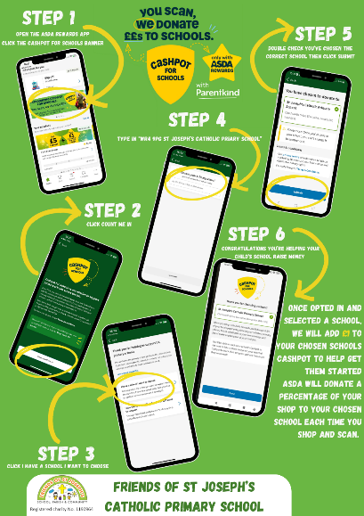
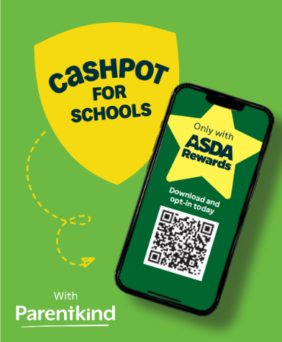
Asda cash for kids
Please help us raise money by shopping at Asda with their ‘Cashpot for Schools’ initiative
All you have to do is, opt in through the Asda Rewards app, choose St Joseph’s Catholic Primary School WR4 9PG, then shop and scan in store or shop online at Asda.com, between 2nd September and 30th November 2024 and they will donate money straight to us. You will also receive your own reward points.
Christmas cards project
Our Christmas card designs have been completed, a copy of your child’s fantastic artwork will be sent home shortly and then you will be able to purchase lots of lovely items online. A percentage of every sale is added to our fundraising pot to support the children at school.
Easyfundraising  | Clothing bin  Having a clear out?  We need your old clothes please!  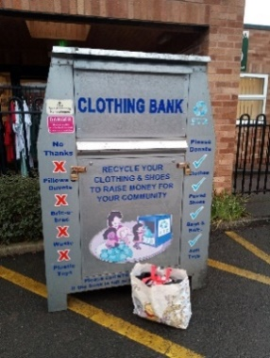  Please remember to put your old clean reusable clothes, shoes (in pairs), handbags, belts and bedsheets, duvet covers, pillow cases into the clothing bin at the front of the school. This really helps to top up our fundraising, so please use them as much as you can.
Thank you Kate Lowe
Chair of Friends of St. Joseph’s committee
Any personal information that you share with Friends is handled confidentially and disposed of securely afterwards.

