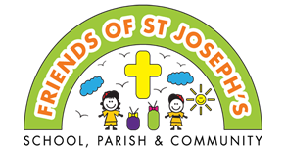
Friends of St. Joseph’s
Summer 2024
WE NEED YOUR HELP!  Our Friends of St Joseph’s fundraising group needs more volunteers! We would like to run after school events for the children but we can’t without your help. If you think you could help with preparing or helping at events, please get in touch asap. Please talk to a committee member or email friendsofstjos@yahoo.co.uk  We look forward to hearing from you.  Friends events this term  Father’s Day sale - 14th June  Sports day refreshments - 18th, 19th, 24th & 26th June  Clothing bin donations - ongoing  Afterschool tuck shop - Friday 28th June  Carnival workshops and parade - July  Non-uniform day – bring a raffle prize - Tues 25th June  Summer raffle tickets on sale Mon 1st July-Mon 8th July  Summer raffle draw - Wed 10th July  Reception picnic - 12th July  Year 6 leavers party - July  Easyfundraising shopping app - ongoing  Preparation for Fete on Saturday 12th October |  | Non-Uniform Day – Bring a Raffle Prize  Tuesday 25th June  We invite you to come to school dressed in non-uniform in exchange for a donation for our raffle hamper prizes.  There will be a GOLD, SILVER & BRONZE winner for each year group.  We would like to link prizes to the Olympics, Euros and summer time, so are suggesting donations of games, toys, balls, flags, foods, sweets, chocolates, crafts that keep the kids entertained during the summer… the possibilities are endless. Thank you in advance for your donations.  Please ensure all food and drink items have long best before dates and are unopened.
Friends of St. Joseph’s
Summer 2024
Summer Raffle  Tickets on sale between Monday 1st July – Monday 8th July via class teachers and at the school gates.  £1 per strip  Please send in correct money in a named envelope clearly marked with  ‘Friends Summer Raffle’.  We will ensure tickets are added to the draw and a record of sale kept.  The raffle will be drawn on Wednesday 10th July.  Prizes will be sent home with the lucky winners to enjoy.  Please retain this ticket information in line with licencing laws.  Promoter: Friends of St. Joseph’s Catholic Primary School. Registered charity No. 1190964  Kate Lowe, St. Joseph’s Catholic Primary School, Chedworth Drive, Worcester WR4 9PG  Draw: Wednesday 10th July 2024 | Thank you for your generosity and continued support with Friends events. Easy ways to support Friends of St. Joseph’s fundraising; raising money to purchase extra things for our children at school.  Clothing Bank  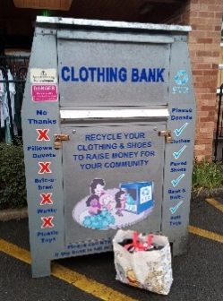  Having a clear out?  We need your old clothes please!  Please remember to put your old clean reusable clothes, shoes (in pairs), handbags, belts and bedsheets, duvet covers into the clothing bin at the front of the school.  This really helps to top up our fundraising, so please use them as much as you can.  Our next meeting is on Wednesday 26th June 6:30pm  We are always keen to hear from new volunteers, please email friendsofstjos@yahoo.co.uk

