

St Joseph’s Catholic Primary School, Worcester

‘Following Jesus in all we do’

Mathematics Vocabulary Progression

Maths Co-ordinator

Miss L Malpass

St Joseph’s Catholic Primary School,

Chedworth Drive

Warndon

Worcester

WR4 9PG

Telephone: 01905 452772

Date: May 2025

Review Date: May 2026

Progression in Maths vocabulary for the new National Curriculum

Maths vocabulary for EYFS

Number and place value | Addition and subtraction
Number | Number bonds, number line
Zero, one, two, three to twenty, | Add, more, plus, make, sum,
and beyond | total, altogether
None | Inverse
Count (on/up/to/from/down) | Double
Before, after | Half
More, less, least, greater | Subtract, take away, minus
Ones, tens
Numeral



Measure


Full, half full, empty

Holds

Container

Weigh, weighs, balances

Heavy, heavier, heaviest, light, lighter, lightest

Time

Days of the week: Monday, Tuesday, etc.

Seasons

Day, weekend

Morning, afternoon

Bedtime, dinnertime, playtime

Today, yesterday, tomorrow

Next, last

Hour, o'clock, half past

How long will it take to…?

Once, twice

First, second, third, etc.

Estimate, close to, about the same as, just over, just under Too many, too few, not enough, enough Length, width, height
Long, longer, longest, short, shorter shortest, tall, taller, tallest, high, higher, highest

Money, coin, penny, pence, pound, price, cost, pay

How much? How many?

Total

Geometry (position and Geometry (properties of


direction) shape)

Position Group, sort

Over, under, underneath, Cube, cuboid, pyramid,

above, below, top, bottom, sphere, cone, cylinder, circle,

side triangle, square

on, in, outside, inside Shape

around, in front, behind Flat, curved, straight, round

Front, back Solid

Before, after Corner (point, pointed)

Beside, next to, Side, edge

Between, middle,

Corner

Fractions General/problem solving


Whole Listen, join in

One half, two Start from, start with, start at

halves

Look at

Put

Arrange

Find, choose, collect, use, make, build

Count, work out

number line, number cards

Counters, cubes, dice, dominoes

Maths vocabulary for year 1


Number and place value

Zero, one, two, three to twenty, and beyond

many, few, fewer, fewest, smallest, lesser

Equal to, the same as

Odd, even

Pair

Ten more/less

Digit

Figure(s)

Compare

(In) order/a different order

Size

Value

Between, halfway between

Above, below

Addition and subtraction


Near double

Halve

Equals, is the same as (including equals sign)

Difference between

How many more to make..? How many more is…than..? How much more is..?

How many fewer is…than..? How much less is..?
Multiplication and division

Odd, even

Count in twos, threes, fives

Count in tens (forwards from/backwards from)

How many times?

Lots of, groups of

Once, twice, three times, five times

Multiple of, times, multiply,

Repeated addition

Double, halve

Share, share equally

Group in pairs, threes, etc.

Equal groups of

Divide, left, left over

Measure


Scales

Spring, summer, autumn, winter

Week, month, year

Birthday, holiday

Evening, night, midnight

Before, after

Now, soon, early, late

Quick, quicker, quickest, quickly , fast, faster, fastest, slow, slower, slowest, slowly

Old, older, oldest, new, newer, newest

Takes longer, takes less time

Clock, watch, hands

How long ago? How long will it be to…?

How often?

Always, never, often, sometimes, usually

Low, wide, narrow, deep, thick, thin

Far, near, close

Metre, ruler, metre stick

Buy, sell, spend, spent, change, dear(er), costs more, costs less, cheaper, costs the same as
Geometry (position and Geometry (properties


direction) of shape)

Opposite Hollow

Apart Corner (point, pointed)

Edge, centre Face

Direction Make, build, draw

Journey

Left, right, up, down, forwards,

backwards, sideways

Across

Close, far, near

Along, through

To, from, towards, away from

Movement

Slide, roll, turn, whole turn,

half turn

Stretch, bend

Fractions


Equal parts, four equal parts

A quarter, two quarters

General/problem solving


Say, think, imagine, remember

Point to

Place, fit

Rearrange

Change, change over

Split, separate

Carry on, continue, repeat & what comes next?

Tell me, describe, pick out, talk about, explain, show me

Read, write, record, trace, copy, complete, finish, end

Fill in, shade, colour, tick, cross, draw, draw a line between, join (up), ring, arrow

Cost

Answer, check same number(s)/different number(s)/missing number(s)

Number facts, number track, number square,

Abacus, blocks, rods, die, pegs, peg board

Same way, different way, best way, another way

In order, in a different order

Not all, every, each

Maths vocabulary for year 2

 | Addition, Subtraction, |  | Geometry (position and
Number and place value | Multiplication and | Measure | Geometry (position and | Geometry (properties of shape) | Fractions | Data/statistics | General/problem solving
Number and place value | Multiplication and | Measure | direction)
 | Division |  | direction)
Numbers to one hundred | Array, row, column | Quarter past/to | Rotation | Size | Three quarters, one third, a | Count, tally, sort | Predict, prove
 |  |  |  |  | third
Hundreds | Multiply by | m/km, g/kg, ml/l | Clockwise, anticlockwise | Bigger, larger, smaller |  | Vote | Describe the pattern, describe the
 |  |  |  |  | Equivalence, equivalent |  | rule
Partition, recombine | Divided by | Temperature | Straight line | Symmetrical, line of symmetry |  | Graph, block graph, pictogram,
 |  | (degrees C) |  |  |  |  | Find, find all, find different
 |  |  | Ninety degree turn, right
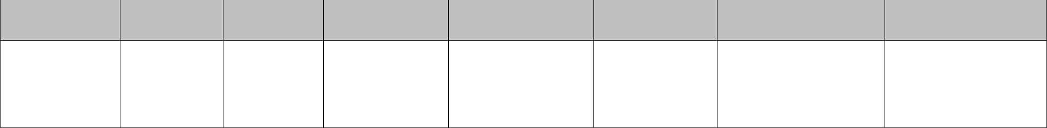

Hundred more/less Inverse angle Fold Represent Investigate

Match Group, set, list, table

Mirror line, reflection Label, title

Pattern, repeating pattern Most popular, most common, least

popular, least common

Maths vocabulary for year 3

Number and place value | Addition and | Multiplication and | Measure | Geometry (position and direction)
Number and place value | subtraction | division | Measure | Geometry (position and direction)
Numbers to one | Column addition and | Product | Leap year | Greater/less than ninety degrees
thousand | subtraction | Multiples of four, eight, | Twelve-hour/twenty-four- | Orientation (same orientation,
 |  | fifty and one hundred | hour clock | different orientation)
 |  |  | Roman numerals I to XIII
 |  |  |  | Perimeter and area


Geometry (properties of shape)


Horizontal, perpendicular and parallel lines

Quadrilaterals

Triangles

Fractions | Data/statistics
Numerator, denominator | Chart, bar chart, frequency table,
Unit fraction, non-unit fraction | Carroll diagram, Venn diagram
Unit fraction, non-unit fraction | Axis, axes
Compare and order | Axis, axes
Compare and order | Diagram
Fifth, two fifths, four fifths, | Diagram
tenths
Equivalent

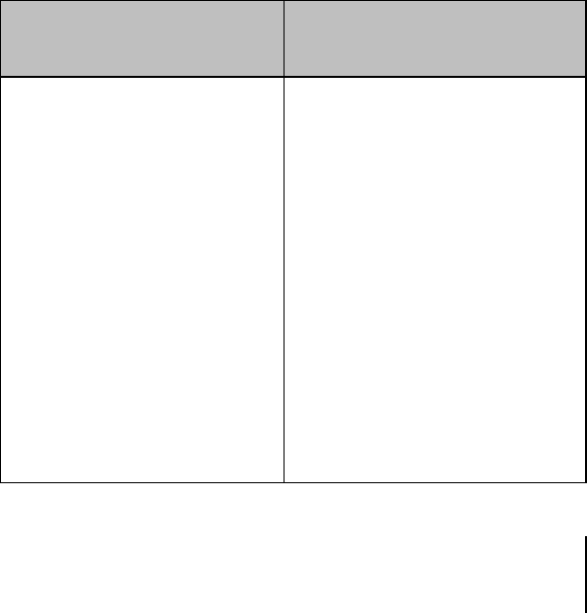

New maths vocabulary for year 4

Number and place value

Tenths, hundredths
Decimal (places) Round (to nearest) Thousand more/less than Negative integers Count through zero Roman numerals (I to C)

Multiplication and division | Measure
Multiplication facts (up to 12x12) | Convert
Division facts
Inverse
Derive


Geometry (position and direction)

Coordinates

Translation

Quadrant

X-axis

Y-axis

Perimeter and area

Geometry (properties of shape)

Quadrilaterals

Triangles

Right angle, acute and obtuse angles

Fractions and decimals Data/statistics

Equivalent decimals and fractions Continuous data

Line graph

New maths vocabulary for year 5

Number and place value | Addition and subtraction | Multiplication and division | Measure | Geometry (position and | Geometry (properties of shape) | Fractions, decimals and percentages
 |  |  |  | direction) | Geometry (properties of shape) | Fractions, decimals and percentages
Powers of 10 | Efficient written method | Factor pairs | Volume | Reflex angle | Regular and irregular | Proper fractions, improper fractions, mixed
 |  | Composite numbers, prime number, | Imperial units, metric units | Dimensions | Polygons | numbers
 |  | prime factors, square number, |  |  |  | Percentage
 |  | cubed number |  |  |  | Ratio, proportion
 |  | Formal written method |  |  |  | Ratio, proportion

New maths vocabulary for year 6

Number and place value | Addition and subtraction | Multiplication and | Geometry (position and | Geometry (properties | Fractions, decimals and | Algebra | Data/statistics
Number and place value | Addition and subtraction | division | direction) | of shape) | percentages | Algebra | Data/statistics
Numbers to ten million | Order of operations | Order of operations | Four quadrants (for | Vertically opposite | Degree of accuracy | Linear number sequence | Mean
 |  | Common factors, | coordinates) | (angles) | Simplify | Substitute | Pie chart
 |  | common multiples |  | Circumference, radius,
 |  |  |  | diameter |  | Variables | Construct
 |  |  |  |  |  | Symbol
 |  |  |  |  |  | Known values


