St Joseph’s Catholic Primary School, Worcester
‘Following Jesus in all we do’

Forest School Policy

St Joseph’s Catholic Primary School,
Chedworth Drive,
Warndon,
Worcester
WR4 9PG

Telephone: 01905 452772
Email: office@st-josephs-pri.worcs.sch.uk
Date April 2024

‘Let then look at the mountains and the stars up above. Let them look at the beauty of the waters and the trees and flowers on earth. They will then begin to think, and to think is the beginning of a real education.’
David Polis

Forest School is based fundamentally on the Woodland Warriors idea, which is based on respect for children and young people and for their capacity to instigate, test and maintain curiosity in the world around them. It believes in the child’s right to play and learn; the right to access the outdoors (and in particular a woodland environment); the right to access risk and the vibrant reality of the natural world and the right to experience a healthy range of emotions through all the challenges of social interaction, in order to build a resilience that will enable continued and creative engagement with their peers and their potential. It is an approach to education that makes use of the outdoor environment to create a unique learning experience.

Forest School sessions provide increasingly diverse opportunities for children to benefit from an outdoor curriculum that can help children build positive values and attitudes about themselves, about learning and the environment in which they live. Children are given appropriate, challenging and achievable tasks that build their confidence, skills, knowledge and independence.

At St Joseph’s we have 2 outdoor learning sites: Woodland Warriors and Little Leaves.

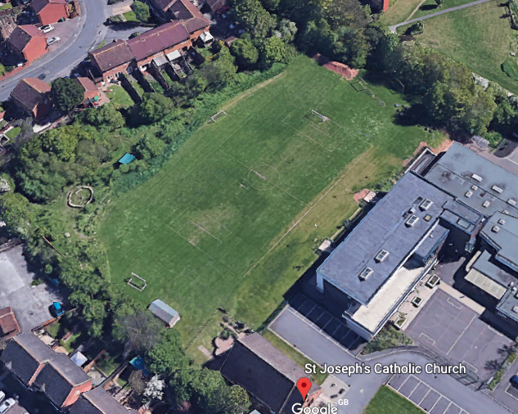
Woodland Warriors site

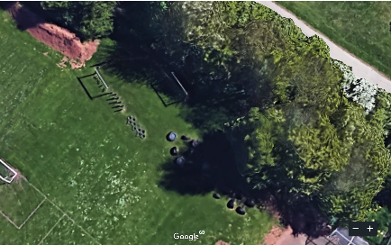
Little Leaves site

Risk Management

The aim of outdoor learning at St Joseph’s is to develop children’s self-esteem, independence and motivation to learn in a safe environment. In order that these aims can be met, the Woodland Warriors Leader will:
Consistently apply the three-step approach to risk assessment for all outdoor learning activities:
- Look for hazards.
- Decide who may be harmed and how.
- Evaluate the risks and decide whether existing controls are adequate or whether more should be done before continuing.

A pre-visit check to be carried out by the Outdoor Learning Leader (teacher) or the Supervising Adult (SA) on site to be used prior to a day’s activity, as near to the start of the activity as is reasonably practical.

Minimum of 2 adults needed for any outdoor learning in Woodland Warriors or Little Leaves site.

Cancel activities if weather conditions such as high winds or the threat/occurrence of electrical storms make work outdoors unsafe.
Inform staff, volunteers and children of potential hazards and methods of working in order to minimize their risk further.
Involve staff, volunteers and children in risk assessment, as appropriate, as part of learning.
Ensure that all staff, volunteers and children are aware of the emergency procedures for the Woodland Warriors site (detailed below).
Be responsible for teaching children adequate skills in order to keep themselves safe.
Ensure a nil-by-mouth policy is adopted in all outdoor learning sessions.

First Aid

Outdoor learning Leaders shall take a 1st aid bag out to the outdoor learning site with them. Staff shall follow the school 1st aid policy and procedure should an accident occur; this may involve a trained 1st aider being called to assist.

Accident and Emergency Procedure

All staff, volunteers and participants will be briefed on what to do in case of an emergency:

- A whistle will be blown as a signal to stop what you are doing
- Gather with a member of staff
- Be silent and wait for instructions.

The Leaders will assess the situation, the nature and extent of the injury/accident. They will ensure that the rest of the group are safe from danger and are adequately supervised. They will attend to any casualties, giving First Aid as necessary if this is the incident. An Accident Form will be completed later at the School Office. A RIDDOR record will be created, along with an Accident Report for any serious injury, seven-day injury or death.

Dangerous Occurrence:
A RIDDOR record will be created, along with an Incident Report for any serious near-miss incident at or in the vicinity of the Woodland Warriors Site.

Toileting Procedure
Before a Woodland Warriors session, children will be given the opportunity to go to the toilet. During a Woodland Warriors session, children needing the toilet will be escorted back to school by a member of staff where possible or the adult will watch them leave the site and the school field safely.

Maintenance of site
The Woodland Warriors site maintenance is managed by ‘Smart Cuts’ ground maintenance and landscape company under the direction of the school Site Manager.

Equal Opportunities

St Joseph’s actively promotes the inclusion of all children and adults into sessions and will endeavour to ensure that the opportunities for learning, development and participation are available to everyone, irrespective of race, gender, ability, religion, sexual orientation or age. St Joseph’s Woodland Warriors will follow the school’s Special Educational Needs and Inclusion Policy.

Daily Operating Procedure

Before the Session
Teachers will complete a medium-term plan for outdoor learning sessions in Woodland Warriors or Little Leaves (this does not apply for one off sessions).
- The Outdoor Learning Leader will check the site before the lesson using the checklist provided. The session will only go ahead if the checklist has been satisfied.
- The Leader will ensure that enough adults are present for the session to go ahead (minimum of 2 adults) and that the weather conditions allow it to take place.
- The Leader will take a whistle to the site to use to gather the class when needed.
- The Woodland Warriors Base Camp area will be set up with seating if required.
- The equipment required for the session will be assembled, checked and taken to the Woodland Warriors site if needed.
- Children will go to the toilet before heading to the site and will put on wellies if needed or apply sun cream, where necessary.

During the Session
- A headcount check will be undertaken on arrival at the site and whenever the group is brought together.
- Risks will be continually assessed and appropriate action taken to reduce or remove any risks found.

After the Session
- A headcount check will be undertaken at the end of the session, before returning to the school building.
- If the Tool Bag and/or Tool Box have been taken to the site, the contents will be checked by an adult to ensure no items are missing.

SCHOOL FIRE ALARM

If the school fire alarm sounds during a session the following will apply:

All children and adults will walk across the field and down the steps to the fire assembly points, where children will line up at the correct place for their year group. All adults will report to the designated fire officer.

Lost Children procedure
The St Joseph’s Woodland Warriors site is within the grounds of the school. Should a child be discovered to be missing the following procedure will be followed:

- Assemble rest of children and ensure they are safe
- As soon as a child is found to be missing, make an immediate search of the vicinity.
- Check toilets and search both Key Stage One and Two buildings
- Alert Office and Senior leadership Team.
- Follow School’s Critical incident procedure

