"Therefore, if anyone is in Christ, the new creation has come: The old has gone, the new is here!"
2 Corinthians 5:17
18th September 2023

Dear parents,

We would like to update you on the arrangements for Breakfast care for school and pre-school children.

The new earlier time of 7:30am will begin on Monday 25th September at a new cost of £3.00 per child. Pre-school costs will remain at £4.00 due to ratio and staffing needs.

Breakfast will be served at 8:00am.

If you would like to access the provision, please use the Parent Mail system in advance where possible. For pre-school contact Mrs Cree.

If you would like to pay cash on the door, then it is extremely important that it is in a named envelope stating clearly the child’s name, dates of attendance for the week and contains the correct money as no change can be given.

Children are to be dropped off at the kitchen door as normal and must be signed in by a parent at all times. Children do not sign in themselves. In exceptional circumstances, permission may be granted for an Upper Key stage 2 child to sign themselves in. This must be agreed with the school as part of safeguarding procedures. Please see the attached form which must be completed and handed in to the school office or to a member of breakfast club staff. All forms will be kept for our records.

Any questions, please email the office.

Yours in faith and partnership
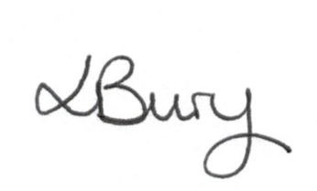
Mrs Louise Bury
Headteacher

Permission Form for Breakfast club
I give permission for my child …............................................................in class …............ to arrive at Breakfast club alone and sign themselves in due to the following circumstances:
….......................................................................................................................................................................................................................................................................................................................
Signed.....................................
Date.........................................

