**St Joseph’s**

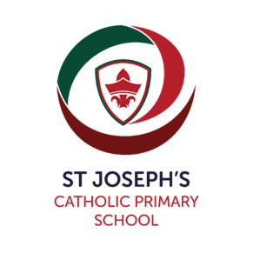

Pre-School Place Request

Telephone 01905 452772

Pre-School for Children Aged 2 to 4 years.

Admissions Criteria:

1/ Baptised Catholic children (see Note 1 below) who have a brother or sister (see Note 2 below) attending St. Joseph’s Catholic Primary School at the time of admission.

2/ Baptised Catholic children (see Note 1 below).

3/ Non-Catholic children who have a brother or sister (see Note 2 below) attending St. Joseph’s Catholic Primary School at the time of admission.

4/ Non-Catholic children.

Priority will be given in order of application to those requesting 15 hours or 30 hours funding per week.

Midday sessions can only be booked if your child is staying all day 8.45am to 3.15pm and priority will be offered to those booking full time (five days per week).

A minimum of 3 x sessions per week is required.

**Note 1**

For a child to be considered as Catholic, evidence of Catholic Baptism will be required. For a definition of a Baptised Catholic, see Pre-School Admissions Policy. Those who face difficulties in producing written evidence of Catholic Baptism should contact their Parish Priest.

Parents making an application for a Catholic child should provide a copy of the Baptism certificate, attached to the application request. If you do not provide the information, this is likely to affect your child’s chance of being offered a place at this Pre-School.

**Note 2**

For all applicants the definition of a brother or sister is:

* A brother or sister sharing the same parents
* A half-brother or half-sister, where two children share one common parent
* A step-brother or step-sister, where two children are related by a parents’ marriage or where they are unrelated but their parents are living as partners.
* Adopted or fostered children

The children must be living permanently in the same household.

Parents will be notified by letter, the term before the child is due to start, informing them if they have been successful in securing a place.

Oversubscription Criteria:

If there is over-subscription, then children will be put on to a waiting list, following the admissions criteria.

**St Joseph’s**

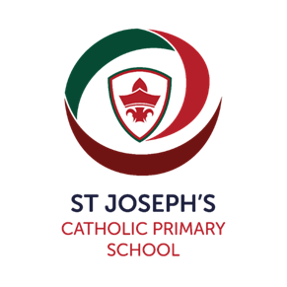  


Pre-School Place Request

Telephone 01905 452772

Child’s Full Name: ……………………………………………………………………….

Date of Birth: ……………………………………..

|  |  |  |
| --- | --- | --- |
| Title:  (Parent/Carer) |  | |
| Name: |  | |
| Address: |  | |
| Post Code |  | |
| Email address in CAPITAL LETTES: |  | |
| Mobile telephone number: |  | |
|  |  | |
| Is the above named child a Baptised Catholic? | YES | NO |
| Does the above named child have a brother or sister attending St. Joseph’s Catholic Primary School at the time of admission into Pre-School? | YES | NO |
| Name and Year: |  |

Please indicate which term and year you would like your child to start preschool:

|  |  |  |
| --- | --- | --- |
| September  Year………… | January  Year………… | April  Year………… |

Early Years Government Funding**.**

|  |  |  |  |  |
| --- | --- | --- | --- | --- |
| My Child is not Funded. | 2 Year Funded Child  15 Hours | 2 Year Funded Child  30 Hours | 3 and 4 Year Funded Child  15 Hours | 3 and 4 Year Funded Child  30 Hours |
|  |  |  |  |  |

**Wraparound Care** – St Joseph’s School offers Wraparound care for children from 3 years old – 11 years, Breakfast Club from 7.30am and After School Club to 6pm

Please indicate below Sessions/Days required.

Please note midday sessions can **only** be booked for those children staying all day, (you will need to provide a healthy lunch box)

|  |  |  |  |
| --- | --- | --- | --- |
| Days | Morning Session  8.45am – 11.45am | Midday Session  11.45am – 12.15pm  Only available for full days | Afternoon Session  12.15pm – 3.15pm |
| Two Year Olds | £20.50 or  **3 hours free funding** | £4.00 or  **30 minutes free funding** | £20.50. or  **3 hours free funding** |
| Three and four Year Olds | £16.50 or  **3 hours free funding** | £4.00 or  **30 minutes free funding** | £16.50 or  **3 hours free funding** |
| Monday |  |  |  |
| Tuesday |  |  |  |
| Wednesday |  |  |  |
| Thursday |  |  |  |
| Friday |  |  |  |

**Tick below**

|  |  |
| --- | --- |
| I have attached a copy of my child’s birth certificate |  |
| I have attached a copy of my child’s Catholic Baptism certificate |  |

**PRINT NAME:** ………………………………………………………………………………………………………………………

**PARENT SIGNATURE:** ……………………………………………………… **DATE**: ………………………………..