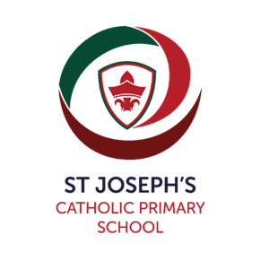**Pre School Places for 2 – 4 year olds**

**for September 2025 and January and April 2026**.

We welcome children and families from all faiths and with no faith. We offer flexible free funded places across our sessions.

**St Joseph’s Pre-School**

**Open Morning**

**Wednesday 12th March 2025**

**from 9am to 11am**

Come and look around our Acorn Room for two-year-old children and our Oak Room for three and four-year-old children.

We offer session from 8.45am to 3.15pm term time only, we also have a breakfast club.

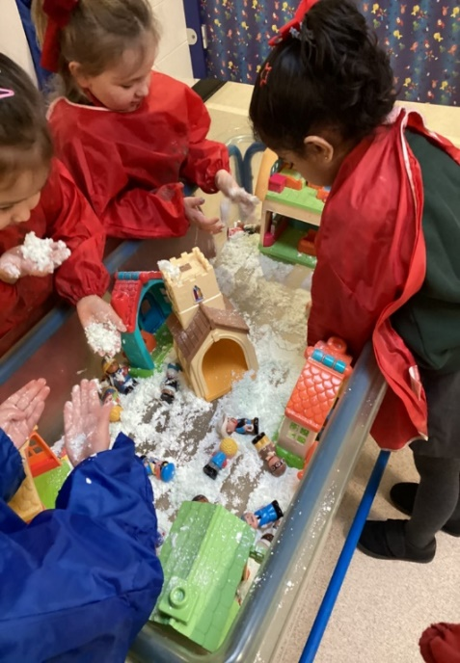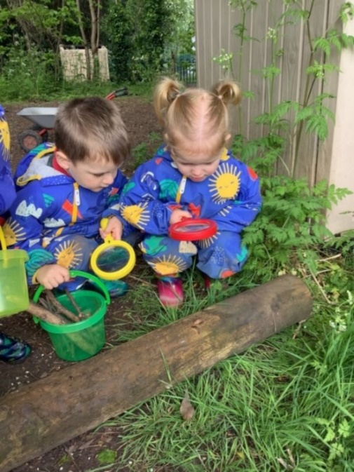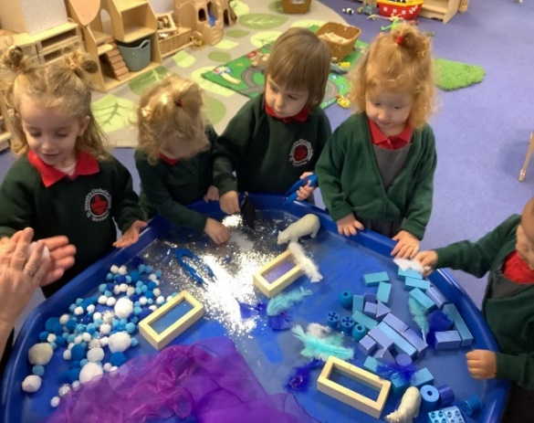

For further information contacts us on 01905 452 772 or email the office

St Joseph’s Catholic Primary and Preschool, Chedworth Drive, Worcester, WR4 9PG

**One of the top ten schools in Worcester!!**