St Joseph’s Catholic Primary School, Worcester

‘Following Jesus in all we do’

Science Policy

At St Joseph’s we provide a safe and healthy environment, in which children are encouraged to develop their interest and curiosity about the world around them. The Science curriculum provides the foundations for understanding the world and promotes respect for the living and non-living. At St Joseph’s our aim is for all children to leave the school as enthusiastic, confident and curious scientists. Children will have a secure understanding of the scientific skills and knowledge taught through the curriculum. Additionally, science will play a role in the broader curriculum of the school in developing additional key skills such as collaboration and perseverance.

Equal Opportunities and Inclusion

At St Joseph’s, we are committed to providing all children with an equal entitlement to scientific activities and opportunities. In school, we aim to meet the needs of all our children by adopting an adaptive teaching approach. Children will have opportunities to develop their scientific knowledge as well as their skills for working scientifically, and adaptations will be put in place where necessary to support any barriers that are identified. For those children who are identified as having strong subject knowledge and use of scientific skills, challenges will be provided to stretch and deepen their learning.

Curriculum

Our Science Policy follows The National Curriculum for Science Guidelines.
- Early Years - ‘Early Learning Goals’ (DFE 2024)
- KS1 and KS2. - National Curriculum Programme of Study for Science. (DFE 2023)

Our Science Policy aims to ensure that all pupils:

- Develop through practical work the skills of observation, prediction, investigation, interpretation, communication, questioning and hypothesizing, and can use precise measurement skills.
- Effectively communicate scientific ideas by using scientific vocabulary confidently.
- Appreciate that we do not always know the answer and results when carrying out scientific enquiry and are excited by the unknown!
- Are encouraged to offer their own suggestions, be creative in their approach to science, and build on their enthusiasm and natural sense of wonder about the world.
- Develop an understanding of how to treat the living and non-living environment with respect and sensitivity. This is supported through structures such as Little Leaves, Forest School and the use of our Marian Garden.
- Understand personal and group safety by using resources correctly.

Planning
The science curriculum is planned out in a way that ensures coverage of the National Curriculum objectives but also provides children opportunities to embed their learning and make connections cross-curricula as well as with wider concepts. There are opportunities for children to visit places of scientific interest during school trips e.g. the Bishops Wood Centre, local farms, the Birmingham Thinktank, and Sealife. When relevant, visitors will be invited into our school to support the learning objectives for specific units of science.

Science Progression Map

​ | Autumn 1 ​ | Autumn 2 ​ | Spring 1​ | Spring 2 ​ | Summer 1​ | Summer 2​
Year 1 ​ | Materials ​ | Materials ​ | Plants ​ | Animals (including humans) | Human body ​ | Weather and seasonal  change ​
Year 2 ​ | Living things and their habitats​ | Living things and their habitats​ | Plants ​ | Everyday material ​ | Animal including  humans ​ | Animal including  humans ​
Year 3 ​ | Light and dark​ | Forces & Magnets ​ | Rocks and soil​ | Plants ​ | Animals including  humans​ | Animals including  humans​
Year 4 ​ | Electricity ​ | Sound ​ | Animals Including  humans ​ | States of matter​  (water cycle)​ | States of matter​  (water cycle)​  ​ | Living things and their  habitats​
Year 5 ​ | Forces ​ | Earth and Space ​ | Properties and changes of materials  (Materials and their properties) | Properties and changes of materials | Living things and their Habitats | Animals, including Humans
Year 6 ​ | Animals and living humans ​  (Healthy bodies) | Evolution  and Inheritance ​ | Living things and their habitats ​  (Classifying organisms?) | Electricity ​  A unit behind? | Light​ | Only 5 units ​  (recapping time)​

The EYFS framework is structured very differently to the national curriculum as it is organised across seven areas of learning rather than subject areas. The aim of this document is to help subject leaders to understand how the skills taught across EYFS feed into national curriculum subjects.
This document demonstrates which statements from the 2020 Development Matters are prerequisite skills for science within the national curriculum. The table below outlines the most relevant statements taken from the Early Learning Goals in the EYFS statutory framework and the Development Matters age ranges for Three and Four-Year-Olds and Reception to match the programme of study for science.
The most relevant statements for science are taken from the following areas of learning:
- Communication and Language
- Personal, Social and Emotional Development
- Understanding the World
Science
Three and Four-Year-Olds | Communication and Language | Understand ‘why’ questions, like: “Why do you think the caterpillar got so fat?”
 | Personal, Social and Emotional Development | Make healthy choices about food, drink, activity and toothbrushing.
 | Understanding the World | Use all their senses in hands-on exploration of natural materials.  Explore collections of materials with similar and/or different properties.  Talk about what they see, using a wide vocabulary.  Begin to make sense of their own life-story and family’s history.  Explore how things work.  Plant seeds and care for growing plants.  Understand the key features of the life cycle of a plant and an animal.  Begin to understand the need to respect and care for the natural environment and all living things.  Explore and talk about different forces they can feel.  Talk about the differences between materials and changes they notice.
Reception | Communication and Language | Learn new vocabulary.  Ask questions to find out more and to check what has been  said to them.  Articulate their ideas and thoughts in well-formed sentences.  Describe events in some detail.  Use talk to help work out problems and organise thinking and activities, and to explain how things work and why they might happen.  Use new vocabulary in different contexts.

Knowledge Organisers
For each Science topic, children have a unit cover which includes the national curriculum aims for teachers to assess against, as well as knowledge Organisers. These provide the children with key vocabulary related to the topic, diagrams, facts, and definitions that will be related to a part of their learning. Children are encouraged to use these to support themselves in their learning. Knowledge Organisers also allow teachers to see the objectives that need to be met within a topic and use these to indicate whether and to what level a child has accomplished this.

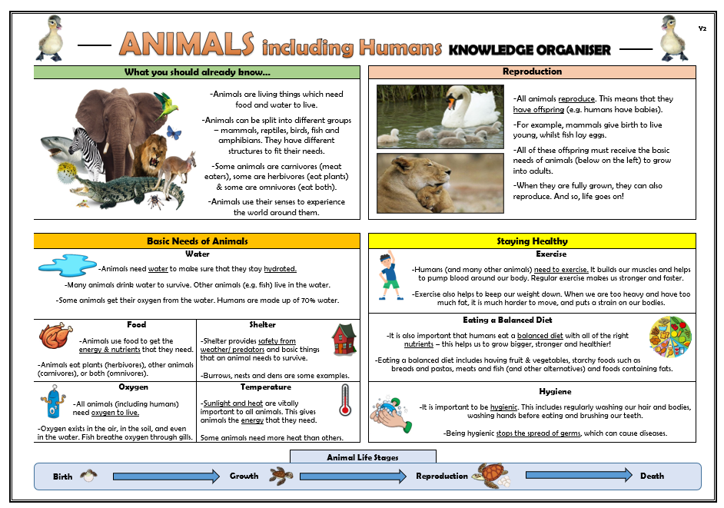

Assessment and Marking

Assessment is conducted in a variety of forms within science. Marking individual lessons allows teachers to interpret children’s understanding before moving on, as well as addressing misconceptions. The pupil’s learning is marked in accordance with the school’s marking policy. As well as this, at the start of a lesson, prior learning mini quizzes are conducted to review children’s retention of prior learning.
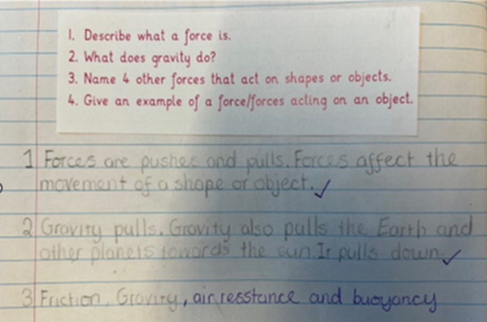
It is the role of teachers to conduct these assessments and record them accordingly. It is the role of the subject leader to monitor this assessment.
Assessment in Early Years is ongoing and uses the Early Learning Goals.
Progression and attainment Progress and attainment are reported to parents through parents’ evenings and end-of-year reports. Reports describe each child’s attitude towards science, progress in scientific inquiry and understanding of the content of science.

Health and Safety
The safe use of science equipment and materials is upheld at all times. Teachers consider the school’s Health and Safety policy at all times. Teachers are also aware of the allergies/needs of individual pupils when planning a science investigation or experiment.

ROLE OF THE SUBJECT LEADERS
- To undertake the monitoring of standards in science and use this to inform the yearly science action plan.
- Provide leadership and management of their subject to ensure high quality teaching and learning throughout the school.
- Develop and review the science policy.
- To liaise with outside agencies and attend subject-specific courses.
- To report to the Head Teacher and Governing Body on science related issues.
- To audit, organise and purchase science resources in accordance with the available budget.
- To provide CPD when necessary.

