Year 4 Homework
Pick 1 activity to complete each week.
Complete 15 minutes on Times Table Rock Stars each week
We are being curious and active this half term. |  | Write instructions about how to look after your teeth. Include a labelled diagram of the different sort of teeth we have.  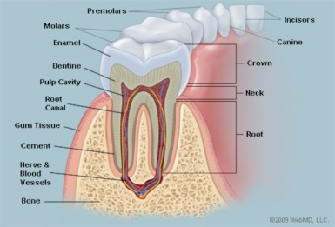
Research a rainforest, such as the Amazon. Present your research in an interesting way.  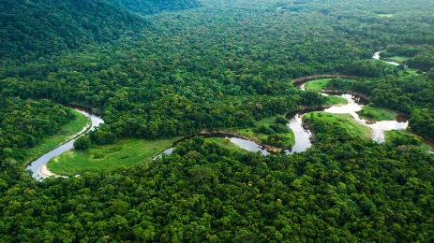 | For PE we need to think about the different muscle groups in our bodies that we use. Draw a person and label the major muscles in the body.  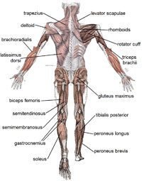 | Create a 3D model to explain the different features of a mountain.  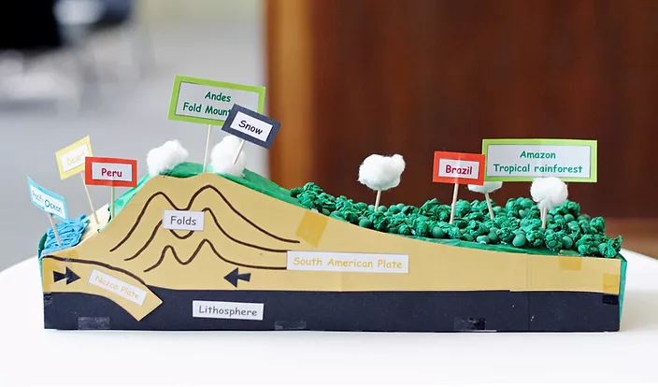
Hand in Dates:  Thursday 13th January  Thursday 20th January  Thursday 27th January  Thursday 3rd February  Thursday 10th February |  | Find and collect images of mountains, mountain ranges and their surrounding features for your Art sketchbook. Create a collage of images on an A4 sheet that you can stick into your sketchbook.

