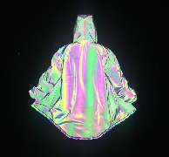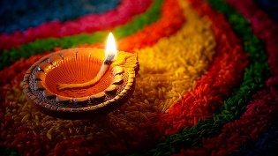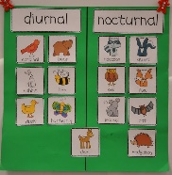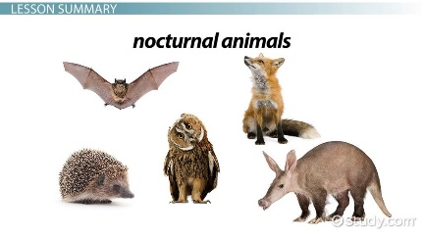[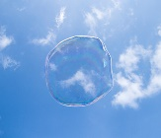](https://www.google.co.uk/url?sa=i&rct=j&q=&esrc=s&source=images&cd=&ved=2ahUKEwjMkaetsLXkAhVToXEKHU_9CSsQjRx6BAgBEAU&url=https%3A%2F%2Fwww.lindseypollak.com%2Fwhy-transparency-matters-your-three-step-guide-to-a-more-transparent-workplace%2F&psig=AOvVaw2dsiguRb-DvqManTKXAxe2&ust=1567624997940733)[](https://www.google.co.uk/url?sa=i&rct=j&q=&esrc=s&source=images&cd=&ved=2ahUKEwiph8WWsLXkAhXFRxUIHd2QDuwQjRx6BAgBEAU&url=https%3A%2F%2Fwww.shutterstock.com%2Fsearch%2Fhard%2Band%2Bsoft&psig=AOvVaw1PedE3xyPJdUADEGMCaRxR&ust=1567624952375573)[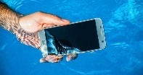](https://www.google.co.uk/url?sa=i&rct=j&q=&esrc=s&source=images&cd=&ved=2ahUKEwj5orqGsLXkAhWyXhUIHdNUA7EQjRx6BAgBEAU&url=https%3A%2F%2Fiprice.ph%2Ftrends%2Ftechnology%2Fwaterproof-vs-water-resistant-vs-splash-proof-whats-the-difference%2F&psig=AOvVaw1OlIymIvjkhRLFatHl_AWx&ust=1567624916065395)[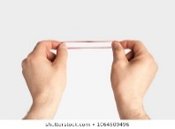](https://www.google.co.uk/url?sa=i&rct=j&q=&esrc=s&source=images&cd=&ved=2ahUKEwi5yIPpr7XkAhWhVBUIHReWA4EQjRx6BAgBEAU&url=https%3A%2F%2Fwww.shutterstock.com%2Fsearch%2Felastic%2Bhand&psig=AOvVaw0uFiqUONTgUN_lp8eNLa9e&ust=1567624859156393)[](https://www.google.co.uk/url?sa=i&rct=j&q=&esrc=s&source=images&cd=&ved=2ahUKEwjNwL3br7XkAhVDsXEKHcGeDv4QjRx6BAgBEAU&url=http%3A%2F%2Fwww.mountainsafety.co.uk%2FNav-Magnetic-Interference.aspx&psig=AOvVaw0W283hyW-VTSD7gDnCUCfh&ust=1567624831078482)[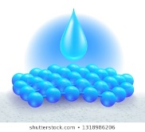](https://www.google.co.uk/url?sa=i&rct=j&q=&esrc=s&source=images&cd=&ved=2ahUKEwjvhtrKr7XkAhV3QhUIHUwgC5sQjRx6BAgBEAU&url=https%3A%2F%2Fwww.shutterstock.com%2Fsearch%2Fabsorb&psig=AOvVaw2W2GQZxtgEvGG416qDw177&ust=1567624793106833)[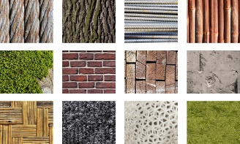](https://www.google.co.uk/url?sa=i&rct=j&q=&esrc=s&source=images&cd=&ved=2ahUKEwiXsLO9r7XkAhUcQxUIHZPaAwsQjRx6BAgBEAU&url=https%3A%2F%2Fwww.urbangreencouncil.org%2Fcontent%2Fevents%2Fmaterials-transparency-healthy-products-leed-v4-epds-hpds&psig=AOvVaw3lqRHvDVQrwdANWdJG1Chs&ust=1567624756288588)[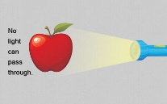](https://www.google.co.uk/url?sa=i&rct=j&q=&esrc=s&source=images&cd=&ved=2ahUKEwj68YOpr7XkAhVRqHEKHfElBtkQjRx6BAgBEAU&url=https%3A%2F%2Fsciencestruck.com%2Fdifference-between-translucent-transparent-opaque-materials&psig=AOvVaw0rD8Bxq1NghWZM2O00MNX2&ust=1567624714129510)[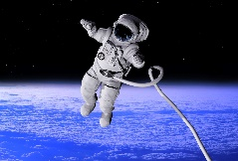](https://www.google.co.uk/url?sa=i&rct=j&q=&esrc=s&source=images&cd=&ved=2ahUKEwi0-4znrbXkAhXcThUIHaiFCx0QjRx6BAgBEAU&url=https%3A%2F%2Fwww.theschoolrun.com%2Fhomework-help%2Fgravity&psig=AOvVaw036CDWuIU4gGFVWLXsadwa&ust=1567624317530761)[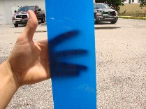](https://www.google.co.uk/url?sa=i&rct=j&q=&esrc=s&source=images&cd=&ved=2ahUKEwi_18qNr7XkAhXcSxUIHWOnCroQjRx6BAgBEAU&url=https%3A%2F%2Fwww.glasspaint.com%2Ftranslucent-glass-paint-effects%2F&psig=AOvVaw0z5-l6D31XNhNJ3KWaxXMl&ust=1567624666673452)[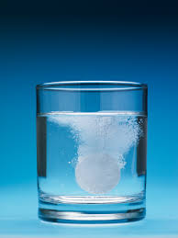](https://www.google.co.uk/url?sa=i&rct=j&q=&esrc=s&source=images&cd=&ved=2ahUKEwidkJKAr7XkAhXkURUIHfj7CxYQjRx6BAgBEAU&url=http%3A%2F%2Fwww.all-science-fair-projects.com%2Fprint_project_1272_38&psig=AOvVaw2UPhvy_4f-Kr4HnvbOmeWN&ust=1567624632571344)[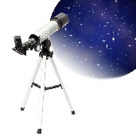](https://www.google.co.uk/url?sa=i&rct=j&q=&esrc=s&source=images&cd=&ved=2ahUKEwiMgpPXrrXkAhU5VBUIHSlvC_AQjRx6BAgBEAU&url=https%3A%2F%2Fwww.banggood.com%2FF360x50-High-expansion-HD-Refractive-Astronomical-Telescope-Monocular-p-939442.html&psig=AOvVaw1AYlMTm530ARHF_ibWwmNk&ust=1567624533721271)[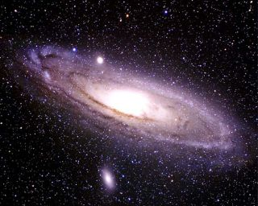](https://www.google.co.uk/url?sa=i&rct=j&q=&esrc=s&source=images&cd=&cad=rja&uact=8&ved=2ahUKEwia6e-arrXkAhVkQRUIHcuqDKsQjRx6BAgBEAU&url=%2Furl%3Fsa%3Di%26rct%3Dj%26q%3D%26esrc%3Ds%26source%3Dimages%26cd%3D%26ved%3D%26url%3Dhttps%253A%252F%252Fwww.space.com%252F2066-milky-andromeda-study-settles-massive.html%26psig%3DAOvVaw2RLCZGZgvYFZ4NizoMWEsV%26ust%3D1567624421779268&psig=AOvVaw2RLCZGZgvYFZ4NizoMWEsV&ust=1567624421779268)[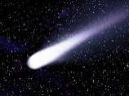](https://www.google.co.uk/url?sa=i&rct=j&q=&esrc=s&source=images&cd=&ved=2ahUKEwjv16CNrrXkAhU6UxUIHRSKAg0QjRx6BAgBEAU&url=https%3A%2F%2Fwww.independent.co.uk%2Ftopic%2Fcomet&psig=AOvVaw2YyIBa1ihQvutN5hvZsI6y&ust=1567624397315920)[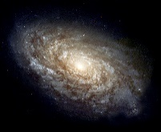](https://www.google.co.uk/url?sa=i&rct=j&q=&esrc=s&source=images&cd=&ved=2ahUKEwit7Y-CrrXkAhUBsXEKHUS-BL8QjRx6BAgBEAU&url=https%3A%2F%2Fen.wikipedia.org%2Fwiki%2FGalaxy&psig=AOvVaw36tyRt9fQXPmoT1yIxcl-8&ust=1567624374974691)[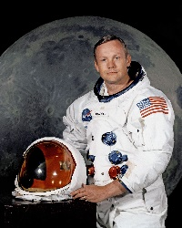](https://www.google.co.uk/url?sa=i&rct=j&q=&esrc=s&source=images&cd=&ved=2ahUKEwirvLzXrbXkAhXuSBUIHeTJBFEQjRx6BAgBEAU&url=https%3A%2F%2Fen.wikipedia.org%2Fwiki%2FNeil_Armstrong&psig=AOvVaw0J4h1THpLznhWzS1W6NOK8&ust=1567624283975677)[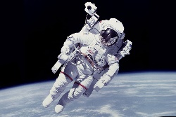](https://www.google.co.uk/url?sa=i&rct=j&q=&esrc=s&source=images&cd=&ved=2ahUKEwjy25vKrbXkAhX1QxUIHcXBCaMQjRx6BAgBEAU&url=https%3A%2F%2Fwww.theverge.com%2F2017%2F12%2F5%2F16737728%2Fnasa-spacewalk-astronaut-space-suit-automatic-return-system&psig=AOvVaw1-kRutUHD9ulpF0uw_oLl9&ust=1567624256843122)[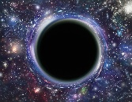](https://www.google.co.uk/url?sa=i&rct=j&q=&esrc=s&source=images&cd=&ved=2ahUKEwjCq_m8rbXkAhVfRhUIHfX1Ay8QjRx6BAgBEAU&url=https%3A%2F%2Fphysicsworld.com%2Fa%2Falmost-certain-escape-from-a-black-hole%2F&psig=AOvVaw2OMp_hO8cSOmBZVBzBNhuZ&ust=1567624228972068)[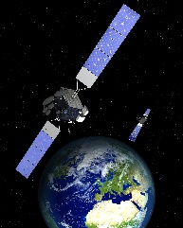](https://www.google.co.uk/url?sa=i&rct=j&q=&esrc=s&source=images&cd=&ved=2ahUKEwjZyJuwrbXkAhUGRxUIHVTWCS4QjRx6BAgBEAU&url=https%3A%2F%2Fspacenews.com%2Fnorthrop-grumman-to-build-two-triple-payload-satellites-for-space-norway-spacex-to-launch%2F&psig=AOvVaw1PIBOq1YqQ-Msy1rhACrf-&ust=1567624202094812)[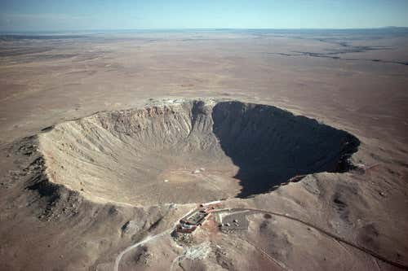](https://www.google.co.uk/url?sa=i&rct=j&q=&esrc=s&source=images&cd=&ved=2ahUKEwjrmMyjrbXkAhWkTBUIHZhrAocQjRx6BAgBEAU&url=https%3A%2F%2Fwww.newscientist.com%2Fgallery%2Fimpact-craters%2F&psig=AOvVaw2iXpAhJE6t53Kss-CFb8Ix&ust=1567624175413574)[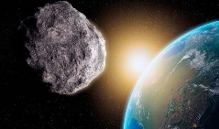](https://www.google.co.uk/url?sa=i&rct=j&q=&esrc=s&source=images&cd=&ved=2ahUKEwi1g9iXrbXkAhURVRUIHb9kD04QjRx6BAgBEAU&url=https%3A%2F%2Fwww.express.co.uk%2Fnews%2Fscience%2F1173391%2Fasteroid-news-asteroid-heading-for-earth-nasa-news-2019&psig=AOvVaw3XkJt8DLCuhDrxl03HpBAi&ust=1567624146761771)[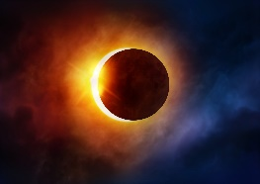](https://www.google.co.uk/url?sa=i&rct=j&q=&esrc=s&source=images&cd=&ved=2ahUKEwiiuu6IrbXkAhUdUxUIHSTlDx8QjRx6BAgBEAU&url=https%3A%2F%2Fmetro.co.uk%2F2019%2F07%2F02%2Fsolar-eclipse-today-people-get-see-10097196%2F&psig=AOvVaw3KiuVm4YJyqbvFC_S_-7fr&ust=1567624119106401)[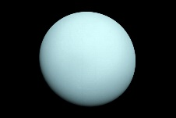](https://www.google.co.uk/url?sa=i&rct=j&q=&esrc=s&source=images&cd=&cad=rja&uact=8&ved=2ahUKEwivjo79rLXkAhWSs3EKHRIMD08QjRx6BAgBEAU&url=%2Furl%3Fsa%3Di%26rct%3Dj%26q%3D%26esrc%3Ds%26source%3Dimages%26cd%3D%26ved%3D%26url%3Dhttps%253A%252F%252Fwww.forbes.com%252Fsites%252Fstartswithabang%252F2019%252F01%252F22%252Fwhy-is-uranus-the-only-planet-without-interesting-features-on-it%252F%26psig%3DAOvVaw23Mhd_8lJWQc0-BxCmTZf6%26ust%3D1567624093574378&psig=AOvVaw23Mhd_8lJWQc0-BxCmTZf6&ust=1567624093574378)[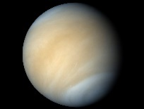](https://www.google.co.uk/url?sa=i&rct=j&q=&esrc=s&source=images&cd=&cad=rja&uact=8&ved=2ahUKEwjozbjyrLXkAhVPThUIHZQhBRwQjRx6BAgBEAU&url=%2Furl%3Fsa%3Di%26rct%3Dj%26q%3D%26esrc%3Ds%26source%3Dimages%26cd%3D%26ved%3D%26url%3Dhttps%253A%252F%252Fwww.universetoday.com%252F138935%252Fcould-there-be-life-in-the-cloudtops-of-venus%252F%26psig%3DAOvVaw12JXtXc7pXN3-31es2ajjy%26ust%3D1567624072596046&psig=AOvVaw12JXtXc7pXN3-31es2ajjy&ust=1567624072596046)[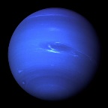](https://www.google.co.uk/url?sa=i&rct=j&q=&esrc=s&source=images&cd=&ved=2ahUKEwjWn43orLXkAhWRuHEKHTecB1YQjRx6BAgBEAU&url=https%3A%2F%2Fen.wikipedia.org%2Fwiki%2FNeptune&psig=AOvVaw0i46ozDEZYfAN8iT2f_aOF&ust=1567624052187870)[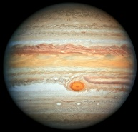](https://www.google.co.uk/url?sa=i&rct=j&q=&esrc=s&source=images&cd=&ved=2ahUKEwilh-3brLXkAhVjtHEKHaDpDvQQjRx6BAgBEAU&url=https%3A%2F%2Fen.wikipedia.org%2Fwiki%2FJupiter&psig=AOvVaw2HUTVj_dlGtorx0cyFUEYo&ust=1567624026532385)[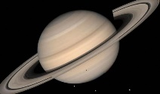](https://www.google.co.uk/url?sa=i&rct=j&q=&esrc=s&source=images&cd=&ved=2ahUKEwi2zuPQrLXkAhVDSBUIHXHtCoMQjRx6BAgBEAU&url=https%3A%2F%2Fwww.express.co.uk%2Fnews%2Fscience%2F1156016%2Fsaturn-nasa-discovery-alien-life-cassini-solar-system-enceladus-brian-cox-bbc-spt&psig=AOvVaw0kY3PQk1FpHbS9AyZLrQAz&ust=1567624001855445)[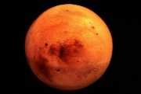](https://www.google.co.uk/url?sa=i&rct=j&q=&esrc=s&source=images&cd=&ved=2ahUKEwjA_8nDrLXkAhWSXRUIHUQzAsYQjRx6BAgBEAU&url=https%3A%2F%2Fwww.classicalwcrb.org%2Fpost%2Fmusic-mars&psig=AOvVaw3SVfGbQVJ2IlzEE83Chlkq&ust=1567623975059458)[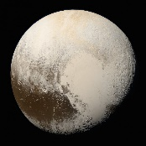](https://www.google.co.uk/url?sa=i&rct=j&q=&esrc=s&source=images&cd=&ved=2ahUKEwjIs8-5rLXkAhUpTBUIHXYNDDYQjRx6BAgBEAU&url=https%3A%2F%2Finterestingengineering.com%2Fa-planet-sized-debate-nasa-chief-says-he-still-classifies-pluto-as-a-planet&psig=AOvVaw3oc0PFVai_BoZM6dJ8YL96&ust=1567623952556597)[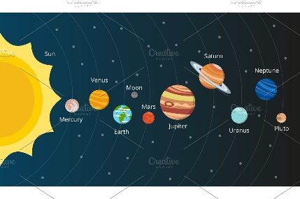](https://www.google.co.uk/url?sa=i&rct=j&q=&esrc=s&source=images&cd=&ved=2ahUKEwjvhsKsrLXkAhV0sXEKHTi3DOMQjRx6BAgBEAU&url=https%3A%2F%2Fcreativemarket.com%2Fonyxprj%2F2116785-Scheme-of-solar-system.-Planets-in-vector-style&psig=AOvVaw1YGNQsdhbA8mjsAffJ_RRF&ust=1567623925891143)[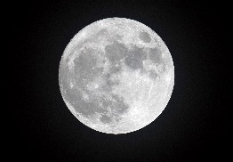](https://www.google.co.uk/url?sa=i&rct=j&q=&esrc=s&source=images&cd=&ved=2ahUKEwiNy5ShrLXkAhVDVBUIHQc-CpgQjRx6BAgBEAU&url=https%3A%2F%2Ftime.com%2F4666332%2Ffull-moon-lunar-eclipse-comet-watch%2F&psig=AOvVaw2FERN2j3ocrYTAQ1WWdNib&ust=1567623902818214)[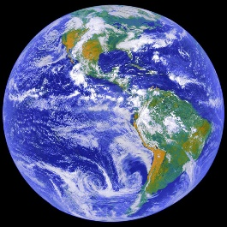](https://www.google.co.uk/url?sa=i&rct=j&q=&esrc=s&source=images&cd=&ved=2ahUKEwiAsoyWrLXkAhXtShUIHbGDA7YQjRx6BAgBEAU&url=https%3A%2F%2Fwww.universetoday.com%2F73813%2Fequator%2F&psig=AOvVaw23rddWP9Ja0C4fGLrTi2tv&ust=1567623879823762)[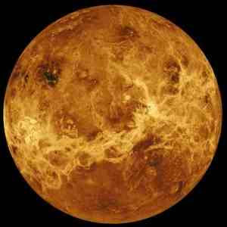](https://www.google.co.uk/url?sa=i&rct=j&q=&esrc=s&source=images&cd=&ved=2ahUKEwiWxOuLrLXkAhXgRBUIHRobBrcQjRx6BAgBEAU&url=https%3A%2F%2Ftallbloke.wordpress.com%2F2013%2F04%2F04%2Ftom-van-flandern-was-the-planet-mercury-once-a-moon-of-venus%2F&psig=AOvVaw1JjPzzDOIkl1rgyG6RyXWB&ust=1567623854315314)

Reflective

Diurnal

Nocturnal

Diwali

Milky way

Transparent

Soft

Gravity

Soluble

Black hole

Satellite

Eclipse

Jupiter

Solar System

Neil Armstrong

Astronaut

Translucent

Crater

Telescope

Hard

Waterproof

Opaque

Elastic

Absorb

Saturn

Mercury

Earth

Magnetic

Materials

Galaxy

Uranus

Neptune

Pluto

Our Topic:

Light and Dark

Comet

Venus

Moon

Asteroid

Mars