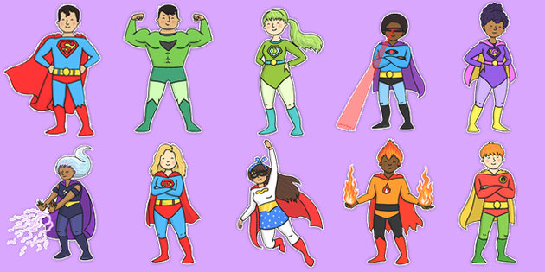

**General Reminders…**

* We will have Woodland Warriors on Friday morning – children will need their own wellies as spares are very limited. If they do not have wellies then they might not be allowed to go to Woodland Warriors.
* We will cover the topic of physical differences in our bodies during the Love & Relationships RE unit. The scheme we follow has been approved by the Birmingham Archdiocese and is used in many Catholic schools. As well as the science based topic, we will also learn about the social and emotional changes we experience as we grow.

**Homework in Year 4**

Please can we remind you that children need to have their reading books in school every day as well as their reading records. We expect a comment in their reading records at least 3 times a week.

Spellings will be set on Friday and tested the following Thursday or Friday. Please can you talk through the meaning of the words with the children. It helps if you put the word into a sentence so the children can hear the word in context. (This is how we test the children.)

Once again, the children will bring home a homework sheet for the whole half term. An activity needs to be completed each week and handed in by Thursday.

**PE in Year 4**

PE days:  
OAK: Monday & Thursday

PEAR: Monday & Tuesday

We will try to be outside for PE as much as possible therefore children would benefit from the winter PE uniform of plain, dark joggers. Please note that leggings are not part of our school PE uniform. Children can wear their jumper or cardigan if needed. Trainers not pumps please.

If children wear ear rings they need to cover these with tape for each lesson. Tape is not provided; children will need to bring it with them.

# Year 4 Pear & Oak

Welcome back! We have a very busy term ahead and have lots of exciting things planned, including some sort of Easter assembly performance in April. This is all dependent on any restrictions at the time, but we are hopeful that we can do something with the children. We will of course keep you up to date nearer the time.

**Welcome to**

**Spring Term!**