Dear Parents and Carers
‘Children are great imitators, so give them something great to imitate’
We are committed to ensuring a safe and supportive learning environment for all our pupils. Recently, we have become aware that some children are discussing content from age-inappropriate shows, such as Squid Game and other horror-themed media. These discussions can be unsettling for younger children. We are aware that some children have been particularly upset by things they are hearing from their peers.
15+ or 18+ content is highly inappropriate for primary aged children. However, the themes and ideas in these shows are crossing over into platforms and apps which might be considered ‘safe’ for children to be using.
This issue is becoming increasingly worrying. Many age-restricted shows and films, such as Squid Game, Five Nights at Freddy’s, and Chucky, are being widely discussed and referenced on platforms that children frequently use. Despite not necessarily watching the age restricted content, accessing it through ‘safer’ apps still causes harm. Clips, memes, and recreations often strip away important context while still portraying violent, frightening, or disturbing themes. This can lead to children misunderstanding the content, normalizing harmful behaviours, or feeling anxious.
It is important that we are all aware that even indirect exposure can have an impact. As parents you need to set clear boundaries around what is appropriate for your child’s age and emotional development. Children can sometimes be inadvertently exposed to inappropriate material in a variety of ways, including:
- Streaming platforms (e.g., Netflix, Disney+, Amazon Prime) where autoplay features or shared accounts may expose them to content beyond their age group.
- YouTube and social media (e.g., TikTok, Instagram, Snapchat, and Facebook) where short clips, memes, and discussions about trending shows can appear—even if children are not actively searching for them. Algorithms on these platforms often promote viral content, which can include age-inappropriate material
- Gaming Crossovers Age-inappropriate content often finds its way into games that children play. For example: Roblox has user-generated games that replicate violent or horror-themed shows. Squid Game-themed games became hugely popular on Roblox, even though the show itself is rated 15+ or 18+. Minecraft and Fortnite also feature mods, skins, and custom maps inspired by 15+ or 18+ media, making it accessible to young players.
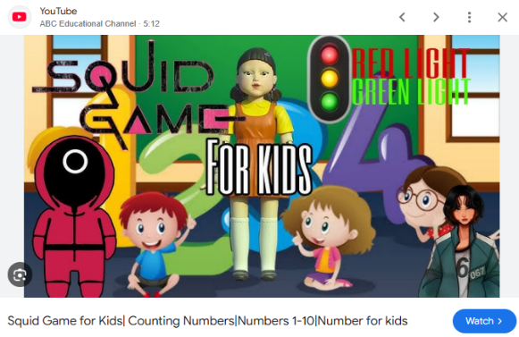
YouTube Kids: Although YouTube Kids does filter content, inappropriate material can still slip through due to the vast amount of user-generated content. Often children may find Adult Themes in "Child-Friendly" Videos – Some videos appear child-friendly but reference horror, violence, or disturbing themes from adult shows in ways that children may not fully understand.

To help ensure children are only accessing age-appropriate content, we encourage parents to:
- Enable parental controls and use restricted modes on streaming services, social media apps, and internet browsers to filter age-inappropriate content. Guides on this can be found on our e-safety page and on National Online Safety.
- Monitor game downloads and be aware of user-generated content in games like Roblox and Minecraft.
- Monitor your child’s use of their device as they may be consuming content related to inappropriate shows or games through ‘safer’ apps.
- Talk to your child about what they see online and encourage them to come to you if they encounter something upsetting.
- Encourage safe online habits by setting clear boundaries around screen use and discussing the importance of avoiding unsuitable content.
- Ask if you are unsure – some popular content is aimed at younger adults so for most of us as parents we might be entirely unaware the film/game being referenced!
We appreciate your support in helping us maintain a positive and age-appropriate learning environment. If you would like further guidance on this, please do get in touch. You can contact Mr Bowring through email, or even use our new online worry box, using the link or QR code below.
Thank you for your support Mr Bowring, Online Safety Lead
Online Safety Worry Box:  https://padlet.com/wbowringlossock/do-you-have-any-concerns-around-online-safety-would-you-like-y9lvox7ur3l9a8em  Be aware your post will be public, but it can be anonymous! |   Or Scan this QR code:

