ADVICE SHEET
Creating a 3 Point Incredible Scale

The 5-Point Incredible Scale & Emotional Regulation was created by Kari Dunn Buron (www.5pointscale.com)
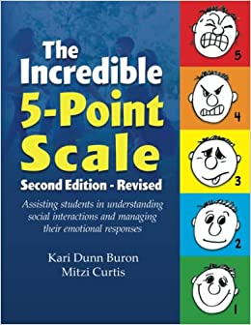
IMPORTANT
- You need to teach each stage before moving onto the next
- Link this into your functional behavioural analysis & Behaviour Support Plan
- Use the How I am Feeling Powerpoint to explore feelings
- This is to be used with children who can recognise and understand feelings, both their own and others. Generally, the child would need to be at a developmental level of around 4 years (Portage SEND Best Practice Assessment Toolkit – Managing Self)

Stage 1- Heading of Chart
The first stage is to identity the problem areas for the child.
It might be changes in routine, being around peers or recognising how they are feeling inside.
Ultimately we are looking to help ‘understanding my feelings’ under the following headings:

Rating | Looks Like | Feels Like | I can try to
3- Angry | 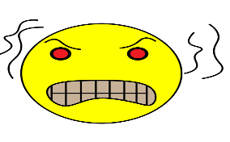
2-
Wobbly/
Aggy

Happy/Ok

Stage 2-Naming the feelings in My chart
Talk about feelings especially those in the chart- use books and photos of faces from magazines etc so they can label what the key emotions are when they see pictures of them.
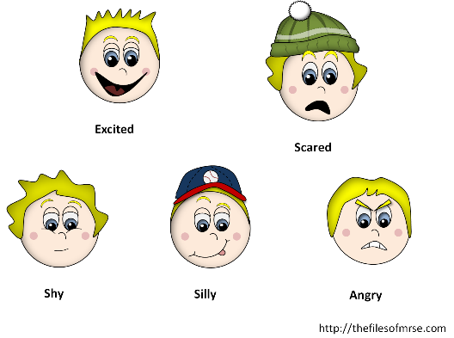

Stage 3-Exploring My Feelings
Think about what these feelings look & feel like in themselves and others- this is where we need to point them out to them in the moment.

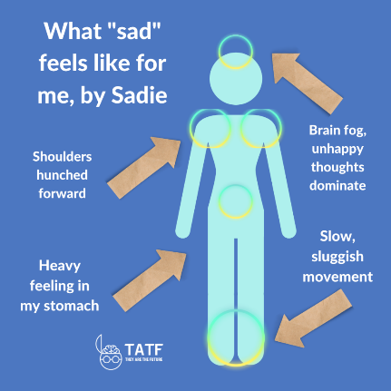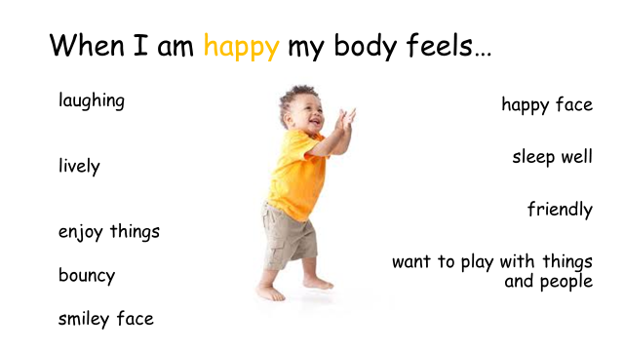

Stage 4- What can I do about My feelings?
This is the crucial bit and is very individual for each child.
@ 2 it might be breathing, finding an adult, listening to music, looking at a book
@ 3 it might finding the calm down zone, jumping on a trampoline, doing ‘heavy work’ or going into my squishy boxes
We are working towards helping them get back to 1 and ok again.

Stage 5- Making it Visual
This is where you put a chart together and how complicated that is will depend on the child.
Remember to use their favourite things/special interests
Reward them for using the chart /coming to you because they need you to co-regulate them
Show them you are using it too
Reassure them that sometimes they will hit 3 and its ok & we all get angry and upset, it’s what we do when we feel that way that counts!
The chart can be completed with pictures/words/ whatever the child relates to.

** See website for a template to use.

Books you might find useful:

Book Title | Author
What makes me happy? | Catherine & Laurence Anholt
Once Upon a touch – story massage for children | Mary Atkinson & Sandra Hooper
Happy! | Caroline Castle & Sam Childs
When my worries get too big – A relaxation book for children living with anxiety | Kari Dunn Buron
Listening to my body | Gabi Garcia
The Huge bag of worries | Virginia Ironside
My body sends a signal | Natalia Maguire
When I am sad | Endorsed by Dr Janet Rose
How are you feeling today? | Molly Potter
What’s going on inside my head? – starting conversations with your child about positive mental health | Molly Potter
Daisy’s Dragons – a story about feelings | Frances Stickley & Annabel Tempest
Hey Awesome | Karen Young
Hey Warrior | Karen Young

