Check out the MOVE 2.6 Challenge here https://www.enhamtrust.org.uk/26-challenge-move

“The Move Programme is a philosophy, a way of life for disabled children, and disabled people with complex needs; providing the personalised care and support they need to gain functional mobility, and increased independence”

Put simply, the Move Programme is a practice put in place so disabled children and disabled people with complex needs are supported to gain the physical and communication skills they need in order to:

- SIT to eat, participate in activities, education and eventual employment
- STAND to increase strength, mobility and flexibility
- WALK to participate in play or complete tasks, with and without support
- TRANSITION from bed to chair or sitting to standing.

At St Nicholas; students who have a MOVE programme in place will practise their individual tasks and targets daily. However we also have bespoke weekly MOVE sessions; where we work in collaboration with our Physio’s, OTs and SaLTs to deliver topic based sessions that encourage the students to practise and show off their skills. Examples of themes this year will include: a UV party and the winter fair

Term 3 and 4
Winter fair
During this term the students will enjoy a range of activities through exploration. They experience being at a winter fair. They will listen to music and make sounds using objects and voices. They will participate in varied activities to support, encourage and motivate to practice their skills.

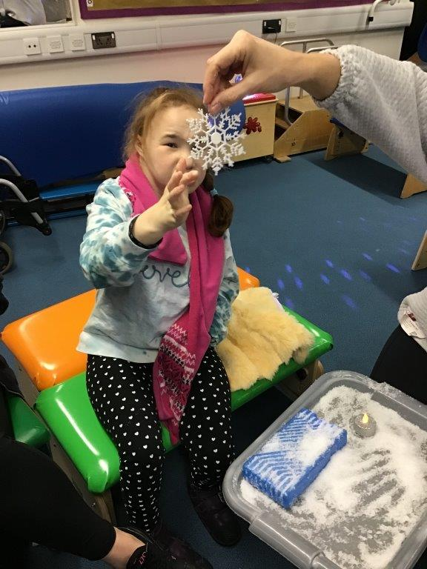
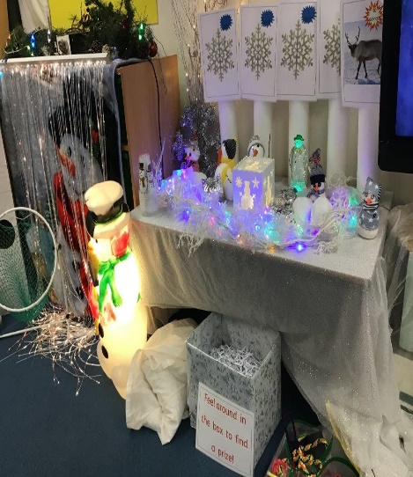
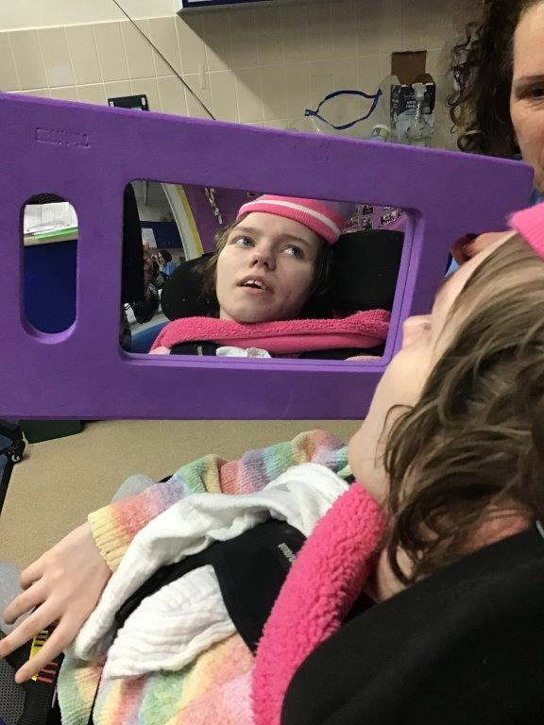
These tasks have encouraged students to practise several functional skills such as developing their hand and eye coordination, practising and developing their sitting skills, transition skills to and from the floor, and some students have practised their standing and walking too. Students have also been encouraged to practise and develop their communication skills making choices about what activities they want to do. We have seen some excellent progress.

