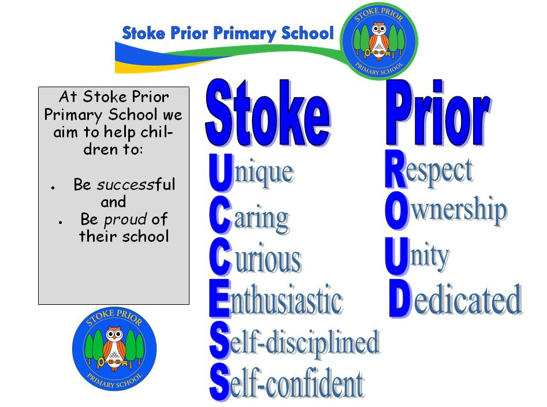

Summer 2025 – Report to Governors

**Annual report on the progress of implementing the provisions of Equality Information and Objectives Policy GN7**

As the Headteacher for Stoke Prior Primary School I can confirm the following is implemented and adhered to, as appropriate and to the best of my knowledge:

* Implement and champion this policy and its procedures
* Ensure that all staff members receive the appropriate equality and diversity training as part of their induction and CPD
* Ensure that all parents, visitors, and contractors are aware of, and comply with, the provisions of this policy
* Actively challenge and take appropriate action in any case of discriminatory practice
* Address any reported incidents of harassment or bullying in line with DfE guidance
* Produce an annual report on the progress of implementing the provisions of this policy and report it to the Trust Board

Ensure Staff will:

* Be mindful of any incidents of harassment or bullying within TCAT
* Address any minor issues of harassment or bullying and report any major breaches of the policy to the Executive Headteacher/CEO or to their Headteacher/Head of School
* Identify and challenge bias and stereotyping within the curriculum and the TCAT’s culture
* Promote equality and good relations, and not harass or discriminate in any way
* Monitor pupils’ progress and academic needs to ensure the appropriate support is in place
* Keep up to date with equality legislation and its application by attending the appropriate training
* Champion diversity and inclusion

Ensure Pupils will:

* Not discriminate or harass any other pupil or staff member
* Actively encourage equality and diversity in TCAT by contributing their cultural experiences and values
* Report any incidences of bullying or harassment, whether to themselves or to others, to a senior leader, member of the pastoral team or to another member of staff
* Abide by all TCAT’s equality and diversity policies, procedures, and codes

As a school we:

1. Promote Inclusive Education and Reduce Attainment Gaps

* Ensure that all pupils, regardless of gender, ethnicity, socio-economic background, disability, or special educational needs (SEN), achieve their full potential
* Identify and address attainment gaps by implementing targeted interventions, particularly for disadvantaged pupils (e.g., Pupil Premium students)
* Monitor progress and adapt teaching strategies to ensure equitable access to learning resources across the school

2. Foster a Culture of Respect, Diversity, and Inclusion

* Embed diversity and inclusion across the curriculum, ensuring that teaching materials and school activities reflect a wide range of cultural backgrounds, experiences, and perspectives
* Deliver anti-discrimination training for staff and pupils to tackle racism, sexism, homophobia, ableism, and other forms of prejudice
* Implement an effective anti-bullying strategy that specifically addresses issues related to protected characteristics

3. Improve Representation in Leadership and Staffing

* Ensure recruitment and promotion processes promote diversity and reflect the communities that TCAT serves
* Provide career development and leadership opportunities for underrepresented groups within the teaching staff, leadership teams, and governance structures
* Establish mentoring and professional development programmes to support staff from diverse backgrounds to progress into leadership roles

4. Enhance Support for Pupils with SEN and Disabilities

* Ensure equitable access to the curriculum and extra-curricular activities for pupils with SEN or disabilities
* Provide training for staff to effectively support pupils with additional needs and promote inclusive teaching strategies
* Improve accessibility across all school sites, ensuring that physical and digital learning environments cater to all pupils' needs

5. Strengthen Community Engagement and Partnerships

* Develop stronger links with parents, carers, and community groups, particularly those from underrepresented or marginalised backgrounds
* Provide opportunities for parents and carers to engage in their child’s education, with particular attention to hard-to-reach families
* Work with external organisations to promote diversity, equity, and inclusion in school activities, governance, and decision-making

6. Promote Gender Equality and Challenge Stereotypes

* Ensure equal access to all subjects, activities, and leadership opportunities for both boys and girls
* Challenge gender stereotypes in subject choices, particularly in STEM (Science, Technology, Engineering, and Maths) and creative arts
* Implement policies and practices to ensure that all pupils feel safe, valued, and respected, regardless of their gender identity or expression

7. Regularly Monitor, Review, and Report on Progress

* Collect and analyse equality data across all schools in the MAT to track progress against objectives
* Ensure pupil voice and stakeholder feedback shape ongoing equality strategies
* Publish an annual report on equality progress, identifying key achievements and areas for improvement

During this academic year there have been no incidents of grievance, prejudice or complaints against staff, pupils and parents.

Mr Matt Lewis

Headteacher

July 2025