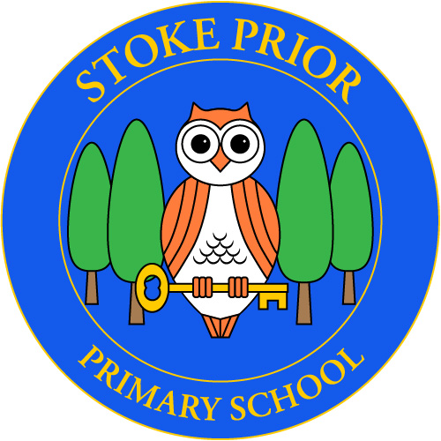
Stoke Prior
Primary School

31/07/26

To: The Parents of Willow and Oak Classes

Dear Parents

Visit to Hay Festival
Thursday 22nd May

I am writing to inform you about the exciting opportunity for our students to attend events by celebrated authors, Frank Cottrell Boyce and Patrice Lawrence at the Hay Festival. The events are taking place on Thursday 22nd May. We will leave school at 9am and return for the end of the school day – by 3pm.
Attending the Hay Festival events will not only broaden our students' literary horizons but also provide them with an enriching and memorable experience. We believe that exposure to such accomplished authors can fuel their passion for reading and writing.

Children should wear school uniform. They will also need to bring a picnic lunch. Please remember to cancel your school dinner on this day. If it is a hot day, please remember to apply sunscreen in the morning.

Children may bring a maximum of £15 spending money for the purchase of a book and an ice-cream or snack. Alternatively you could purchase one of the author’s books beforehand. This is entirely at your discretion.

The PTFA are kindly paying for the transport for this trip.

The classes will be accompanied by staff.

Please submit the form via the link below to give consent for the trip.

https://forms.office.com/e/wN25fWyhE6

Mr Lewis

