Music development plan summary:
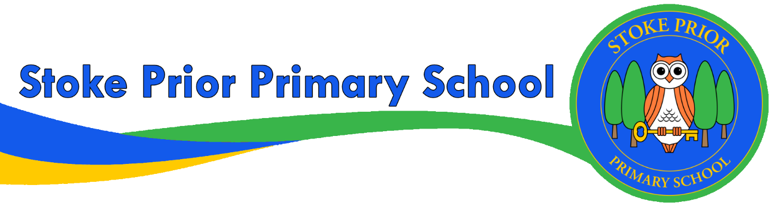
Detail | Information
Academic year that this summary covers | 2024/25
Date this summary was published | September 2024
Date this summary will be reviewed | September 2025
Name of the school music lead | Mr Matt Lewis
Name of local music hub | Encore Enterprises

This is a summary of how our school delivers music education to all our pupils across three areas – curriculum music, co-curricular provision and musical experiences – and what changes we are planning in future years. This information is to help pupils and parents or carers understand what our school offers and who we work with to support our pupils’ music education.

Part A: Curriculum music
This is about what we teach in lesson time, how much time is spent teaching music and any music qualifications or awards that pupils can achieve.
Please see our website for information about our Music Curriculum.
Intent
Music should be an enjoyable experience for pupils and teachers. Children participate in a range of musical experiences, building up their confidence at the same time. They develop their understanding of rhythm and pitch and learn how music is structured, as well as learning technical vocabulary for these elements. As children’s confidence builds, they enjoy the performance aspect of music. Children experience listening to music from different cultures and eras.
Implementation
Music is taught as a discrete subject but also across the curriculum. Areas of learning, such as times tables in maths, vocabulary in languages and movement in dance can all incorporate different elements of music. Performances, such as Christmas plays and nativities and Harvest productions, demonstrate that music is important to the life of the school. Extracurricular activities, such as choir and peripatetic music lessons, also provide children with experience of making music. We are committed to providing whole class musical tuition in KS1 and KS2. We have a detailed plan for listening and appraising a range of classical music and music from different cultures to provide cultural capital for the children. As a school we have built a bespoke Music Scheme utilising many units of work from Charanga.
In line with the curriculum for music and guidance from Ofsted, this Scheme moves away from the previous levels and learning objective/outcome concepts to an integrated, practical, exploratory and child-led approach to musical learning.
Ofsted have stated that “We will not always know the learning outcomes” so segregated learning objectives at the start of each lesson are not appropriate. Instead the interrelated dimensions of music weave through the units to encourage the development of musical skills as the learning progresses through listening and appraising, differing musical activities (including creating and exploring) and performing.
Impact
The impact of teaching music will be seen across the school with an increase in the profile of music. Whole-school and parental engagement will be improved through performances, extracurricular activities and opportunities suggested in lessons/overviews for wider learning. Participation in music develops wellbeing, promotes listening and develops concentration. We want to ensure that music is loved by teachers and pupils across school, encouraging them to want to continue building on this wealth of musical ability, now and in the future.
The school is committed to 1 hour per week of music curriculum teaching. This uses Charanga resources and is informed by the Model Music Curriculum.
Our plans that are bespoke for our school dedicate curriculum time to whole class ensembles in the following instruments.
- Keyboards
- African Drums (Djembe)
- Ukelele
- Recorders
- Glockenspiel
The teaching of these are supported through Encore Music service and the school has accessed grant funding in the past to fully resource these instruments.
The music coordinator has developed effective links with Encore music hub.

Part B: Co-curricular music
This is about opportunities for pupils to sing and play music, outside of lesson time, including choirs, ensembles and bands, and how pupils can make progress in music beyond the core curriculum.
Our school promotes and offers Music lessons across all instruments where this is feasible. Currently piano / Keyboard lessons are taken by 6 children. Encore Music Service support the school by providing lists of available music teachers.
Our school choir is held weekly and recently achieved Gold Medals in county performances. This is an incredible achievement for such a small school in competitive singing.
While we currently have no pupils attending Saturday Music Centre in Hereford this is promoted and we have had past pupils attend when the instrument that they played was suited to concert band or strings.
The music coordinator has previously secured grant funding to allow Pupil premium students to access peripatetic music lessons when there was a clear interest.
A number of existing pupils further develop their singing skills through membership of musical theatre groups within the community.

Part C: Musical experiences
This is about all the other musical events and opportunities that we organise, such as singing in assembly, concerts and shows, and trips to professional concerts.
Children across the school get a variety of opportunities to perform
- Harvest Festival singing and musical performance.
- Christmas nativity Play KS1
- Carol Concert LKS2
- Christmas Show UKS2
- Village Christmas Church service within the community.
- Instrumental performances when appropriate throughout the year.
- Leavers service singing.
- Choir perform at Hereford Performing arts festival, Leominster festivals, recently sang for royalty. Also at local church events.
- The school has previously attended Large Choir Events
- Singing with schools across the county in 2023 as part of “Stand Up And Sing”
We also try to give children opportunities to experience musical performances.
- Regular Drama productions featuring music within school and on trips.
- Sealegs Puppet theatre.
- Annual commitment to “Music On the Move” this involves a performance within school of either Rock and Pop, Musical Theatre or Classical music. It is through our engagement with Encore Music.
- Courtyard Pantomime and other opportunities for musical theatre performances.

In the future
This is about what the school is planning for subsequent years.
- Look to apply for funding through Sylvia Short to afford a whole class set of another type of instrument (woodwind or brass) for whole class tuition.
- Re-introduce the musical performances annually for parents (that focus on musical instruments rather than choral performances

