

**Stoke Prior School**

**Personal Social and Health Education (PSHE) and**

# Sex and Relationships Education (SRE) Policy

**Co-ordinator: Headteacher**

**Lead Governor – Chair (Mrs L Firth)**

A key aim of the school is that each pupil will develop the skills and knowledge to make decisions. Decisions about how they relate to others can only be made if they have adequate knowledge and understanding of their own physical and emotional development. This is not a task for the school in isolation, and we seek to work with parents to ensure that the teaching of PSHE and SRE reflects their expectations and complements teaching at home. Parents will be informed about the teaching of sex education prior to it being delivered so that they can decide whether or not to withdraw their child. Other aspects of the PSHE curriculum including relationships are compulsory and there is no right to withdraw.

During 2020 the entire PSHE policy was reviewed to take into consideration the new requirements to ensure that the school meets its statutory duty in ensuring teaching meets the guidance.

All staff were consulted about this policy and the contents of the schemes of work. The content of the PSHE curriculum is shared with parents and carers and comments are invited. This forms part of the consultation. Parents are informed of the content of the scheme of work before any Sex Education takes place with the children in Key Stage 2.

### ROLES AND RESPONSIBILITIES

The *governing body* will:

* Ensure that the school meets its statutory duty with regard PSHE and SRE.

The *headteacher* will ensure that:

* The governing body is advised about the nature and organisation of PSHE and SRE and how it reflects the aims and values of the school;
* PSHE and SRE is provided in a way that encourages pupils to consider morals, the value of family life, the value of marriage and stable loving relationships.
* Monitor how our delivery of PSHE and RSE is in line with The Equality Act 2010
* Ensure that the policy is compliant with DFE guidance
* Pupils are protected from inappropriate teaching materials;
* A scheme of work is agreed and implemented;
* Parents are consulted about the content of the PSHE curriculum including relationships education.
* *Parents are given the right to withdraw from Sex education. The aspects of the PSHE curriculum where parents have the right to withdraw their children is highlighted in the curriculum plan.*

*Staff* who teach PSHE and SRE are expected to:

* Provide PSHE and SRE in accordance with this policy and in a way which encourages pupils to consider morals and the value of family life;
* Participate in training to PSHE and SRE in line with the school curriculum policy;
* Ensure that content is accessible for pupils with SEND following advice from SENCO and our SEND policy,
* Implement the agreed scheme of work wherever time limits allow;
* Ensure parents of all children who take part in Sex education are informed of the content prior to the delivery and provide signed written consent to their children taking part.
* Ensure that children whose parents wish them not to take part are provided with alternative lessons that do not draw attention to this issue.
* Draw to the attention of the headteacher any materials which they consider to be inappropriate;
* Respond appropriately to those pupils whose parents wish them to be withdrawn from sex education.

**DELIVERY OF RSE**

* RSE is about the emotional, social and cultural development of pupils, and involves learning about relationships, sexual health, sexuality, consent, healthy lifestyles, diversity and personal identity.
* RSE involves a combination of sharing information, and exploring issues and values.
* RSE is not about the promotion of sexual activity.

As part of RSE, pupils will be taught about the nature and importance of marriage for family life and bringing up children. They also need to understand that there are strong and mutually supportive relationships outside of marriage. Either of these can include heterosexual or same-sex relationships. Teaching about families requires sensitive and well-judged teaching based on knowledge of pupils and their circumstances. Families of many forms provide a nurturing environment for children. (Families can include for example, single parent families, LGBT parents, families headed by grandparents, adoptive parents, foster parents and carers amongst other structures.) We ensure that no stigma is placed on children based on their home circumstances.

We aim to provide accurate information and to help to develop skills to enable them to understand differences and respect themselves and others. We hope to prevent and remove prejudice. RSE should contribute to promoting the spiritual, moral, cultural, mental and physical development of pupils at school and within society, thus preparing them for the responsibilities and experiences of adult life. We will work towards this aim in partnership with parents and carers.

We carry out the main RSE curriculum in PSHE lessons (See the website for details of curriculum coverage), however we also teach RSE through other subject areas e.g. Science, PE and RE, where we feel that they contribute significantly to a child’s knowledge and understanding of his or her own body, and how it is changing and developing. Linked with RE, children reflect on family relationships, different family groups and friendship. They learn about rituals and traditions associated with birth, marriage and death and talk about the emotions involved. Linked with PE, children learn about healthy lifestyles and the importance of exercise. The staff have access to the Shropshire scheme of work to provide high quality teaching resources for all aspects of PSHE. Teachers use ongoing assessment to ensure they have a detailed picture of what children know and understand in this area. This is monitored by focus groups periodically by governors and the Headteacher.

Since RSE incorporates the development of self-esteem and relationships, pupils’ learning does not just take place through the taught curriculum but through all aspects of school life including the playground. It is important then that all staff understand they have a responsibility to implement this policy and promote the aims of the school at any time they are dealing with children.

The science curriculum covers aspects of the lifecycle of Human and other animals. Many aspects of PSHE and RSE may be covered within this curriculum area.

### ARRANGEMENTS FOR MONITORING AND EVALUATION

The headteacher will provide a report on the implementation of the scheme of work once each year in July, together with feedback on parental consultation that will take place in the Autumn term 2020. Any further feedback subsequently can be discussed by Governors annually.

**FAQs for PARENTS AND CARERS**

[**https://www.gov.uk/government/news/relationships-education-relationships-and-sex-education-rse-and-health-education-faqs**](https://www.gov.uk/government/news/relationships-education-relationships-and-sex-education-rse-and-health-education-faqs)

**LINK TO GUIDANCE**

[**https://www.gov.uk/government/publications/relationships-education-relationships-and-sex-education-rse-and-health-education**](https://www.gov.uk/government/publications/relationships-education-relationships-and-sex-education-rse-and-health-education)

**The Equality Act 2010**

[**https://www.legislation.gov.uk/ukpga/2010/15/contents**](https://www.legislation.gov.uk/ukpga/2010/15/contents)

[**https://assets.publishing.service.gov.uk/government/uploads/system/uploads/attachment_data/file/719902/Sexual_violence_and_sexual_harassment_between_children_in_schools_and_colleges.pdf**](https://assets.publishing.service.gov.uk/government/uploads/system/uploads/attachment_data/file/719902/Sexual_violence_and_sexual_harassment_between_children_in_schools_and_colleges.pdf)

**For more information on Sexual Violence and Harrassment see our Safeguarding policy.**

***Reviewed by: Headteacher***

***Adopted by Governors on 1st September 2024 Date for review: Sep 2027***

Appendix 1

# Stoke Prior Community Primary School

Stoke Prior

Leominster

Herefordshire

HR6 0ND

Tel/Fax: 01568 760207 Headteacher: Mr M Lewis

e-mail: [admin@stokeprior.hereford.sch.uk](mailto:admin@stokeprior.hereford.sch.uk)

Date

Dear Parents and Carers

I am writing to inform you of our Personal Social and Health Education (PSHE) Policy and Curriculum. This includes Sex and Relationships Education. (SRE)

The details of our intended curriculum for this area are outlined on our website

<https://www.stokeprior.hereford.sch.uk/curriculum>

Alongside our PSHE and SRE curriculum map you will find our curriculum maps for other areas of learning.

Changes have been made to the statutory requirements of SRE from September and we will begin teaching this curriculum from January 2021.

Please also note our PSHE and SRE policy on our website

<https://www.stokeprior.hereford.sch.uk/policies/>

It is a requirement that we consult with parents about this aspect of our curriculum. If you would like to make any comments or ask any questions please email me on [mlewis@stokeprior.hereford.sch.uk](mailto:mlewis@stokeprior.hereford.sch.uk) or contact me at school.

Yours Sincerely

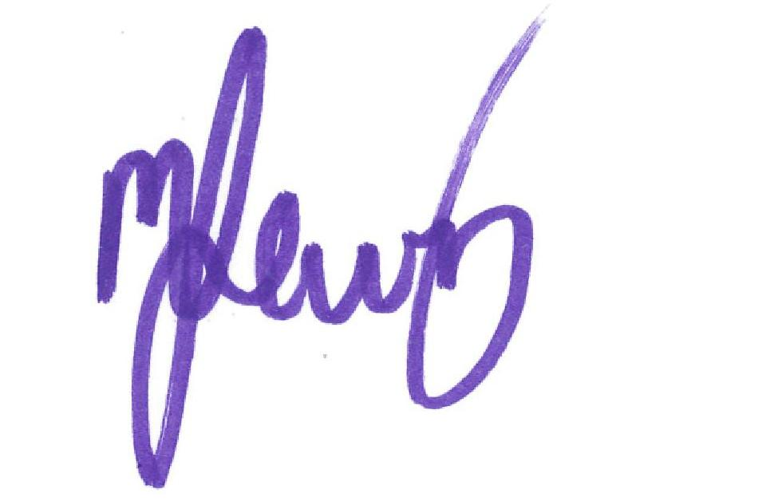

Mr M Lewis