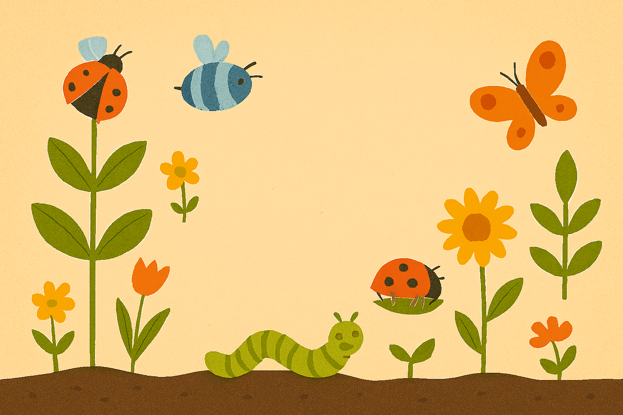
Spring 2
Come Outside
The children will create a sequence of dance moves. Explore moving a ball with their feet. Direct a ball to a set place. Practice kicking the ball from a standing position to each other. Kick the ball as they move slowly. Stop a ball which is rolling towards them and retain their balance. Stop and then kick a ball. Confidently use cutlery, tweezers and other small equipment to manipulate materials. Be able to control a fine paint brush to produce detailed paintings. Form recognisable letters with an effective pencil grip.

The children will design with a purpose & explain the process they used. Make 3D models of favourite bugs, ensuring that they have the different features. Draw an object (flower/plant) from careful observation talking about the features they included. Make props to use in role play & small world play. Know a repertoire of songs. Imitate and create movement in response to music. Tap out simple repeated rhythms & make some up showing interest in the way musical instruments sound. Explore high and low pitch. Create collaboratively sharing ideas, resources and skills. Use tools & techniques with increased care and precision. Mix a range of colours needed for a purpose. Use white to create different shades. Create 3D sculptures of animals.

EAD
The children will know that it is our right to have a home and some children live in poverty. Know that some places are special to people in my community. Notice lots of physical geography outside in our environment and in the wider world. Name human features in our local community. How can we look after our environment? Understand how to care for nature. Talk about signs of spring / changes from winter to spring – spring walk. Understand the effect of changing seasons on the natural world around me. Explore the natural world around me, making observations and drawing pictures of animals and plants. Life cycles- tadpoles/frogs, caterpillars/ butterflies. Pond dipping. Planting and growing – vegetables. Name parts of a plant. Key Vocab: Spring, seasons, Easter, changes over time, seasons, past, present, future, Church, religion, society, technology, travel, trade, physical features, human features, environment, recycling, positional language, life cycles, observe, changes, flower, stem, roots, leaves. Pond dipping nets, camouflage, new life, seeds, chicks, babies.

UTW
PD
The children will explore length, height and time. Compare length and height. Order and sequence time. Find 9 and 10. Represent 9 and 10. 1 more. 1 less. Subitising. Bonds to 10. Doubles. Odd and even. Recognise and name 3D shapes. Find shapes. Copy, continue and find patterns
Maths
The children will be able to safely access resources & different areas of the classroom & outdoor areas. They will know some behaviour is unacceptable/unsafe. Be able to talk about how to stay safe in different situations and places. Be able to explain how rules keep them safe and know right from wrong.

PSED
The children will know and use recently introduced vocabulary during discussions about stories, non-fiction texts, rhymes and poems during role play. Be able to segment read & write words with Level 2 and 3 graphemes & read and write some of the tricky words. Be able to form most Level 2 graphemes correctly. Start to be aware of sentence structure (capital letters, finger spaces and full stops). Read and write simple sentences with increasing independence. Be able to write a simple character description. Use writing in their play. When reading a well-known or repeated story children will join in. Show an increasing confidence in sequencing a story. Give a suggestion to the ending of a story using the front cover, blurb and beginning to support their suggestions. We will be reading and exploring the books ‘The Hungry Caterpillar’, @Oi Frog’, ‘Stanley’s Stick’, ‘Oliver’s Vegetables’ and many more.
Literacy
C&L
The children will be able to retell a story with repetition and some story vocabulary. They will be able to articulate their ideas and thoughts in well-formed sentences. Plan activities with others…I am going to… Shall we… Use connectives to retell stories, such as first, then, finally, so, because, and. Offer explanations for why things might happen.

