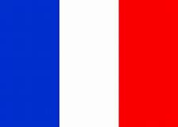

Stoke Prior Primary School
Progression in Skills for Languages

As a Linguist … | Phase 1  Year 1 and 2 | Phase 2  Year 3 and 4 | Phase 3  Years 5 & 6
Oracy |  | - I can listen and respond to a song, story or game.  - I can make links between sounds and spellings.  - I can ask and answer a question.  - I can present information about myself. | - I can have a simple conversation.  - I can express an opinion.  - I can give a short presentation on a topic.  - I can apply my knowledge of sounds to pronunciation.
Literacy |  | - I can write simple words and phrases.  - I can read simple words.  - I can write my own sentence.  - I can spot patterns in the language.  - I can adapt a sentence. | - I can write several sentences.  - I can adapt a model text.  - I can read and understand sentences.  - I can spot patterns in the language and use them to write my own sentences.  - I can write phrases from memory.  - I can find vocabulary using an online dictionary.
Intercultural Understanding | - I know people speak different languages around the world.  - I respect others.  - I can listen to other people speaking another language.  - I know that there are similarities and differences in cultures.  - I can compare my own culture with that of another country.

