
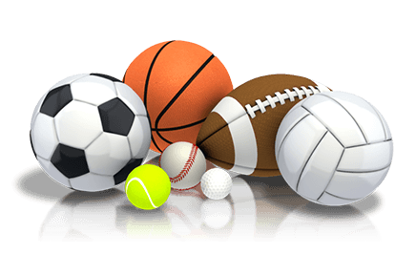
Stoke Prior Primary School
Progression in Physical Education Skills

 | Phase 1  Year 1 and 2 | Phase 2  Year 3 and 4 | Phase 3  Years 5 & 6
Movement and control  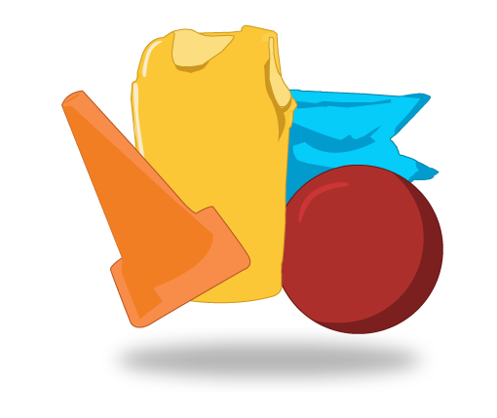  Using equipment and athletics | - Copy actions.  - Repeat and explore skills.  - Move with some control and care.  - Throw a ball underarm.  - Roll a ball or a hoop.  - Hit a ball with a bat.  - Copy and remember actions.  - Repeat and explore skills. | - Move with co-ordination and control.  - Throw and catch a ball with control and accuracy.  - Strike a ball and field with control.  - Sprint over a short distance.  - Run over a longer distance, conserving energy.  - Have a range of throwing techniques (underarm, over arm, putting and hurling).  - Throw with accuracy to hit a target.  - Jump in a number of ways, sometimes using a short run-up. | • Link skills, techniques and ideas and apply them accurately and appropriately.  • Choose the most appropriate tactics in a game.  • Use forehand and backhand when playing racquet games.  • Field well.  • Use a variety of techniques to pass.  • Strike a bowled ball.  • Work with a team or alone to gain possession of the ball.  • Combine running and jumping well.  • Show accurate control, speed, strength and stamina in my athletics.
Movement and control  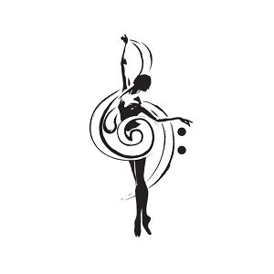  Dance | - Perform some dance moves.  - Put moves together to make a short dance.  - Show rhythm in my dance.  - Choose the best movements to show different ideas.  - Move carefully with control.  - Use space safely.  - Move with careful control, co-ordination and care.  - Perform my dance actions with control and co-ordination.  - Link two or more actions together to make a sequence.  - Remember and repeat dance movements.  - Choose the best movements to communicate a mood or feeling. | - Dance movements communicate an idea.  - Refine my movements into sequences.  - Dance movements are clear and fluent.  - Know that dance can express a variety of things. | - Creative and imaginative in composing my own dances.  - Perform expressively.  - Show precision, control and fluency.  - Dance matches the mood of the accompanying music.
Movement and control  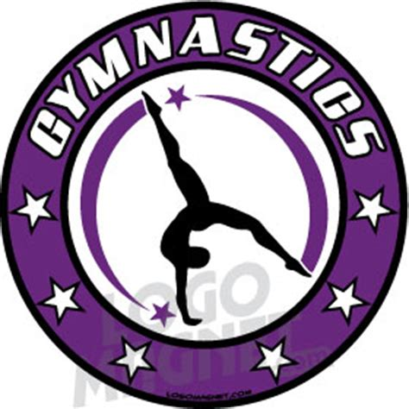  Gymnastics | - Show control and co-ordination when travelling or balancing.  - Choose which actions to make.  - Copy sequences and repeat them.  - Be able to roll.  - Travel in lots of ways.  - Balance.  - Climb safely.  - Stretch body.  - Curl body.  - I plan sequences of movements.  - Show contrasts such as small/tall, straight/ curved and wide/narrow.  - Movements are controlled.  - Balance on different points of body. | - Body is balanced.  - Shapes are controlled.  - I plan, perform and repeat sequences.  - Sequences include changes in speed and level.  - I work on improving strength and suppleness by practising stretches and shapes. | - I am controlled and skilful in actions and movements.  - Movements are controlled and express emotion or feeling.  - Make complex sequences that include changes in direction, level and speed.  - Combine actions, shapes and balances in gymnastic performance.  - Movements are clear, accurate and consistent.  - Prepare and perform to an audience.  - I practise and perform with control.  - Movements include very controlled balances, shapes, levels and actions.
Movement and control  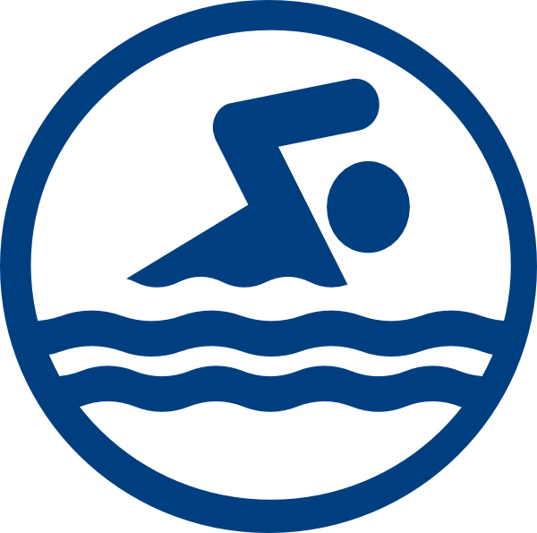  Swimming | - With help can swim up to 20 metres with floats.  - Swim up to 5 metres without floats.  - Put head in the water.  - I join in water activities at the pool.  - I explore different ways of moving in water.  - Swim up to 20 metres using arms and legs to move.  - I use one basic stroke to swim, breathing properly.  - Using floats, I swim with a controlled leg kick.  - I describe different swimming strokes. | - Swim between 25 and 50 metres.  - Arms and legs are co-ordinated.  - I use more than one swimming stroke.  - I swim both on the surface and below the surface of the water.  - Breathing is co-ordinated with the stroke I am using. | - Swim between 50 and 100 metres.  - I use breast, front crawl and back stroke styles confidently.  - Swimming uses arms and legs in a confident and co-ordinated manner.  - Swim over 100 metres.  - I swim fluently.  - I use all three strokes with control and sustain this for over 2 minutes.  - I breathe so that the pattern of swimming is not interrupted.
Planning and implementing  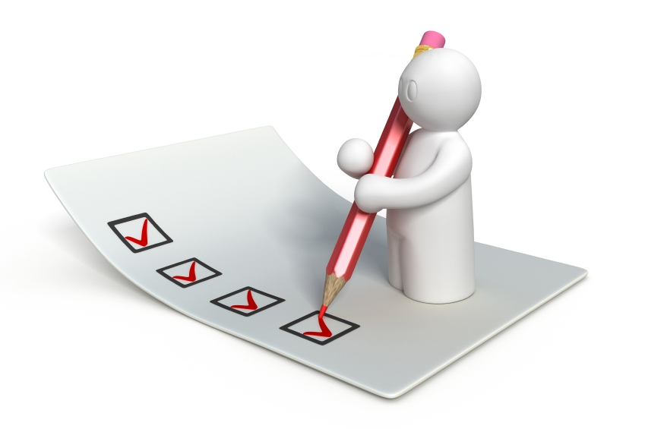 | - Use the terms ‘opponent’ and ‘team-mate’ when playing games.  - Use rolling, hitting and kicking skills in games.  - Decide on the best position to be in during a game.  - Have developed some tactics for the game I am playing. | - Select and use the most appropriate skills, actions and ideas.  - Choose the appropriate tactics to cause a problem for the opposition.  - Follow rules in a game.  - Keep possession of a ball (feet, hockey stick, hands).  - Improvise with ideas and movements.  - Use plans and diagrams to help me get from one place to another.  - Enjoy solving problems or challenges outdoors. | - Link skills, techniques and ideas and apply them accurately and appropriately.  - Choose the most appropriate tactics in a game.  - I am creative and imaginative in composing own dances.  - Select and combine skills, techniques and ideas.  - Apply skills, techniques and ideas accurately, appropriately and consistently.  - Use tactics and follow rules.  - Plan approach to attacking and defending.  - Know and follow event rules.  - Use senses to assess risks and adapt plans accordingly.  - Prepare well by considering safety first.  - Plan with others, seeking advice.
Reflecting and evaluating  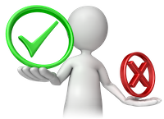 | - Exercise safely by looking for space.  - Talk about the differences between own and others’ performances.  - Say what has gone well and why.  - Identify how a performance could be improved.  - Describe how body feels during different activities, using parts of the body to describe the effects. | - Work and behave safely.  - Discuss I say how work is similar to and different from others’.  - Use this understanding to improve own performance.  - Give reasons why warming up before an activity is important.  - Give reasons why physical activity is good for health. | - Explain and apply basic safety principles in preparing for exercise.  - Analyse and comment on skills and techniques and how they are applied in own and in others’ work.  - Modify and refine skills and techniques to improve performance.  - Explain how different parts of body react during different types of exercise.  - Warm up and cool down in ways that suit the activity.  - Describe why regular, safe exercise is good for fitness and health.

